Evaluation of the Involvement and Motivation of Older Commission Staff (above 50 years)

FINAL REPORT
Version 2.0

Prepared for DG ADMIN

by

The EPEC Consortium

November 2008
Table of Contents
EXECUTIVE SUMMARY……………………………………………………………………... i
1 INTRODUCTION 1
2 the european cOMMISSION cONTEXT 2
2.1 The Commission Administrative Reform 2
2.2 The Commission Culture 3
2.3 The Commission’s Current Age Profile 4
2.3.1 Age Breakdown by Gender 5
2.3.2 Age Breakdown by Function 6
2.3.3 Age Breakdown by Job Families 8
2.3.4 Age Breakdown by DG Grouping 10
2.4 The Commission’s Future Age Profile 13
2.4.1 Aggregate Projected Retirements 13
2.4.2 Projected Retirements by Function - AD 14
2.4.3 Projected Retirements by Function - AST 15
2.5 HR Management and a Maturing Workforce in the Commission 16
2.5.1 The Commission’s Operational Context 16
2.5.2 Alignment of Commission HR Policies to State-of-the-Art HR Policies for Mature Staff 17
2.6 Commission Staff and Older Employees’ Needs and Aspirations 26
2.7 Employers and Older Employees 30
2.8 Role of HR Managers and Line Managers 33
3 summary of methodology 35
3.1 The Evaluation Aims and Research Questions 35
3.2 Methodological Approach 35
3.3 Evaluation Work Activities Undertaken 38
3.3.1 Work Package 1: Inception Phase – Stage 1 (Scoping) 38
3.3.2 Work Package 2: Inception Phase – Stage 2 (Focus Groups) 39
3.3.3 Work Package 3: Online Survey 40
3.3.4 Work Package 4: Stakeholder Interviews 41
3.3.5 Work Package 5: Synthesis, Analysis and Reporting 43
3.3.6 Work Package 6: Project Management 43
3.4 Revisions to the Work Plan and Schedule 44
4 Profile of older commission staff 47
4.1 Demographic Profile of Staff 47
4.1.1 Staff Sample 47
4.1.2 Breakdown by gender 47
4.1.3 Breakdown by age 47
4.1.4 Breakdown by nationality 48
4.1.5 Breakdown by place of assignment 50
4.1.6 Breakdown by nature of employment 50
4.1.7 Breakdown by length of service 51
5 skills, coMPETENCES and talents OF OLDER COMMISSION staff 53
5.1 Perceptions of Skills and Competences of Older Commission Staff 53
5.1.1 Comparison of views: most important skills and competences 55
5.1.2 Comparison of views: least important skills and competences 56
5.1.3 Staff’s perceived difference of their skills and competences 57
5.2 Talents and Qualities of Commission Staff aged 50+ 59
5.2.1 Comparison of views on talents and qualities 60
5.3 Evolution of Skills and Talents over time 62
5.3.1 Views of how Skills, Motivation and Performance evolve over time 62
6 satisfaction OF OLDER COMMISSION STAFF 72
6.1 Job Satisfaction among Staff aged 50+ 72
6.1.1 Variation by function group and gender 74
6.1.2 HR Managers’ views of staff job satisfaction 74
6.2 Commitment of Older Commission Staff 78
6.2.1 Current commitment 78
6.2.2 Changes in commitment 78
6.2.3 Reasons for change in level of commitment 79
6.3 Motivating factors 81
6.3.1 Utilisation of Skills 84
6.3.2 Structural issues and their effect on motivation 85
7 well-being at work 86
7.1 Working arrangements 86
7.2 Retirement 86
7.3 Medical services 87
8 MOBILITY, PROFESSIONAL AND cAREER DEVELOPMENT OF OLDER COMMISSION STAFF 89
8.1 Professional and Career Development of Older Commission Staff 89
8.1.1 Survey Response: Career Development 89
8.1.2 Staff Perceptions about their career progression 90
8.1.3 Managers’ perceptions of staff career progression 90
8.1.4 Changes in opportunities for career progression 91
8.2 Ambitions of Older Commission Staff 97
8.2.1 The views of managers 97
8.2.2 The views of HR managers 98
8.2.3 The views of staff 98
8.2.4 Age versus performance 99
8.3 Alternative Careers 100
8.3.1 The role of advisor 100
8.4 Mobility of Older Commission Staff 101
8.4.1 Barriers to internal mobility 101
8.4.2 Treatment of staff aged 50+ in respect of job mobility 106
8.4.3 Experiences of staff 110
8.4.4 Job applications 112
8.4.5 Evidence supporting survey respondents’ views 113
9 Older Commission Staff Recommendations 117
10 Commission mANAGEMENT 118
9.1 Demographic Profile of Management 118
9.1.1 Management Sample 118
9.1.2 Gender Breakdown of Management Sample 118
9.1.3 Age Breakdown of Management Sample 118
9.1.4 Breakdown of Management Sample by Length of Service in the Commission 119
9.1.5 Breakdown of Management Sample by Length of Service in current Managerial Job 119
9.1.6 Breakdown of Management Sample by Nationality 120
9.1.7 Breakdown of Management Sample by DG 121
9.1.8 Breakdown of Management Sample by Place of Assignment 121
9.2 Management’s Skills, Satisfaction and Motivation/Involvement 122
9.2.1 50+ Managers’ Own Competencies 122
9.2.2 50+ Managers’ Own Involvement and Motivation 124
9.3 Management’s Attitude towards Older Commission Staff 128
9.4 Effectively Managing Staff Aged 50+ 131
9.4.1 Managers’ Understanding of Staff Motivation linked to different Life Stages 131
9.4.2 Managerial Challenges when Managing Older Staff 133
9.4.3 Whether Managers have dealt with Age-Related Problems 136
11 HUMAN RESOURCES STAFF 139
11.1 Demographic Profile of HR Staff Sample 139
11.1.1 Gender Breakdown of HR Staff Sample 139
11.1.2 Age Breakdown of HR Staff Sample 139
11.1.3 Breakdown of HR Staff Sample by Length of Service in the Commission 140
11.1.4 Breakdown of HR staff Sample by Length of Time in Working in HR in the Commission 140
11.1.5 Breakdown of HR Staff Sample by Nationality 141
11.1.6 Breakdown of HR Staff Sample by Place of Assignment 142
11.2 HR Staff’s Skills, Activities and Knowledge 143
11.2.1 HR Staff’s Familiarity with Life Course Approach to Managing Human Resources in the Commission 143
11.2.2 HR Staff Role and Function 144
11.2.3 Whether HR staff have dealt with Age-Related Problems 145
11.3 Effectively Managing Older Commission Staff 148
11.3.1 HR staff Perceptions about the Importance of Age Diversity in the Commission 148
11.3.2 Equal Opportunities Policy 151
12 BENCHMARKING 154
12.1 Factors of Successful Implementation of HR Policies for Older Workers 154
12.2 Good Practice Examples 154
12.2.1 Examples from the US 155
12.2.2 Examples from Australia and New Zealand 161
12.2.3 Examples from Europe 165
13 CONCLUSIONS 171
13.1 Answering the Evaluation Questions 171
14 RECOMMENDATIONS 179
15 Appendices 190

executive summary
The EPEC consortium was commissioned by DG Personnel and Administration to investigate the issue of the involvement and motivation of Commission staff aged 50 and over in the light of a maturing workforce and the recent (2004) enlargement of the European Union.

The overall aims of this evaluation were to:-
- understand the issues involved in retaining the full involvement and commitment of Commission staff over 50 years of age, across grades
- examine the extent to which staff over 50 years of age may feel excluded or underutilised in the Commission
- make recommendations, based on knowledge of Human Resource Management current good practice, as to how the Commission might go about learning from and improving the current climate for older staff (50+) in terms of engagement, motivation and utilisation.

The specific over-arching research questions to be answered by this evaluation were identified as:-
- Are there specific issues for maintaining AST, AD, Middle/Senior Managers’ commitment? To what extent is this generalised or particular to individuals or categories of staff? Which are the most important or tractable issues?
- Is there a need to take any specific action? Are there realistic options?

Methodology

In order to address the overarching evaluation aims and research questions, a mixed methods (quantitative and qualitative) approach was adopted, with triangulation of methods and data sources. These methods involved a documentary analysis of Commission items, an HR literature review, initial structured interviews with key stakeholders, a preliminary staff focus group, further staff focus groups, with one aimed at ADs and one at ASTs, an on-line survey (comprising separate questionnaires for staff aged 50+, managers and HR managers), and individual interviews with HR personnel. Key stakeholders were identified as representatives from, for example SCOP; the Medical Services and Psyco-Social Interventions team; the Equal Opportunities Unit; Network of ReLOPs, and the PMO. Findings are based on the above sources of evidence, which include responses to the online survey from 1,043 staff aged 50 and over, 134 managers and 23 HR managers.

Main findings and conclusions

Below are the main conclusions, and the findings on which they are based, set out according to the key issues which the research addressed.

The treatment of older staff
Both the staff and management survey results indicated that the prevalent view among both older staff (45%) and management (53%) is that, compared with their younger colleagues, older staff are not treated equally in the Commission. Such a view was backed up by both verbal and survey feedback from 45.5% of HR staff as well as by the staff focus groups during scoping. Furthermore, 24% of staff and 14% of managers reported that they had experienced age discrimination. Among the staff group, 26% of men as opposed to 20% of women felt they had been discriminated against. Older male staff from EU15 think that they are at the moment discriminated against for a number of reasons, of which the equal opportunities policy aimed at gender equality and the influx of younger officials as a result of the 2004 enlargement are the most prominent..
Within function groups, 29.7% of AD staff compared with 18.8% of AST staff considered that they had been discriminated against. ADs were also slightly more inclined than ASTs to believe that those over 50 were treated unequally compared with younger staff and less likely than ASTs to believe that age diversity is important to the Commission.
Just over half (50.3%) of staff in External Services DGs, and just under half (49.2%) of those in Policy DGs, believed that older staff were not treated equally, compared with 43.1% of staff in General Services DGs and 32.7% of staff in Internal Services DGs. Age discrimination was reported by 27.1% of staff working in Policy DGs and 23.3% working in External Services DGs. The proportions for Internal Services DGs and External Services DGs were respectively 21% and 19%. The majority of older staff (51%) in Policy DGs thought that the Commission valued younger staff more: the proportions for other groups were General Services – 46%, External Services – 45.5% and Internal Services – 42.3%.
The skills and expertise which older staff believed they offered were: expertise; self-sufficiency and the ability to be proactive; the capacity to solve problems and make judgements; people skills; the ability to manage and deliver work; and loyalty to the organisation. While recognising that IT skills were not their main strength, they considered themselves to be adaptable to new technologies. They believed that certain qualities, such as providing knowledge and expertise; mentoring and coaching; reliability to colleagues; productivity; and dealing with heavy workloads, improved with age.

However, there was an over-riding perception from this survey and earlier Commission staff feedback that these attributes, skills and areas of proficiency were not the ones which were currently most appreciated by their managers, nor did they fit with the current Commission culture of privileging younger staff, women and those from New Member States. The perceived culture of youth (“culture du jeunisme”) leaves little room for the appreciation of qualities, skills and long-term expertise of older people, which can result in de-motivated and disillusioned older staff. Nevertheless, one of the most interesting findings from this survey is that a large majority of staff aged 50 and over continued to feel committed to their work and the organisation.

Internal mobility

Just over half of staff (51%) and over two thirds (70%) of management stated that there were barriers to mobility, of which age was the most important. Older male staff thought themselves especially disadvantaged in this respect. Half of both staff and management respondents reported that older staff did not have the same mobility and career progression opportunities as younger staff, the latter being preferred by managers because of their perceived greater flexibility. Half of older staff felt that managers were more likely to award merit points to their younger colleagues, with which a third of managers themselves agreed.
A considerably higher proportion of AD staff (61.5%) –- and especially men –- than AST staff (40.3%) felt that there were internal barriers to mobility. The growing demand for financial experts, secretaries and others, most of whom are at AST level, means that mobility for this group is easier than for ADs. (The findings of the 2007 Progress Report on the Implementation of the Mobility Policy in the Commission showed that among the various function groups, ASTs had the most mobility.)
Again, the largest proportion (63.7%) of staff in our survey reporting mobility barriers worked in External Services DGs, followed by staff in Policy DGs (51.1%). For the former, a major issue was mobility and integration after returning from a delegation, and they were most likely to have applied for another job in the previous two years.
As targets had to be met for staff from the New Member States, those from the Older Member States, and especially men, felt they were at a particular disadvantage when they needed or wished to move (women benefited more from the equal opportunities policy). Staff found little encouragement, and sometimes active discouragement, from managers if they wished to apply for another post. They also felt that applications were often unsuccessful even when their self-perceived ability and qualifications were not in question. The blame for this was seen to lie partly with the current structure of the organisation and partly with managers who were viewed as giving preference to younger applicants on account of their perceived willingness and ability to learn quickly, better technical skills and likelihood of remaining longer in post. According to staff, managers were not sufficiently well trained and/or experienced in dealing with the age diversity of the workforce.
In turn, this created difficulties for managers, half of whom stated that their most important challenge was to manage older staff who had not gained a managerial post.

Retaining key experts

Both staff (over 50%) and management (65%) singled out older staff’s technical expertise, knowledge and experience as being very important but almost half (48%) of staff over 50 and 38.7% of managers felt that the Commission failed to recognise/appreciate such qualities. However, 43.5% of staff felt that their knowledge and skills were used well or very well by the Commission and 27% thought they were sufficiently used. Staff most likely to think that their skills were not well used were men, ADs and employees in External Services and Policy DGs. Staff in Internal Services DGs were most likely to think their skills were well used. One area where older staff felt they could be better used was in mentoring and sharing their knowledge and institutional memory with younger colleagues.
Notwithstanding areas of dissatisfaction, the overwhelming majority (80.6%) of staff felt either involved or very involved in the organisation. Two-thirds of staff (and roughly equal proportions of men and women) felt the same level of commitment as earlier in their career. A slightly higher proportion of AST staff than ADs reported a constant level of commitment and among DG groups, those in General Services reported the most commitment and least alienation. Reduced levels of commitment stemmed from the under-utilisation of skills coupled with the inability to find another post, disillusionment with the changing culture in the Commission, or tensions between older and younger staff.
In terms of retaining key experts, the opinion of staff is that the Commission could do more, especially in the areas of transfer of knowledge/learning and knowledge management.

Developing the competences of staff aged 50 and over

Although almost all older staff in the survey reported that they wished to continue to develop and progress further in the organisation, over a quarter (28.4%) felt that they are not offered the same professional development opportunities as younger staff. Such perceptions were considerably stronger among AD staff (33.9%) as opposed to AST staff (23%), and men (31.5%) as opposed to women (23.2%).
Again, more staff working in External Services (33.6%) and Policy DGs (31.4%) than staff in other grouped DGs felt that they did not have the same professional opportunities as younger staff.

Options for optimising the competence, motivation, deployment and usability of staff aged 50 and over

Given the desire of older staff to pass on their knowledge and skills to younger colleagues, increased opportunities for mentoring and coaching would be a way forward. The Commission already has mentoring guidelines, but, given the high degree of decentralisation of operations that currently characterises the Commission, the implementation of practice is not uniform across DGs and Units. Support from the local HR services assigned to each DG might be helpful in moving this forward.
Additionally, older staff could be given specific roles such as developing knowledge management systems or sharing specific assignments with younger staff. This would both optimise the knowledge, expertise and organisational memory of older staff and make them feel valued by the organisation.
Commission managers might benefit from help in understanding and addressing the pertinent issues, including appreciating how motivation changes over time, coping with and managing a diverse workforce, and supporting their older staff to achieve a good work-life balance, which many a staff feel does not currently happen. Although many older staff stated that they had sufficient possibilities to work flexi-time or part-time, others said they would like improved opportunities for working in either way.
Other options might include:
- adopting a life-course approach to the management of human resources which would mean that HR policies addressed the different needs of staff at different life stages
- ensuring that there is an equality of opportunity which is clearly visible to all. This would avoid suspicions that women, younger staff and those form New Member States were receiving favourable treatment from managers
- checking that policies and practices do not disadvantage older staff.

Providing sustainable careers for staff aged 50 and over

The prevailing view among staff is that only managerial posts denote career success. Such posts have always had a relatively large pool of potential candidates owing to the traditionally low staff turnover in the Commission. That pool has become much larger since the 2004 enlargement, an increased trend towards external recruitment and the lowering of grades for management posts.

This indicates a need for an alternative, non-managerial, horizontal career path, which does, in fact, exist in the form of the “Recognised Expert”. However, its implementation is both variable and limited: raising awareness among both staff and management about its existence and operation might be a useful way forward in avoiding older staff believing that there is no reward for their efforts. It would also signal to older staff that their extensive knowledge and expertise is recognised and appreciated.

In view of the strongly expressed need for greater recognition by older staff, the Commission may wish to promote more widely the use of honorary titles which also denote an appreciation of knowledge and expertise.
There may be a case for an awareness-raising campaign among managers, linked to the business case for using staff aged 50+ more effectively. Increasingly, additional activities and responsibilities have to be undertaken without an increase in human resources, which means that the whole workforce has to be optimally utilised if objectives are to be achieved.
The Commission should continue to provide training and support to older staff so that they proactively manage their career progression. There may be a need for improving the awareness about and visibility of the central and local career guidance services, whose staff could also act as key information contacts for the monitoring of the mobility of older staff within a particular DG. Special attention should be paid to the way internal mobility is taking place. Closer monitoring of internal mobility might be needed, for example by having HR representatives present at the short-listing and/or interviewing of job applicants.
Both the online survey data and key informants indicated that, although the Commission has made great progress with the new rigorous systems for management selection, there is still scope for improving the skills of its managers, and in particular those of its middle managers.
Main recommendations
The overwhelming majority of older Commission staff expressed a strong wish to be integrated in the workforce on equal terms with younger staff, rather than being singled out for special treatment. In view of this, it would seem that the best way forward is for the Commission to adopt a life-course approach whereby policies – such as those relating to caring responsibilities for children or parents, preventative healthcare, career management, and appropriate training – are sufficiently flexible to accommodate the changing needs and aspirations of its staff.
The Commission might also consider further strengthening the multiple aspects of diversity, including age, while at the same time continuing to implement a rigorous equal opportunities policy. We understand that the Commission is in the process of preparing a Communication on Diversity, as part of which age-related issues can be addressed. A greater focus on all aspects of diversity would mean recognising and valuing people’s differences, while at the same time creating a respectful and inclusive environment which can maximise the use of all employees’ skills and qualities.
Nevertheless, given the current views of older Commission staff and the expectations raised by the commissioning of this report, we believe that some immediate action would be beneficial. Below we propose a number of measures that can be implemented in the near future, especially since a number of relevant policies are already in place. Other, longer-term measures are included in the full report.
The following recommendations are based on the findings from the study, on proven good practice, and the Commission’s unique context and culture.
- Actively market the existence of alternative career paths to line managers as a useful career management tool and ensure that both management and staff are fully aware of these
- Raise awareness of SCOP/ReLOP services among staff, including those over 50, in relation to career guidance and advice

- Provide training that would allow older staff to manage their career progression, better, for example, career planning and management

- Ensure that the short-listing process for mobility and/or career progression purposes is devoid of age-related bias by having a proper HR overview at local level

- Put in place systematic mentoring and/or coaching arrangements where they do not exist and promote the greater and more frequent use of mentoring of younger staff by older staff

- Promote other forms of knowledge transfer, such as job shadowing, job sharing between younger and older staff, and including older staff in the training cycle of new staff

- Raise awareness of and train managers in managing an age-diverse workforce, including making them aware of the importance of recognition for older staff

- Make sure that the implementation of flexible working arrangements is consistent across the organisation

- Increase awareness of all the services aimed at promoting well-being at work that are at the disposal of staff and can be of particular relevance to those over 50, such as socio-psychological services and access to ergonomic advice

- Promote a positive image of those over 50, for example, by increasing their visibility and profile in the Commission’s publications

- Provide more personalised pension and retirement related support, for example, by PMO.

INTRODUCTION
This Final Report has been prepared as part of the work that the EPEC consortium conducted in the Commission aimed at evaluating the motivation and involvement of its older staff (50+). It contains the main findings from the study, which included an extensive literature review of both Commission documents and wider age management, staff focus groups, stakeholder interviews and a major online survey carried out among older Commission staff, management and stakeholders.
This report presents the background to the study including a discussion on the human resource (HR) challenges vis-à-vis an ageing workforce and the attendant management implications (Section 2).
In Section 3, the report presents a summary of the workplan as well as the work that was carried out since February 2008, with particular emphasis on the online survey.

The main findings of the survey are broken down by respondent group, i.e. older Commission staff; management; and HR managers. Sections 4 to 9 inclusive deal predominantly with staff responses but include relevant findings from managers and HR managers. Sections 10 addresses the findings from managers and section 11 the findings from HR managers.

Section 12 includes updated information on Benchmarking and good practice examples for age management from both Europe and overseas, most notably the United States and Australia.

Finally, in Section 13 we present our conclusions and in Section 14 we put forward our recommendations.

the european cOMMISSION cONTEXT
This chapter presents an overview of the Commission context in relation to its demographics, current operational constraints/challenges and HR policies. In relation to the latter, we chose to present both the HR policies that have both theoretically and empirically proven to be best suited for a maturing workforce and how the specific Commission HR policies relate to them.

The Commission Administrative Reform

In order to understand better the findings of our study (presented in the following Sections of this report), we need to discuss briefly the wider historical and cultural context within which the Commission and its staff of all ages operate. As is widely known, the Commission embarked upon a major administrative reform programme in 2000, with the publication of its White Paper “Reforming the Commission”, which encompassed the entire operational, financial, procedural, HR, etc. framework of its operations. The White Paper brought together three strands of the reform package proposed by Neil Kinnock and his team, each of which responded to a particular set of challenges facing the organisation.

The first strand, aimed at matching resources to objectives/activities, involved a mechanism for the setting of political priorities and the allocation of resources. A new decision-making mechanism (Activity-Based Management) was introduced to ensure that responsibilities are matched to necessary resources, and that the results are regularly evaluated. The second strand involved the reform of the Commission’s financial management system, with the aim of empowering departments to establish internal control systems, so that the responsibilities of all actors involved in financial management became clear, and allowing for systematic checks to be undertaken by the Commission’s “new” Internal Audit Service. The third strand, which is the most relevant for our purposes, involved the whole-scale reform of the Commission’s human resources policy. The emphasis in this case is on
“performance, continuous training and quality of management, as well as improving recruitment and career development”
(Commission White Paper, 2000)
The reform of Commission Human Resources Management was accompanied with the later publication of the New Staff Regulations which came into force on 1 May 2004 and, inter alia, “established a linear career system designed to increase staff motivation and enhance meritocracy”. By linking promotion more closely to performance the new system aims at elevating the importance of the merit principle over seniority, while at the same time prioritising career development for individuals, equal opportunities and wider access to training.
Crucially, there were transitional arrangements for long-standing staff already working at the Commission at the time, which apply to a large proportion of those over 50. However, as we will see later all three strands, but especially the HR and financial management ones, have caused concern to such staff, not least because of the radical change that these strands introduced in both the way the Commission was organised and operated and in how they themselves are treated, managed, moved and progressed in the organisation.

The Commission Culture

Significantly, this ground-breaking reform process was also linked to major shift in the Commission’s culture from that of a “centralised bureaucracy set up to deal with the problems and responsibilities of the past towards a more performance-based management” with the aim to foster, both internally and externally, a culture based on service. The main characteristics of such a service culture include independence, responsibility, accountability, efficiency and transparency which, in turn, elevates the importance of an ‘administrative’ or ‘management’ culture.
At the same time the Commission culture started to change in another way, with the organisation evolving from being primarily an “administration de mission” towards embracing also “administration de gestion”. Such a shift from policy conception and development to managing/monitoring policy and programme implementation has affected those over 50 to a greater degree, not least because some were attracted to the Commission because of its strong mission, vision and policy focus at the time. Indeed, as will be shown in later sections of this report, some older Commission staff have difficulties coping with such a cultural shift. Linked to this are the changed requirements for management selection which put a premium on managerial/generalist (as opposed to technical/specialist) skills, which again signal in the eyes of older Commission staff a major departure from the past.
Finally, the last major enlargement of 10 + 2 New Member States has inevitably had an impact on the working culture (and language) within the Commission, not least because of the influx of a younger pool of officials (many of whom belong to Generation Y) who, in the eyes of older Commission staff, have very different attitudes and values as well as attributes and behaviours from them. The implications for inter-generational relations in the Commission emanating from such views of older Commission staff will be discussed later in the report.

The Commission’s Current Age Profile

In line with wider demographic trends in many Member States, the Commission’s workforce is maturing (Figure 1). This trend is further reinforced by the historically low turnover rate and the operation of (until recently) a quite rigorous internal labour market for all appointments.
Figure 1: Evolution of Age Distribution in the Commission (1995-2007)
0
200
400
600
800
1000
1200
22
24
26
28
30
32
34
36
38
40
42
44
46
48
50
52
54
56
58
60
62
64
66
âge
1995
2007
Source: DG ADMIN (2008), Rapport Ressources Humaines
For example, as of 31.12.2007, the average age of officials and temporary agents is 44.5 years. Significantly, looking at the age distribution between 1995 and 2007 within the Commission, one can see clearly that those in their 40s and 50s are quite prevalent (Table 1).

Table 1: Age Breakdown of Commission Staff as of 31/12/2007
 | Permanent Officials & Temporary Agents |  | Contract Agents
Age | AD | AST |  | GFI | GFII | GFIII | GFIV | Total
20-29 | 4.2% | 4.8% |  | 20.0% | 20.3% | 24.1% | 14.5% | 19.2%
30-39 | 27.3% | 23.0% |  | 40.0% | 47.4% | 53.7% | 63.3% | 54.6%
40-49 | 37.6% | 39.5% |  | 40.0% | 24.0% | 19.1% | 16.4% | 20.1%
50+ | 31.0% | 32.6% |  | 0.0% | 8.3% | 3.0% | 5.8% | 6.1%
Source: DG ADMIN (2008), Rapport Ressources Humaines
The above tallies with our own analysis of age-related statistics for Commission staff which points to a median age of 45, meaning that half of its workforce is older. Although the 2004 enlargement has attracted a relatively larger pool of younger staff, in view of the increased average age of recruits, this did not result in a major readjustment of the Commission’s age profile towards younger ages. That said, thanks to the successive enlargements the “ageing” of the Commission’s staff is not as pronounced as it could have been.

Age Breakdown by Gender
However, as is already clear from Table 1 in reality this picture is more fluid and complex. Specifically, not all segments of the Commission’s staff are maturing, or at least are maturing at the same rate. At present, as Figure 2 shows, it is the male Commission population who is relatively older than the female population. Indeed, among the male Commission staff there is a relative lack of younger men accompanied by a larger proportion of more mature officials.

Figure 2: Age Distribution of Commission Staff ¹ by Gender (31/12/2007)
0
100
200
300
400
500
600
21
23
25
27
29
31
33
35
37
39
41
43
45
47
49
51
53
55
57
59
61
63
65
67
Men
Women
Source: DG ADMIN (2008), Rapport Ressources Humaines
¹ Contract Agents not included

Age Breakdown by Function
Similarly, the AST group is on average older than the AD group (), one reason being that at present a relatively large proportion of the latter group consists of women, who have a younger age profile. For example, 72% of AST as opposed to 69% AD staff are over 40, including 33% of AST as opposed to 31% of AD staff being over 50. Obviously such figures have implications about the manpower flows (exit/retirement) of Commission staff in the next 5-10 years (see Section 2.3.1 for projected retirements). Although it is unlikely that the Commission will have to face a massive exodus in the near future, the number of staff bound to leave in the medium term warrants a reassessment of the changing age profile of the organisation, the required skills set, function mix, balance between management and non-management staff, etc.

Figure 3: Age Distribution of Commission Staff by Function (31/12/2007)
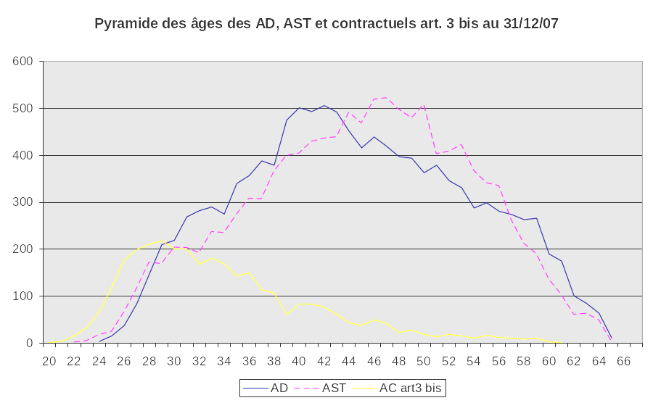
Source: DG ADMIN (2008), Rapport Ressources Humaines
Interestingly, there are also gender-related variations in the age distribution within these two distinct function groups. Specifically, among the AST group both men and women follow the overall age distribution within the Commission, i.e. relatively fewer younger staff and predominance of those aged over 40. In contrast, among the AD function group it is men who conform to this average Commission age profile, with women being characterised by a younger age distribution. Indeed, as a recent report indicated, the male AD population stays in the Commission for longer time and is characterised by the largest proportion of those aged over 55.
Finally, both male and female contract agents working at the Commission are considerably younger that the rest of the Commission staff. Specifically, the age of the majority of contract agents is between 25 and 40.

Age Breakdown by Job Families
The recent Commission Report on its human resources presented interesting information in relation to how specific job families are characterised by particular age distributions. By examining more closely the age distribution by job family, the Commission can see in which job families it is likely to face a greater number of staff retiring in the medium terms, as a result of which it could plan its future manpower requirements more effectively.
Overall, a large proportion of staff working in Policies (see Figure 4); Legal and Audit services; and Compliance and infringement handling are under 40. The last job family in particular shows an age distribution noticeably skewed towards younger ages (see Figure 5).
Figure 4: Age Distribution in Policies
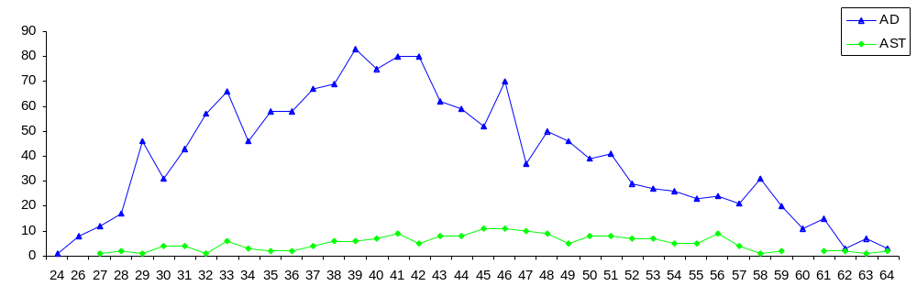Source: DG ADMIN (2008), Rapport Ressources Humaines
Figure 5: Age Distribution in Compliance & Infringement Handlling
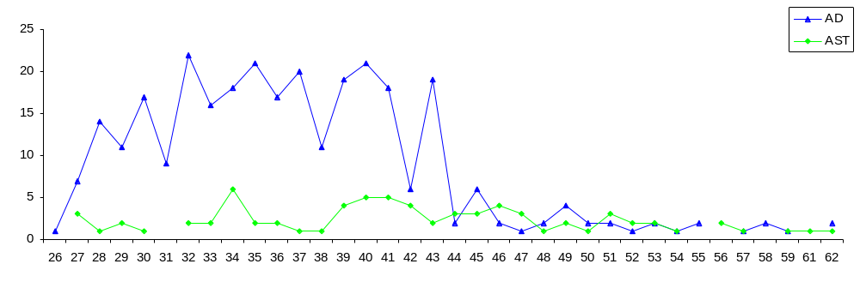Source: DG ADMIN (2008), Rapport Ressources Humaines
In contrast, most staff working in Logistics Support (see ); Control and Inspection; Information and Documentation Management; and, not surprisingly, Management are over 40, with management in particular being concentrated in the over 50 category (see Figure 7).

Figure 6: Age Distribution in Logistics Support
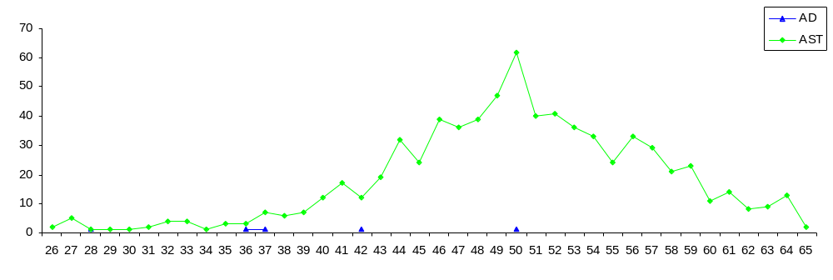Source: DG ADMIN (2008), Rapport Ressources Humaines
Figure 7: Age Distribution of Commission Management
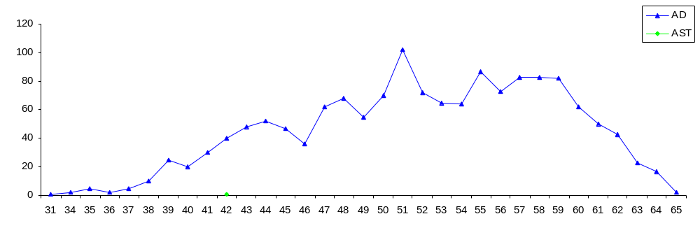Source: DG ADMIN (2008), Rapport Ressources Humaines
As stated in the report, one of the reasons why the age profile of these job families is older is the fact that much fewer permanent and temporary staff for these types of jobs have been recruited in recent years.

Age Breakdown by DG Grouping
Using Commission data on the age profile of its entire workforce, we also looked at the age spread by DG groupings, i.e. Policy DGs, External Relations DGs, General Services DGs and Internal Services DGs. As shows, External Relations DGs have the highest proportion of older staff with with 1,269 (40%) of their 3,189 staff being over 50. Conversely, General Services DGs have the lowest percentage of older staff with only 648 (23%) of its 2,779 staff being over 50. The largest DG grouping, Policy DGs, have a total of 11,928 staff of which 3,735 (31%) are over 50, whilst in Internal Services DGs 2,121 (38%) of their 5,583 staff are over 50. Whilst General Services DGs have a low proportion of older staff, nearly a quarter of its staff are over 50, and across the DGs, around one third of the workforce is over 50, meaning that any issues related to older staff have both relevance and significance to the Commission as a whole.

Figure 8: Age Breakdown by DG Group
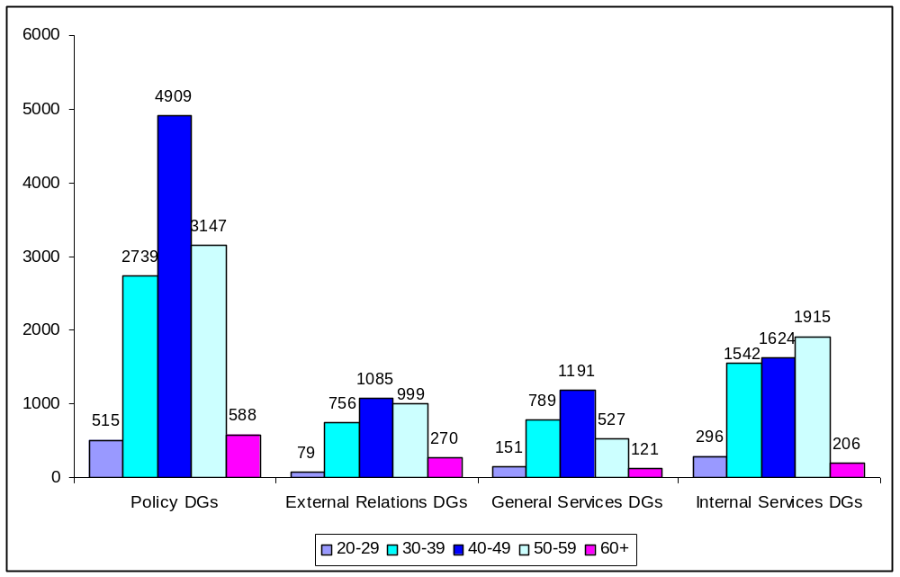
Source: Commission Figures on Age Breakdown of all active Staff (2008)

As regards the age breakdown of female staff, Figure 9 overleaf below shows that Internal Services DGs have by far the greatest proportion of over 50 female staff with 44% of them being over 50 as opposed to only 22% being under 50. For the Policy DGs the situation is reversed with a very high proportion of the younger female staff (52%) and a relatively low proportion of older 50 females (40%). External Services and General Services DGs follow this trend with relatively larger proportions of staff under 50.
Figure 9: Age breakdown of Female Staff by DG Group
22%
13.6%
12.4%
52.1%
44.1%
8%
11%
36.9%
0
10
20
30
40
50
60
Policy DGs
External Relations
DGs
General Services
DGs
Internal Services
DGs
under 50
50+
Source: Commission Figures on Age Breakdown of all active Staff (2008)
In comparison with female staff, there are a similar number of male staff within Internal Services DGs, but far fewer older male staff (20%) (Figure 10). Whilst General Services DGs have a similar proportion of male older and younger staff, External Services DGs have a considerably higher proportion of older male (19%) than female (11%) staff. Similarly, Policy DGs also have more older male staff (53%) than female older staff (37%).
Figure 10: Age breakdown of Male Staff by DG Group
22.2%
52.2%
12%
13.6%
19.7%
53%
18.7%
8.5%
0

10
20
30
40
50
60
Policy DGs
External Relations
DGs
General Services
DGs
Internal Services
DGs
under 50
50+
Source: Commission Figures on Age Breakdown of all active Staff (2008)
In comparison to the Commission as a whole, the DG groups show little variance from the aggregate data. More striking in fact are the similarities: the average age of non-functionaries shows a range of only 3 years, with the lowest mean age of non-functionaries in General Services DGs (42). Even the most common function, Head of Unit has a very similar mean of approximately 54. Consequently, between DGs, there is little variance in the average age of functionaries.

The Commission’s Future Age Profile

Aggregate Projected Retirements
In order to sketch out the Commission’s future age profile we estimated the number of retirements due to take place in the next 5, 10 and 15 years, assuming zero staff turnover and no early retirements. Table 2, Table 3 and Table 4 show the number of Commission staff who will, in 5, 10 and 15 years turn 60, 63 and 65 respectively

As can be estimated from Table 2 (assuming no new entrants) the average age of Commission staff if those who reach 60 are not included in its total workforce would be 47.6 years in 2013; 50.4 years in 2018; and 52.6 years in 2023.

Table 2: Commission Staff turning 60 in 5, 10 & 15 Years
Years | Number of EC Staff turning 60 | % of  Total Staff
2008 – 2013 | 2543 | 10.33%
2013 – 2018 | 3736 | 15.18%
2018 - 2023 | 4546 | 18.48%
Source: Commission Figures on Age Breakdown of all active Staff (2008)
Similarly, Table 3 shows that (again assuming no new entrants) the average age of Commission staff if those who reach 63 are not included in its total workforce would be 48.7 years in 2013; 51.8 years in 2018; and 54.3 years in 2023.

Table 3: Commission Staff turning 63 in 5, 10 & 15 Years
Years | Number of EC Staff turning 63 | % of  Total Staff
2008-2013 | 1488 | 6.34%
2013-2018 | 2977 | 12.68%
2018-2023 | 3992 | 17.0%
Source: Commission Figures on Age Breakdown of all active Staff (2008)
Finally, Table 4 shows that (again assuming no new entrants) the average age of Commission staff if those who reach 65 are not included in its total workforce would be 49.3 years in 2013; 52.6 years in 2018; and 55.4 years in 2023. It is worth noting that a relatively larger proportion of AD staff prefer to work in the Commission until they reach the age of 65 (age of compulsory retirement). For example in the last 10 years, 19% of AD staff retired when they reached 65 and not earlier.
Table 4: Commission Staff turning 65 in 5, 10 & 15 Years
Years | Number of EC Staff turning 65 | % of  Total Staff
2008 – 2013 | 773 | 3.14%
2013 – 2018 | 2543 | 10.33%
2018 - 2023 | 3736 | 15.18%
Source: Commission Figures on Age Breakdown of all active Staff (2008)

Projected Retirements by Function - AD
The above forecasts tally with the ones recently presented by the Commission in its 2008 Report on Human Resources. For example, about 3,300 (30%) of AD staff will turn 60 in the next 10 years, while a further 2,200 (19%) will turn 65 in the same period. As the report argues, the impact of these AD going on retirement will not be felt equally across the Commission. Not surprising (and in line with the age breakdown by DG Grouping - see Section 2.3.4) Internal Services/Administrative DGs, will be most affected since they employ a large proportion of AD staff who will turn 60 in 2018. For example, 50% of OIB staff, 38% of DG ADMIN staff, 37% of OPOCE staff, 34% of SCIC and DIGIT staff and 30% of DGT staff will reach the age of 60 in ten years.
Another DG group most affected by an ageing profile of its current workforce is the one of External Services. Here 41% of DG AIDCO staff, 38% of DEV staff, 36% of DG ELARG, DG RELEX and RELEC DEL staff will turn 60 in 2018. On the other hand, DG TRADE and DG ECHO will be least affected with 17% and 25% of their staff turning 60 in 2018.
A number of Policy DGs will also be affected with a relatively large proportion of their staff turning 60 in 2018. For example, 38% of DG FISH staff, 37% of DG RTD staff, 35% of DG TREN staff and 33% of DG AGRI and DG REGIO staff will reach that age in 2018. In contrast, policy DGs dealing with economic and financial affairs present a younger age profile and will not be considerably affected. DG COMP in particular has a noticeably younger age profile, with only 10% of its staff turning 60 in 2018. This was borne out also by stakeholder interviews in that DG, which underlined the fact that DG COMP was a “younger” DG. Similarly, DG MARKT and DG TRADE with 17% of their staff turning 60 in 10 years are will largely be unaffected.
Looking at the age breakdown of AD staff by job families, it is not surprisingly that over half (57%) of those in management positions today will turn 60 in 2018. A further 45% will turn 65 in the same period. Those job families such as Legal and Audit services, currently characterised by a younger age profile (see Section 2.3.4), will be, not surprisingly, least affected.

Projected Retirements by Function - AST
According to the Commission’s Report on its Human Resources, about 3,800 (35%) of AST staff will turn 60 by 2018, with a further 2,000 (19%) turning 65 over the same period. Again the effect will not be felt equally by all DGs and Commission services, with General services DGs being affected the most. For example, 43% of DG DIGIT staff, 42% of DG BUDG staff, 41% of DGT and DG COMM staff, 40% of DG ADMIN, and SEC GEN staff will be reaching 60 in 2018. Services such as OIB, OIL and PMO show an even “older” future age profile, with 58%, 47% and 45% of staff respectively turning 60 in ten years. Finally, DG AGRI and RELEX.DEL have also a large proportion (over 40%) of staff who will reach the age of 60 in 2018. At the other end of the spectrum, DG ENV, DG RTD and DG MARKT will be least affected, with 19%, 22% and 23% of AST staff respectively turning 60 over this period.
As with AD staff, the impact of an ageing workforce will not be the same across the 24 job families. Not surprisingly, those job families characterised by a “younger” age profile, e.g. Compliance, Audit, etc. will be least affected. Similarly IT, HRM and Planning and Evaluation -related jobs will not be very affected.
In contrast, the job families “Inter-institutional Relations”, “team co-ordination” and “Logistics support” will be most affected, with 34%, 32% and 30% of AST staff respectively turning 60 in 2018.

HR Management and a Maturing Workforce in the Commission

The Commission’s Operational Context
In undertaking this project our intention has been to support the Commission HR management in mediating different drivers at work around staff aged 50+. These drivers include rights-based understandings that underpin the Anti-Discrimination legislative framework; the psycho-social and socio-economic issues involved in self-management by staff aged 50+; and the needs of Commission management in achieving optimal delivery of their tasks. In order to do so, one has to develop an in-depth understanding of the constraints within which Commission staff – including those aged 50+ and HR staff – operate.
Specifically, the Commission works within an environment characterised by the need for vertical accountability, demonstrating that it meets the political demands of the decision making bodies: the European Parliament, to which it is formally accountable, and to Member States’ governments represented by the Council of Ministers. At the same time, given the workload of staff and the multiple demands placed upon them, it is important for reasons of efficiency and value for money that the involvement and motivation of more experienced staff members be retained and optimised. The cost of losing and/or under-utilising vital human resource has dramatic implications for both the effective operation and the knowledge transfer within the organisation. Indeed, in view of the fact that the Commission is currently operating within a cost containment context, the need to optimise the utilisation of all its human resources, including those aged over 50+, becomes even more urgent.
Moreover, Anti-Discrimination legislation at European and national levels has created a framework for good employment practice, which the Commission should be seen to embody for Europe. Demographic changes and changes in working practices also provide the broader context in which this practice is being developed. The European Commission’s concerns surrounding an ageing workforce and the concomitant anxieties relating to both motivation and knowledge transfer resonate across the industrialised nations. Responses to the current situation have emerged within the broader policy framework, whether in the guise of the Finnish model of WorkAbility, or the orientation towards the notion of ‘flexicurity’, as pioneered in Denmark.
In view of the above discussion, the value of age management by organisations has increasingly gained in strategic importance within the EU and beyond. The European Commission itself has highlighted the implications of an ageing workforce, and drawn attention to a number of HR practices that can be used to engage and retain older workers.

Alignment of Commission HR Policies to State-of-the-Art HR Policies for Mature Staff
As part of this work we undertook a thorough and exhaustive literature review of both theoretical and empirical evidence on state-of-the-art age management and its HR policy components. We also looked at the Commission’s own HR policies and how these are aligned to meeting the needs of older staff.
For example, flexible working arrangements are a component of working conditions proven to effectively enhance motivation and improve job retention for older workers. Indeed, national surveys demonstrate that a significant number of older workers would prefer a gradual process of retirement, mainly (but not only) due to health reasons related to ageing. Recognising the importance of flexible working arrangements for promoting both the well-being and motivation of its staff, the Commission has introduced a number of related policies, ranging from the ability to work part-time to flexitime and tele-working. For example, 5% of Commission staff works part-time. Crucially the Commission has made special arrangements for those over 55 who wish to work part-time with officials aged 55 or over being entitled to work half- time with favourable salary conditions. A special type of part-time, “time credits”, aimed at providing officials with greater flexibility over their working arrangement is also available. In a similar vein, flexitime, introduced in the Commission in 2007, allows officials to have a variable work schedule and adjust their working hours to their professional and personal needs. The scheme has proved very successful, with 47% (16,000) of those eligible making use of it in 2008. Finally, the Commission has introduced tele-working as of 2007 and is running a three-year tele-working pilot. In 2008, there are already about 800 tele-workers, 60% of whom are female and 55% AD. All these Commission policies aimed at promoting flexible working arrangements are very important for all staff, but in particular for older staff. As we will see later in this report, such staff, when they are aware of such policies, are appreciative of their existence; however, it seems that the implementation of these policies varies considerably among DGs and even Units within one DG and impinges highly on the personal attitude of the line manager.
The role of the line manager is also crucial for the next set of policies which ther research has shown that best practice HRM in relation to managing older staff. These policies relate to the design and implementation of robust appraisal and development review systems. Such systems aim to identify and find ways for the optimal utilisation of the skills and talents of this category of staff as well as provide them with further opportunities for professional development (see Section 11 on Benchmarking).
As a result of its major administrative reform, the Commission developed a rigorous staff appraisal system (Career Development Report – CDR) and is in the process of introducing a new one at the beginning of 2009. The current appraisal system includes an annual evaluation report based on the achievement of objectives jointly agreed by the assessor and the person being assessed, the latter having to fill in a self-assessment form which is then discussed with his/her assessor (as part of the appraisal dialogue). These objectives are, in turn, based on a job description and task assignment, and the assessor is the assessed person’s line manager, typically a Head of Unit. The report is scored according to a number of criteria (based on performance level to be expected by any job holder) to a maximum of 20 points which are accumulated for promotion purposes. There are, in addition, priority points ‘owned’ by DGs which are used to make discretionary awards to a maximum of 10 points to individual officials. There is an appeals system within each DG and Commission-wide. As will be seen later, both the introduction of the CDR system and the award of points have, in some instances, given rise to concerns among older Commission staff. Again the way CDR is implemented by line managers is crucial in how fair and equitable the process is seen by staff.

The new appraisal and promotion system, due to come into force in January 2009, can be seen as a response to such concerns (raised not only by older Commission staff) and to the changing HR context, which places the emphasis even more on performance (outcomes) rather than on skills and talents (inputs) as such. In the new system, merit marks are being replaced by five (5) performance levels, which require the inclusion of the assessor’s qualitative comments in the CDR, which will then be summarised in to a performance level. The Common Appraisal Standards, classified under three headings (efficiency, ability and aspects of conduct) will continue to play an important role. The CDR will not longer produce points relevant for promotion (as was the case with the merit marks). Each performance level will, instead be linked to a range of promotion points, in an attempt to link appraisal more directly to career development and speed of promotion. Again this is a response (also reflected in comments by older Commission staff) to views that such link between merit reflected in the annual CDR and award of priority points is not always clear at present.

Indeed, there will be a rationalisation of the points system, with only the promotion points (0-12) remaining, and all the other types of points abolished. In addition, unlike the current system of priority points, there will no longer be an overall quota of points. Instead, different quotas will be calculated for each grade and each performance level. This is to be welcomed because allocation of points was an issue of concern among older Commission staff, who felt that the process was both not sufficiently transparent and biased towards privileging younger staff. For example, over half of them (51.1%) thought that in the annual staff appraisal, managers are more likely to give merit points to younger rather than to older staff. Such views have also been confirmed by the 2006 Staff survey, in which 60% of staff respondents have stated that they were either dissatisfied or very dissatisfied with the transparency of the promotion system.
Recognising staff concerns on this issue, the Commission in its new Staff Appraisal and Promotion System has introduced a set of checks and balances which act as control mechanisms and safeguards of the process, e.g. a warning system, targets on promotion speeds, etc. The aim is, inter alia, to increase transparency and show to staff that the new system is not designed for an elite (such concerns were indeed expressed by older Commission staff). So the new appraisal and promotion system is expected to promote: 80% of officials in entry grades (AD5-AD8, AST1-AST4) in three years or faster; 75% of middle grade officials (AD9-AD12, AST5-AST8) in four years or faster; and 70% of officials in grade AST9 in five years or faster. Crucially, a warning system is being set up to monitor progress towards achieving these percentages, with DG ADMIN having the right to take corrective steps, if necessary.
Similarly, research suggests that the opportunity to utilise their full range of skills is rated relatively more highly by older workers who are also willing to convey their knowledge and expertise to younger colleagues within a collaborative and supportive framework. The latter involves proper management of knowledge transfer in terms of both succession planning and management as well as knowledge management. This, in turn, means putting in place strategies that facilitate and encourage knowledge sharing and transfer from more senior/mature/older staff to those who need to apply that knowledge. Such strategies include mentoring and coaching; job sharing; handovers through planned arrangements such as phased retirement; team-based approach managing long-term projects, and good record keeping practices.
As will be seen later, older Commission staff have mixed views about the extent to which the organisation identifies, utilises and matches their considerable knowledge and experience to optimum effect. Even so the Commission is already implementing measures aimed at addressing precisely such concerns. Specifically, in 2002 it developed the Job Information System (JIS) which contains detailed information about the job content of all (about 30,000) posts in the Commission and is in the process of analysing the job descriptions of these posts with the aim of compiling their competency profile (job mapping).
Apart from providing information about the work content, person specification and environment for each job in the Commission, JIS and job mapping will be an integral part of one’s mobility, career development and progression in the Commission. Indeed, both age-management related (and not only) HR theory and practice underline the importance of a formal career planning process for employees of all ages, including those over 50. Crucially, in the new reformed Commission, staff are expected to take responsibility for their own career management, with the support and advice of the organisation. Arguably, this requires a shift in attitudes among both management and staff, especially older Commission staff. Another tool that can be used by staff for mobility, career planning and progression will be the e-CV system, currently under development, comprising an electronic database containing personal and professional profiles of all staff and a matching tool which will allow one to compare their profile with job requirements of the various posts. Using this matching tool as “search engine” staff will be able to match their professional profile to jobs. Overall, the e-CV, expected to be completed in 3 to 4 years, will be part of the Commission’s competency management system and, as a talent management tool, yield accurate information on the human capital available within the organisation.
In view of the historical career development patterns, where staff expected the organisation to advance their career, it is not surprisingly that as a result of this shift of the Commission from being a position-based towards a career-based organisation, older Commission staff expressed serious concerns about such aspects of career policy in the Commission as mobility and career progression. Similar concerns were also recorded in the 2006 staff survey. For example, about one third (32%) of staff surveyed were either dissatisfied or very dissatisfied with the design of the Commission’s mobility policy, with 35% reporting levels of dissatisfaction with the implementation, monitoring and support of the mobility policy. Indeed, in our own survey of older Commission staff, half of the respondents (50.1%) stated that they do not have the same opportunities for mobility and career advancement as younger staff, while 37.6% were dissatisfied or very dissatisfied with career development opportunities provided to them.
The above discussion also highlights the need for proper career management linked to a cultural shift in the Commission. This need was also identified by the Evaluation of the Career Guidance Support in the Commission. Indeed, as the Progress Report on the Implementation of the Mobility Policy states, the Commission has already taken steps towards introducing a career management system, not least by developing a comprehensive job information system and continuing work on the e-CV as well as putting in place both central and local career guidance services.
This, in turn, throws up a wider challenge for both the Commission staff and management as well as HR professionals, i.e. making the transition from a vertical career system based on seniority and length of service to one that involves lateral/horizontal career moves. For example, the Career Guidance Officers’ Working Group on the Management of Commission Senior Staff reported that the 50+ feel de-motivated because they find it difficult to think of a rewarding career if it does not entail a managerial post. The issue of the end-of-career post (and end-of career-grade) was indeed highlighted by both scoping and survey findings, as will be shown later.
It is worth noting that the Commission has recognised the importance of this issue and taken steps to address staff concerns. Significantly for older Commission staff there are provisions in the new system for end-of-career grades (AD13, AD12, AST10, AST6.C, AST4.D). Since for these grades no historical promotion rates exist, a convergence plan cannot be implemented (as is the case with officials either promoted in 2005 or after or recruited after 30 April 2004). Instead, the current practice of setting indicative yearly thresholds will be maintained. However, the new system will introduce an improvement also for these grades by publishing these indicative thresholds at the beginning together with the official launch of the exercise. Similarly, the promotion rate will continue to rise in the coming years. For example, for an AD12 the rate in 2009 increases from 10% to 15%. Such changes should be welcomed by older Commission staff who expressed frustration in the survey and in focus groups about what they perceived to be the slowing down of promotion rates, especially for those on end-of-career grades.

Notwithstanding the career progression and mobility related concerns described above, it should be noted that the Commission has already put in place support and career guidance mechanisms to help staff adapt to the new requirements of mobility, including the 5-year compulsory mobility in sensitive posts, and a career progression driven by the individual. Specifically, it has introduced the Career Guidance Service both centrally (SCOP) and locally in each DG (ReLOP). Career guidance advisors can help staff plan and manage their career though a range of services including both career counselling (either one-to-one or in groups) to help them recognise and use their skills and interests in order to develop their careers and coaching in targeted job search and self-presentation techniques, CV composition and mock interviews. In addition, staff can use the online career planning process roadmap and/or the career navigator, an online career guidance tool to plan their career. Such services can be of particular use to older Commission staff who, judging from their responses to our survey and scoping exercise, are not always aware that they are at their disposal. Such lack of awareness of SCOP/ReLOP services was also reported both in the 2006 Staff survey and in the 2004 Evaluation Report of Commission Career Services.

Apart from career planning, performance management should also be used to provide older staff with access to learning and development opportunities. In relation to professional development and training opportunities, it should not be assumed that older staff are less interested in training or new job challenges. Unfortunately, all existing evidence suggests that older workers have less access to training opportunities. For example, the Fourth European Working Conditions Survey shows that although between 1995 and 2005 access to training for workers had increased, training opportunities provided by employers for older workers are not frequent. Specifically, the survey data demonstrated that only one in five of those aged 55 and over reported having received training paid for or provided by their employer in the previous twelve months (compared to 27% of all workers). For other categories of training, such as on-the-job training, older workers also fare worse than their younger counterparts. OECD also confirms that it has proven particularly difficult to reduce inequalities in training participation by age and skill.

This is not necessarily the case in the Commission, whose training framework is particularly generous and seen as an integral part of its HR provision to staff. The main principles include support for life-long learning; the need for close collaboration between staff and management in determining training needs; the view of training as an investment (as opposed to cost); inclusion in terms of training opportunities offered to all staff; an understandably privileged position for language learning; etc. A key Commission training principle with bearing on this study is that of using training as an instrument for promoting equal opportunities between men and women. Such a premise could be extended to other demographic diversity aspects, most notably age.

Reflecting the importance of learning and training in the Commission, the 2002 Training Guidelines adopted a specific yearly target in terms of staff time devoted to training. So by end-2005 an average of 10 working days per staff member per annum should have been devoted to training activities, divided into an average of 5 days “off-the-job” general training (courses, conferences, etc.) and an average of 5 days language and other less formal training (mentoring, job shadowing, etc.). The training dialogue between line management and staff, taking place either as an ongoing process or at least as part of the CDR preparation, serves as the platform where staff’s training needs of and related activities are discussed. This discussion has both a retrospective element culminating in the Training Passport and prospective element in the form of the Training Map outlining staff’s current training needs and proposed training activities. Moreover, in order to promote a training culture across the organisation the Commission also established a network of local training managers (COFOs) within the various DGs and services. Given the above discussion, it is not surprising that the overwhelming majority (82%) of Commission staff were satisfied with their manager’s support in relation to their access to training. That said, some older Commission staff surveyed expressed concerns about their access to learning and professional development, with 28.4% stating that they did not have the same training opportunities as younger staff.

Another set of policies that are particular important to older workers relate to the availability of early and/or phased retirement schemes. Again the Commission has developed an early retirement scheme which does not carry a reduction of pension rights. In terms of phased retirement, as mentioned above, those over 55 are allowed to reduce their hours of work in order to prepare themselves gradually for retirement. Although this option is welcomed by those eligible, its take up is rather limited. A number of reasons have been put forward as to why this is the case. For example, the 2005 Ex-Ante Evaluation of a Well-Being Policy Report noted that the policy of phased retirement is not particularly flexible in responding to different needs or desires for varying percentages of time. This is due to the fact that the staff regulations only allow the possibility of working half-time during the period before retirement (rather than all the part-time options – 60/75/80/90%). Staff comments in our own survey also point to the need for greater flexibility as to these percentages during pre-retirement. Alternatively, some felt that opting for phased retirement may be perceived by their manager as a sign of lack of motivation and/or lack of interest in furthering their career. On the other hand, showing how valued the current system is, quite a lot of older Commission staff would like to opportunity to work part-time to be extended to those aged 50 or over.
Providing help with one’s preparation for retirement and the provision of financial planning advice has also been shown to be important to older workers. The Training Unit (Admin A3) of Commission is also offering staff nearing retirement the opportunity to attend with their partners a two-day pre-retirement seminar. This “Preparation for retirement” course, open to all officials (and their partners) due to retire over the next year, aims to provide them with information and advice about their rights and obligations, internal administration procedures related to their retirement, and crucially, to prepare them for life after the Commission, by helping them identify new types of satisfying active life in retirement. The course also includes a meeting with a psychotherapist who deals with issues relating to life in retirement. In relation to financial planning, official can seek information and advice about their pension entitlements from the PMO, while they can use the “calcullete” to estimate the level of their pension at any given time. As we will see later, quite understandably, older Commission staff surveyed have strong feelings about pension and retirement related issues, especially about the new early retirement provisions introduced in the new Staff Regulations.

Finally, the Commission has been implementing an Equal Opportunities Policy for some time. In 1991 it set up the Equal Opportunities and Anti-Discrimination Unit within DG ADMIN which is responsible for overseeing the implementation of policies aimed at promoting equal opportunities, most notably gender equality. Recognising the importance of the latter the Commission established four Action Programmes to promote equal opportunities between men and women. Since 1995 the Commission has been setting annual targets for the recruitment and appointment of women to senior and middle management as well as other non-management AD posts. The Commission’s equal opportunities policy extends to all other possible forms of discrimination based on e.g. ethnicity, disability, etc. Interestingly, although age anti-discrimination is also mentioned in Article 1d of Staff regulations (which underpins Commission’s commitment to equal opportunities), it appears to be implied rather than explicitly stated in other Commission documents.
The Commission also implements a Dignity at Work Policy aimed at combating bullying and harassmentand based on Articles 12 and 12a of the Staff regulations and Article 1d 5 (attached in Annex I). The objectives of this policy are to stamp out psychological and sexual harassment by: promoting a culture free of all forms of violence in the workplace; introducing a common policy of prevention for those two kinds of harassment; supporting colleagues facing difficult situations and in need of help by strengthening the existing informal procedure relating to psychological or sexual harassment and consolidating the network of Confidential Counsellors; and, taking appropriate action via the formal channels (including, if necessary, disciplinary measures) against any person who is found guilty of psychological or sexual harassment at the end of a formal procedure.

- On Diversity and inclusion, a Code of Good Practice for the employment of people with disabilities was adopted in 2003. A more coherent and pro-active policy on non-discrimination and diversity (including ethnic diversity and disability) is currently being developed and a Memorandum on diversity in the Commission’s services was sent in inter-service consultation in the first quarter of 2008. It covered different discrimination grounds, mainly disability and ethnic diversity. Priority areas where action should be taken were identified and a survey on disability among the staff was foreseen.

In further promoting well-being at work, the Commission has introduced a number of services and Units, e.g. the Social-psychological Interventions Unit, the Equal Opportunities Unit, etc. which all Commission, including older, staff can consult.
As with the Career Guidance provision, awareness of these services varies among Commission staff. For example, it was pointed out to us that, as a result of the current induction process new Commission staff are undergoing, these are much more aware of the various services. Indeed, the Ex-Ante Evaluation of a Future Well-being Policy of the European Commission confirms this, with newcomers from the EUR10 countries regarding the welcoming and induction procedures more positively than their counterparts from the EUR15. On the contrary, staff aged 50+ may be unaware of the range of these services, or more specifically, what these services can do for them, despite the fact that there have been attempts at raising awareness of such services among all Commission staff, e.g. on the Commission’s intranet, in the Commission en Direct publication, etc.
The above discussion linked the existing Commission HR policies to the ones propagated by age management literature and company practice as being particularly important to older workers. It is obvious that the Commission has in place policies that can cater for the needs of its segment of older staff. However, all age-management related evidence shows that for these policies to work, it is crucial that older staff feel their effort and work is valued and recognised by the organisation. Indeed, this is an area where research has unearthed the biggest gap between the workplace factors that were important to older staff and the level of satisfaction associated with those factors. Crucially, our own survey of older Commission staff revealed a similar discrepancy between the importance awarded by such staff to feeling valued and recognised by the organisation and how they experienced working in the Commission. In relation to the latter they felt that their considerable knowledge, experience and expertise are not adequately valued and recognised by the Commission, which they view as increasingly placing a premium on youth. In their eyes, younger staff tend to be preferred by management in terms of mobility, career progression, and even being given interesting and challenging assignments.
This, in turn, points to the need for the Commission to start managing inter-generational relations especially since research has consistently shown that age-related assumptions typically affect the management of knowledge and skills and the ways in which older and younger workers are employed. Managing age relations in organisations requires an understanding of the ways in which workers of different ages are perceived and how these relate to sub-optimal deployment. However, currently policies directed at older workers alone (where they exist) tend to ignore the age and age group dynamics that pervade workplaces. As a result, current thinking dictates that in order to promote the better deployment of younger and older individuals in rapidly transforming organisations, there is a need for policy makers, employers and employees to be attentive to the age-group relationships that currently inform workplace practices.
Far from ignoring age dynamics, organisations should adopt ‘age aware’ rather than ‘age free’ practices. In such a context, the proposed human resources approach would address individuals' capabilities and not stereotype them by age. It has been argued that such age-aware HR policies and practices can have a general, positive impact on working conditions. Optimising working conditions can, in turn, help older workers remain productively engaged with the organisation for longer. Moreover, when age is seen from what is termed a Life Course perspective, companies tend to make a general effort to improve conditions for all phases of their employees’ careers, and as a consequence, this can increase worker motivation across all age groups. The life course perspective is a holistic interdisciplinary social science concept and theoretical perspective that provides a means of understanding ‘ageing’ over the life course, as opposed to viewing ‘the aged’ as a distinct category of people. Indeed, as will be shown later, the Commission’s own older staff were quite adamant that the organisation do not treat them as a separate group, but rather have policies in place that foster greater integration.

Commission Staff and Older Employees’ Needs and Aspirations

Reflecting the growing importance of retaining and optimising the use of an ageing workforce, an increasing number of studies have looked at the work-related factors deemed important to them. Not surprisingly, this quest for better understanding the aspirations of older workers is linked to the need to develop appropriate HR policies.
For example, from recent research in Australia and New Zealand, 14 work "attributes" emerged which underpin the decision of mature-aged workers to remain in employment:
• Able to work from home | • Flexible working hours
• Able to extend holidays throughout the year | • Plan to gradually reduce the number of days worked
• Access to lifestyle-orientated retirement planning | • Access to financial advice
• Greater opportunity to mentor others | • Work still has new challenges
• Able to work in different areas | • Pay
• Recognition | • Reduce undesirable work
• Friendly work environment | • Commuting time to work per day

As can be seen from the above list, mentoring opportunities are among the work attributes attractive to older staff. Indeed, an overwhelming number of survey respondents among older Commission staff expressed a very strong desire to be employed as mentors/coaches to younger colleagues as well as to be used as a pool of collective institutional memory and knowledge for the whole of the organisation. Yet the opportunities to mentor/coach younger staff that would be welcomed by those aged 50+ seem to vary considerably from DG to DG and from Unit to Unit. For example, DG Competition and DG Market seem to have adopted a more systematic approach to mentoring by teaming up younger employees with older ones. That said, the extent of mentoring does vary and there is a widespread perception that it depends greatly on the particular Director and/or Head of Unit (HoU) of the DG in question. Given the high degree of decentralisation of operations that currently characterises the Commission, such variation is to be expected. Still, there may be a case for more centrally driven mentoring and/or knowledge management policy guidelines, supported by the local HR services assigned to each DG.
Overall, the survey mentioned earlier highlighted seven key drivers that can help organisations attract and retain mature-aged workers. These factors can be summarised as the need for:
- Minimising commuting time to work
- Paying staff well
- Ensuring a friendly work environment
- Recognising staff for the work they do
- Ensuring that work still has new challenges
- Enabling staff to work from home
- Providing flexible working hours
Moreover, this study -- targeted at professional knowledge workers -- found that such mature-aged workers facing retirement or at least retirement as a potential option, actually prefer to remain in the organisation’s staff if working arrangements reflect these seven key drivers. And as has been pointed out by the European Foundation for the Improvement of Working Conditions, all evidence suggests that the employment rate of older workers (60+) with a higher education degree is much higher than those in the same age group with lower education levels. That said, in order to secure the fruitful employment of older professional workers, the organisation must ensure that the seven drivers mentioned above are provided as a bundled and integrated solution. In addition, the study confirmed that later in one’s career, the prospect of working less and/or more flexibly and in a way that allows greater autonomy and control over work is extremely attractive.
Significantly, another study from Australia that looked at public sector professional knowledge workers found the five most important factors contributing to job satisfaction among those aged over 55 were the following:
Staff over 55 | All Staff
Good working relationships | Good working relationships
Opportunity to utilise skills | Flexible working arrangements
Chance to make a useful contribution to society | Opportunities to utilise skills
Flexible working arrangements | Interesting work
Seeing tangible results from work | Salary

Crucially, the same study found a very substantial overlap of reasons for job satisfaction between various age groups. This suggests that the factors that most contribute to job satisfaction remain reasonably stable through life-cycle stages, although their relative importance changes at different times. For example, those aged under 25 rate the opportunity for skill and career development as important factors contributing to job satisfaction, whereas older workers are more interested in having the opportunity to use their skills, make a contribution and see tangible results. Such findings help explain the results of the 2006 Commission staff satisfaction survey, which showed very slight differences in the level of satisfaction between the younger and older age groups.
A recent UK-based study found that that the main issues for older workers could be grouped under work and personal themes. Under work themes the most important issues were: (i) the existing negative stereotypes and people’s assumptions about their abilities, interests and stamina; (ii) linked to this is the role and type of work assigned to older people, i.e. not being given challenging, interesting and fulfilling work; (iii) relationships with other colleagues, most notably younger colleagues, i.e. feelings of younger people “writing them off” and not valuing their knowledge and expertise; (iv) the need for recognition, which featured prominently among the list of issues that are deemed important for those over 50; (v) scope for professional development and career progression, i.e. frustration about real or perceived lack of career and training opportunities (that were more likely to be offered to younger staff); (vi) strong desire to pass on their knowledge and experience to younger colleagues; (vii) need for better understanding of financial issues, most notably pension-related matters; (viii) need to deal with the pace and nature of change, not least the ubiquity of ICTs, e.g. through IT-related training; (ix) feelings of isolation in a workplace dominated by younger workers and attendant need for networking with colleagues who were facing similar challenges.
Crucially, the above themes resonate strongly with our findings from both our scoping exercise and survey of older Commission staff. For instance, the latter feel that people make assumptions about their abilities, career aspirations and physical health. In a similar vein, some feel that younger people are favoured by the Commission, and see themselves as “written off” despite their having devoted their whole professional life to the organisation.
That said, as Davey states, older job seekers can inadvertently reinforce negative stereotypes if they do not present themselves and their skills in ways that demonstrate their relevance for a prospective employer. Even in the Commission, older employees do face difficulties securing a job interview (e.g. as part of the Mobility policy) because they are seen as inflexible, lacking dynamism, set in their ways, with skills that are not up-to-date. Crucially, the older Commission staff themselves very often lack the “job hunting” / “self-promotion” skills that are necessary for succeeding in moving within the internal labour market. This was reported to us by a number of informants, most notably SCOP and ReLOPs but also staff aged 50+. To this end, the Commission has put in place services such as SCOP and ReLOPs, which are specifically aimed at helping people acquire such skills.
Under the personal themes rubric, the most important issues stated by staff aged 50+ were the following: (i) health and fitness, i.e. fears about deteriorating physical and mental health linked with the desire for more factual information and support for healthcare and fitness by their employer; (ii) family commitments in terms of caring for both their children (e.g. student fees) and their own parents (eldercare responsibilities) as well as taking care of their grandchildren (resentment about being the “sandwich generation”); (iii) changing values, dreams and aspirations linked to their feeling of time speeding up or running out resulting in greater urgency and motivation to achieve their goals; (iv) feelings of liberation in that those over 50 felt relieved to have lost the pressure to conform, felt much more comfortable with themselves and were more self-confident, and so forth.
Although the above discussion casts some light on the dominant concerns of those over 50, another note of caution should be inserted here. As has been pointed out, a weakness of virtually all studies on older workers involves the lack of refined age categories. Indeed, a tendency exists in the literature, as well as in the older worker field, to talk simply of “older workers.” Although this may have the advantage of parsimony, it does not necessarily serve older workers themselves or even employers very well. As has been increasingly made clear, older workers are a diverse group with those in the early 50’s likely to have different interests and aspirations from those in the early 60’s. As a recent OECD report stresses:
“Older workers are a very diverse group, and hence any characterization or generalization concerning their work ability, motivation and receptivity to training is likely to be misleading. To the extent that employers’ views of older workers are stereotypes, they could give rise to age discrimination both in the hiring, firing, compensation, training and promotion of older workers”
(OECD, 2006)
Indeed, older Commission staff themselves repeatedly pointed to a great diversity among those over 50, not only on the basis of age group, i.e. 50-55, 56-60 and over 60. For example, a distinction was made between those over 50 who joined the Commission in the recent years as opposed to those more long-standing employees. Another distinction was between those who have families (and who are unlikely to feel isolated post-retirement) and those (mostly female) who are single and are more at risk of isolation in retirement. An interesting, albeit very particular distinction was made between those in delegations and those in Brussels.
Such complexity and diversity, in turn, means that both the Commission and its HR managers face considerable challenges in trying to develop policies targeted at the needs of those over 50 (as opposed to younger staff) since they have to cater to a heterogeneous group of employees, thus making managing multi-generational and diverse workforces one of the biggest challenges facing today’s organisations.

Employers and Older Employees

Current evidence shows that employer attitudes towards older workers vary considerably. Even so there are some persistent myths about older workers that continue to dominate the workplace and the way employers and younger staff view such workers. Although their views are mixed, in most cases they tend to be negatively biased toward older workers. This may, in turn, explain why there is often a lack of corporate focus on older employees, reflected in an absence of programmes to retain and retrain them as well as offer them career opportunities.
Moreover, as Taylor underlines, decades of early retirement have resulted in a self-fulfilling prophecy regarding the attitudes, aspirations and motivations of older workers. A lack of investment in such workers has resulted in a lack of job opportunities and an orientation towards early retirement. An ‘early retirement’ mindset prevalent among management, trade unions and older workers has developed to the extent that alternatives are often not considered.
In general, employers tend to view older workers as (i) lacking innovation and creativity; (ii) too expensive to employ; (iii) too inflexible; (iv) unable to learn and adapt to new technology; (v) prone to absenteeism because of failing health; (vi) not likely to stay as long as younger people; (vii) not willing or interested in retraining; (viii) resistant to change; and (ix) less resilient in coping with increased workloads. In addition, they are concerned as to the level of productivity and job performance achieved by older workers as opposed to younger ones. Indeed, the latter are often associated with “productive” qualities such as creativity, flexibility and technological competence, with older workers associated with reliability and stability. While both sets of qualities can be viewed positively, in the workplace environment “productive” qualities are valued over the “non-productive” attributes associated with older workers.
That said, not all views about older workers are negative. For example, positive qualities associated with them include knowledge and experience; loyalty; responsibility; reliability and stability; trustworthiness; maturity; people skills; life skills; strong work ethic, and attention to detail.
The OECD reported stereotypical views of older workers’ strengths and weaknesses as described above in virtually all the countries they reviewed. For example, in Sweden, 50% of employers in a 2001 survey considered older workers to have less relevant skills than younger workers and to be more rigid and inflexible with respect to changes in the workplace. In the United States, older workers were seen as being more loyal and committed than younger workers. But they were also considered to be less flexible, less willing to participate in training and less likely to have up-to-date skills.
However, it is not only employers that hold such stereotypical views of older workers. Crucially, older workers themselves seem to have accepted these myths. Indeed, McGregor and Gray found that older workers (55+) reinforced employers’ negative perceptions of their desires to retrain, up-skill and improve their technological knowledge. As Davey states, older job seekers can inadvertently reinforce negative stereotypes if they do not present themselves and their skills in ways that demonstrate their relevance for a prospective employer.
Although the myths and stereotypes about ageing and the abilities of older workers are persistent, it should be mentioned that all existing evidence either refutes completely or at best provides mixed results as to the veracity of such myths. The evidence-based discussion presented in Section 2.6 on the aspirations of older workers goes a long way in contradicting these myths. Moreover, a wide range of other research findings also contradicts many of the stereotypes.
For example, a persistent myth sees an inverse relationship between productivity and age, i.e. younger workers are deemed more productive. Yet international studies of productivity indicate more variation within age bands than between them. An extensive review of the literature concluded that there was no clear evidence of a universal age deficit in job performance. The OECD, in their 2006 review, highlights a possible difference between individual productivity as workers age and changes in time in the value of their skills. They also point out that there are numerous dimensions to productivity and areas of decline can be compensated for by suitable workplace adjustments. In summary, the research suggests that individual productivity may decline in some dimensions from about age 50, but that this varies considerably between individuals, work demands and work contexts. Crucially, the evidence does not justify stereotypes and across the board assumptions.
Another commonly held assumption is that older workers are either slow to learn and/or uninterested in further learning and professional development opportunities. Such stereotypes about older workers often restrict their opportunities for training. As Davey underlines, if employers do not facilitate their access to training opportunities or do not encourage age appropriate methods in workplace training programmes, then this simply reinforces the stereotype. Indeed, older workers may themselves reinforce employers’ negative perceptions of their desire to retrain, up-skill and improve their technological knowledge. However, international research indicates that older workers are just as interested in learning and retraining opportunities as younger staff and just as capable of applying their new skills productively. In addition, there is no evidence to show that the learning potential of older people is substantially reduced by ageing per se.
In a similar vein, a study that sought to explore the concept of dignity in and at work found that the companies rated as the most appealing to mature-aged workers in the UK provided learning and development opportunities as well as interesting and meaningful work. This has been echoed in the US, where a study that explored employment motivation in the over-45 workforce found that mature-age workers share many of the same motivation as younger people for working such as income, personal fulfilment, opportunities to contribute to society and a desire for connections.
As far as the Commission is concerned, notwithstanding the concerns of older Commission staff about how they are treated (in relation to younger colleagues), it is worth pointing out that its management, including HR management are well aware of the importance of effective age management. Indeed, this study should be seen as the first step towards establishing baseline information upon which to take action. Crucially, older Commission staff comments both during scoping and in the survey showed appreciation about the fact that the Commission by commissioning this study signalled to them (and to the rest of the organisation) that it was indeed interested in them.

Role of HR Managers and Line Managers
In view of the above discussion, it becomes clear that managing an ageing workforce presents a number of challenges for both HR and line managers.
First, the former should ensure that HR policies are free of any (explicit or implicit) age preference in recruitment, training, promotion and career development. Second, managers should be trained to lead work teams of differing age groups and at the same time actively promote further professional development to mature-age workers, investing in the training (or re-training) of the latter in an equitable manner. Third, and inexorably linked to this is the need to effect a major attitudinal change among managers (e.g. through managerial training) in order to ensure that the assumption of forthcoming or imminent retirement is not a factor in managerial decision-making about further professional development and career progression. Fourth, it is important for HR practitioners to build the capability and confidence of line managers to use flexible and family friendly policies appropriately in order to retain and motivate older employees, e.g. with regard to their eldercare or grandchild-care responsibilities. Fifth, and more generally, line managers need to be aware of the implications of the ageing of their organisation’s workforce, and the strategies available to them to respond to those issues. Finally, line managers need to be encouraged to use their organisation’s performance management and feedback arrangements to ensure that valued employees, irrespective of age, are aware that they are valued and that options exist which can be used to encourage them to stay and/or continue to develop within the organisation. One should also add here that decades of early retirement have left managers with little experience in managing older workers.
As far as the Commission is concerned, a related issue is the current focus on managerial appointments from the New Member States, which can translate to the fact that there has been a need for managerial appointments from the New Member States who are relatively young. Likewise, there are fewer managerial posts up the organisational ladder, which means that in many instances younger managers (or managers at lower grades) find themselves managing older employees (who may also be at higher grades).
Moreover, it has also been argued that HR managers have to take the lead in developing knowledge management systems that capture the extensive knowledge and expertise of older workers, e.g. by introducing mentoring and coaching schemes that allow skill transfer between older and younger workers.
The above discussion highlights the importance of management commitment to and competence in dealing with age diversity and, in particular, older workers. As has been mentioned, the need for strong leadership for policy development and implementation is an unambiguous finding of projects related to combating age barriers at work.
In addition, sufficient management competence is required, with a particular issue being expertise in workforce planning and organisational change, and a strategic vision of the role of HR for organisational performance. Critical to this is the ability to align the age dimension with organisational strategy. Being able to articulate the relationship between age management and organisational performance or competitiveness is highly effective in persuading senior, middle and line management about the need to develop all staff, including older workers. Closely linked to this is the need to develop a proper business case for effective age management in an organisation.
In the Commission, the business case for using staff aged 50+ more effectively could be based on the fact that increasingly, additional activities and responsibilities have to be undertaken without any increase in human resource, i.e. within tightly set budgets. This means that the whole workforce has to be optimally utilised if all objectives are to be achieved. Indeed, this view was expressed by some key informants who emphasised the need for one to make the business case to more effectively engage and motivate Commission staff aged 50+. The need for a business case for age management is an integral part of its implementation process. Indeed, this has been stressed to us by a number of informants, including staff over 50, as the only means by which the hierarchy will be convinced to act in relation to the treatment of staff aged 50+.

summary of methodology
This section presents an overview of the methodology adopted for this evaluation, including a summary of the general approach in relation to the evaluation aims and questions; a detailed account of the various work activities by work packages (strands) actually undertaken; and a brief review of revisions made to both the originally specified work programme (as stated in the proposal) and the project time plan.

The Evaluation Aims and Research Questions

The overall aims of this evaluation were to:-
- understand the issues involved in retaining the full involvement and commitment of Commission staff over 50 years of age, across grades,
- examine the extent to which staff over 50 years of age may feel excluded or underutilised in the Commission; and
- make recommendations, based on knowledge of Human Resource Management current good practice, as to how the Commission might go about learning from and improving the current climate for older staff (50+) in terms of engagement, motivation and utilisation.
The specific over-arching research questions to be answered by this evaluation were identified as:-
- Are there specific issues for maintaining AST, AD, Middle/Senior Managers’ commitment? To what extent is this generalised or particular to individuals or categories of staff? Which are the most important or tractable issues?
- Are older staff treated fairly, equally, without age discrimination?
- Are internal mobility and return from EC delegations free from discrimination?
- Are measures in place to retain key experts?
- Are these categories of staff keen to develop competencies further?
- Is there a need to take any specific action? Are there realistic options?
- What options can optimise competence, motivation, deployment, and usability of resources of 50+ staff?
- What measures have been taken to provide sustainable careers for 50+ staff?

Methodological Approach

In order to address the overarching evaluation aims and research questions a mixed methods (quantitative and qualitative) approach was adopted, with triangulation of methods and data sources (types of respondents) opted for in order to try and ensure validity of findings. In brief, the methodologies employed for this evaluation included:-
- Initial exploration of the issues raised by the tender brief through documentary analysis (Commission items) and a HR literature review looking at age management, plus initial structured interviews with key stakeholders and a preliminary staff focus group to focus the evaluation in terms of issues to be aware of and elucidate upon.
- Further staff focus groups to deepen understanding of the range of views of Commission staff over fifty years of age (one aimed at ADs and one at ASTs).
- An on-line survey (comprising three separate questionnaires for three different stakeholder / staff groups) to measure the extent to which different categories of 50+ staff may or may not perceive difficulties and the Commission’s Management responses to them.
- Data feedback and validation exercise with key HR and Senior Management stakeholders/actors to verify data, elaborate findings and test out implications and ways forward.

For this evaluation, key stakeholders were identified in consultation with the Commission’s Project Manager of this evaluation and included representatives from, for example SCOP; the Medical Services and Psyco-Social Interventions team; the Equal Opportunities Unit; Network of ReLOPs, and the PMO. The ‘beneficiaries’ of this evaluation are considered to be AST, AD and Middle and Senior Managers over 50 years of age across the Commission’s DGs.
Table 5 overleaf summarises the methodological and source triangulation approach adopted to answer the evaluation research questions.

Table 5: Methods for Addressing Evaluation Questions
Methods:  Evaluation Questions: | Documentary Analysis (EC Items) and Lit Review | Initial Stakeholder Interviews | Preparatory 50+ Staff Focus Group | In-Depth 50+ staff Focus Groups | Online Staff and HR Management Survey | Stakeholder Validation
Are there specific issues for maintaining AST, AD, Middle/Senior Managers’ commitment? To what extent is this generalised or particular to individuals or categories of staff? Which are the most important or tractable issues? | X |  | X | X | X
a. Are older staff treated fairly, equally, without age discrimination? |  |  | X | X | X
b. Is internal mobility and return from EC delegations free from discrimination? |  |  | X | X | X
c. Are measures in place to retain key experts? |  | X | X | X | X | X
d. Are these categories of staff keen to develop competencies further?
Is there a need to take any specific action? Are there realistic options? | X | X |  |  | X | X
e. What options can optimise competence, motivation & deployment and usability of resources of 50+ staff? | X |  |  | X | X
f. What measures have been taken to provide sustainable careers for 50+ staff? | X | X |  | X | X | X

Evaluation Work Activities Undertaken

The evaluation research consisted of six inter-related activity strands (referred to as Work Packages), these are summarised in Table 6 below. Detailed accounts of the activities undertaken for each work package are then provided.

Table 6: Summary of the Work Packages of this Evaluation
Work Package No. | Title | Description
1 | Inception Phase Stage 1: Scoping | Deepening understandings of the issues regarding Commission staff aged 50+. Identifying key stakeholders and sources of material, including data from staff surveys. Initial scoping interviews with stakeholders. Preliminary focus group with 50+ staff and key stakeholders who deal with staff aged 50+, e.g. SCOP, Equal Opportunities Unit, Medical /Psychological Service, etc. Refining methodology. Setting up of Steering Committee.
2 | Inception Phase Stage 2: Focus Groups | Two focus groups with staff aged 50+ according to role, i.e. Administrators, Assistants and senior/middle managers.
3 | Online Surveys | An on-line Survey comprised of three separate questionnaires for three different ‘stakeholder’ groups – Staff aged 50+; Managers of staff aged 50+; and HR Personnel (local and central) Survey Design and Sampling Frame. Survey Testing and Administration. Collection and analysis of survey data.
4 | Stakeholder Interviews | Interviews with key stakeholders for staff aged 50+, including HR Managers and Managers of 50+ staff (across DGs). Target = 10 stakeholder interviews.
5 | Synthesis, Analysis and Reporting | Data Analysis, Synthesis and Reporting of results. Production of an Inception Report, an Interim Report and a Final Report. Presentation of these reports to Steering Committee. On the basis of findings, putting forward conclusions and recommendations on improving existing action and proposing new actions. Validation workshop.
6 | Project management | Day-to-Day Project Management. Client liaison. Steering Committee liaison. Quality Assurance. Risk Management.

Work Package 1: Inception Phase – Stage 1 (Scoping)

The starting point for the evaluation was a set of scoping exercises designed to enable the evaluation team to gain a deeper understanding of the issues that are pertinent not only to Commission staff aged 50+, but also to the key stakeholders tasked with dealing with this category of staff (as well as with the rest of the Commission staff in general), e.g. SCOP. The main activities that were undertaken are listed below:-

- An audit of relevant data sources and key informants: Guided by the suggestions of the Steering Committee members, and in particular by Mme Anne Serizier (SCOP) and Mr Emiel Weizenbach, we reviewed a number of key reports and documents as well as staff surveys. Please refer to Annex I for a detailed list of these internal documents.

- Again guided by Mme Serizier and Mr Weizenbach, we interviewed eight key informants/stakeholders. Please see Annex II for the list of interviewees.

- Also with the assistance of Mr Weizenbach, we held an exploratory group discussion with a cross-section of 50+ staff and stakeholders. This group discussion (and the scoping interviews) took place in Brussels on the 29th and 30th of October 2007.

- The final element of the scoping phase part 1 was an extensive benchmarking exercise whereby we looked for good practice examples in age management (based on material from the US; Australia and New Zealand; and Europe).

Work Package 2: Inception Phase – Stage 2 (Focus Groups)

Two 50+ staff focus groups were organised with the help of Mr Emiel Weizenbach and took place in Brussels on 26 November 2007, one was aimed at ADs and another at ASTs. In both of these staff focus groups the main themes explored included staff perceptions and experiences in terms of:-

- fairness and equality of treatment;
- feelings of “discrimination”;
- relevant HR policies (e.g. career progression and end-of-career management, opportunities for professional development; talent management and succession planning, etc.);
- identification of own specific and distinctive competencies and how these can be put to optimal use;
- own expectations of work and career development;
- factors that may be in the way of them fulfilling these expectations;
- own sense of self-worth and self-actualisation in working for the Commission;
- obstacles (real or perceived) to motivation/involvement (e.g. feelings of their contribution being recognised by their employer, their views on how the Commission sees them as opposed to younger staff, scope of their work content, etc.);
- scope and dynamics of relations with younger staff;
- and suggestions on HR policy changes/improvements for their particular age group.

We also sought to sensitively explore the issue of “hidden” or implicit discrimination, which in our work with similar age groups has shown that irrespective of whether it is real or perceived, has a bearing on staff motivation and involvement. In addition to being primary data gathering exercises, the staff focus groups were testing out and validating our preliminary findings from stage one of the Inception Phase. Moreover, we tried to use these groups as a first platform to elicit reactions on a number of HR policies/interventions that international benchmarking has shown are effective in dealing with an ageing workforce. Please refer to Annex III to see the Staff Focus Group Topic Guide used.

Work Package 3: Online Survey

The online survey was designed as three specific questionnaires, each of which were targeted at a particular group, these being (i) staff aged 50+ who are Administrators or Assistants; (ii) middle/senior Managers; and (iii) stakeholders who deal with those aged 50+, e.g. ReLOPs, HR Managers, etc. Whilst the Tavistock team led on the design of the survey questionnaires with respect to content (question items and structure of the SAQs), the GHK online survey expert was responsible for setting up and running the online survey in terms of developing (i) the graphic design; (ii) the user interface; (iii) the backend database; (iv) coding; (v) a response system, including notification of receiving the questionnaire and reminders, etc. Professor Schippers, the HR academic expert involved in this project as an external specialist commented on the development of the design of the three survey tools and reviewed the resulting survey data analysis. Mr Weizenbach and the Evaluation Steering Committee were involved in the design stage of the survey questionnaires, through providing detailed commentary on both actual content of the questionnaires and functionality and appearance of the online survey. Mr Weizenbach piloted the survey amongst colleagues.

The online survey was launched by the Commission on the 10th of July 2008 and, in line with Commission practice, ran for two weeks and was available in French and English versions. To view the web-survey questionnaires please use the following links:-

English versions:
http://www.ghkint.com/surveys/fiftyplus/staff/en/ (Staff aged 50+)
http://www.ghkint.com/surveys/fiftyplus/management/en/ (Managers)
http://www.ghkint.com/surveys/fiftyplus/hr/en/ (HR Staff at Local and Central Level)

French versions:
http://www.ghkint.com/surveys/fiftyplus/staff/fr/ (Staff aged 50+)
http://www.ghkint.com/surveys/fiftyplus/management/fr/ (Managers)
http://www.ghkint.com/surveys/fiftyplus/hr/fr/ (HR Staff at Local and Central Level)

The survey of Commission staff aged 50+ focused on respondents views about the skills and competences of older staff; perceptions amongst age groups within the Commission of staff aged 50+ and experiences of unequal treatment on the basis of age; their own personal feelings of motivation, commitment and job satisfaction; their views on and experiences of opportunities for mobility and professional development of older staff at the Commission; the Commission’s approach to well being at work; and recommendations on how the Commission can best address the needs and aspirations of staff aged 50+. The survey of Managers of staff aged 50+ and the survey of HR Managers also both focused on exploring most of the aforementioned themes, but also sought respondents’ views and experiences of competencies and skills required to effectively manage older staff; and approaches that ensure the optimal use and management of staff aged 50+.
Data analysis of the survey data was by both SPSS and NVivo. SPSS was used for analysing the quantitative data, whilst NVivo, which is a software package especially developed for the analysis of qualitative information, allowed for analysis of all the comments we received through answers to open ended questions.
Initially, 3,532 Commission staff aged 50+ were invited to take part in the online survey. However, 661 of them were either out of office, or on vacation or at the end of service, therefore the real sample was reduced to 2,871.

In relation to Management, 419 were initially invited to take part in the survey, out of whom, 27 were either out of office, or on vacation or at the end of service. So the real management sample was 392.

The stakeholder sample comprised all 40 of the Head of Human Resources units and 66 career guidance officers (local), i.e. a total of 106. Again 10 were out of office, or on vacation, or at end of service, which means that the real sample for this group was 96. Table 7 summarises the profile of the Initial Sample and Response Rate for the complete survey.

Table 7: Online Survey - Initial Sample and Response Rate
Role | No of questionnaires sent | No of questionnaires returned | Response rate
Staff | 2871 | 1226 | 42.7%
Management | 392 | 140 | 35.7%
HR | 96 | 28 | 29.2%
TOTAL | 3359 | 1394 | 41.5%

Unfortunately when starting analysis of the survey data we became aware of an irregularity in the sample profile as regards the nationality distribution. Specifically, out of 1,226 staff responses, 195 were Bulgarian; out of 140 managerial responses, 7 were Bulgarian and out of 28 HR responses 5 were Bulgarian. We contacted the Commission for guidance and we were told that the number and relative proportion of Bulgarian responses in each target group were not in line with the distribution of Bulgarians in the Commission. As a result, we adjusted the sample so as to reflect that fact that the proportion of Bulgarians among the Commission’s workforce is 1%. This, in turn, meant that instead of 195 Bulgarian staff responses, we used 12; instead of 7 Bulgarian management responses we used 1; and we used none of the 5 Bulgarian HR responses. Table 8 shows the adjusted sample and response rate.

Table 8: Online Survey - Adjusted Sample and Response Rate
Role | No of questionnaires sent | No of questionnaires returned | Response rate
Staff | 2871 | 1043 | 36.3%
Management | 392 | 134 | 34.2%
HR | 96 | 23 | 24.0%
TOTAL | 3359 | 1200 | 35.7%

Work Package 4: Stakeholder Interviews
As detailed above (Section 3.1) for the purposes of this evaluation ‘stakeholders’ were defined and identified as those involved in services/units that deal with issues that relate to staff aged 50+, for example SCOP, medical service, the Equal Opportunity Unit, and ReLOPs; And line managers (Heads and/or Deputy Heads of Unit) at the Commission who are tasked with managing a diverse workforce in terms of gender, nationality, grade and category, and crucially, age. In terms of selecting stakeholders for interview, the names and details of the interviewees were agreed and verified by the evaluation Steering Committee, and the people concerned were pre-notified by DG ADMIN's evaluation function on our request. Please refer to Annex IV for a complete list of stakeholders interviewed for work package 4.

In parallel with the on-line survey work, this evaluation undertook eleven face-to-face stakeholder interviews (additional to the 8 scoping stakeholder interviews undertaken in the Inception phase of the evaluation) - five with Heads of HR in a number of DGs (e.g. DG Research, DG Employment, DG Budget) and seven with line managers again from different DGs (e.g. DG Competition, SCIC). These interviews were designed to elicit views and information on the salience of HR policy and organisational culture and practices in relation to staff aged 50+, and also gather views and ideas about options for elaborating good practice HR age management policy interventions. Specifically, interview topics covered included:-

- The HR and other (e.g. medical, social, etc.) issues facing the Commission currently, with particular reference to those relevant to staff aged 50+;

- Age diversity at the Commission and the organisation’s priorities in terms of dealing with such age diversity, e.g. talent management, retention policies, identification of specific competencies among older workers and creating a climate where older workers feel valued and empowered to engage in the transfer of their knowledge and expertise to the rest of the organisation through for instance mentoring schemes, and succession planning.

- Implementing rules (specifically targeted at older staff) of the non-discrimination and equal opportunities legal base in the Staff Regulations (especially in view of the 2000 Age Anti-Discrimination legislation).

- Retirement and end-of-career management policies, including early retirement option and reasons for such take-up.

- Recruitment and promotion in terms of how these address the issue of age.

- Perceptions of age discrimination at the Commission in terms of staff feedback, official complaints, etc.

- Availability of and access to training and professional development opportunities for older staff and how these are (or are not) taken up.

- Availability of flexible working patterns for older staff and how these are (or are not) taken up.

- Policies aimed at helping all staff (including older employees) cope with organisational change (e.g. communications, provision of appropriate training, flexibility).

- Monitoring in terms of the age profile of Commission staff.

- Line management issues as regards managing an age diverse workforce.

- Operational, organisational, and policy constraints under which these stakeholders operate.

- Suggestions and recommendations for further improvements to policy and practice in relation to staff aged 50+, and more generally managing an age diverse workforce.

Work Package 5: Synthesis, Analysis and Reporting

The primary activities of this work package have included:-

- Analysis and synthesise of results from across the data collection activities (the stakeholder, Manager, and 50+ staff survey; stakeholder interviews; stakeholder and 50+ staff focus groups; documentary review of Commission items; and HRM literature review on age management and good practice in this field).

- The production of three reports, including an Inception report, an Interim report, and this, the Final report, which collectively document the developing findings and thinking in relation to the work in progress, and the evaluation conclusions. The Inception report presented our preliminary findings from the Scoping phase, based on the completion of work packages 1 and 2 (the research activities being documentary review; literature review in age management; scoping interviews with stakeholders; and focus groups with 50+ staff and stakeholders). In addition the Inception report provided suggestions in relation to the refinement and elaboration of the evaluation methodology. The Interim report detailed the analysis and findings from the bulk of our research activities, including the on-line survey for staff aged 50+, managers of staff aged 50+, and HR personnel (WP3); and the stakeholder interviews with HR Managers and Managers of 50+ staff across DGs (WP4). The Interim report sought to provide tentative overall evaluation findings. This Final report represents the culmination of learning achieved through this evaluation in terms of the main evaluation conclusions and recommendations that can be drawn on the basis of our research. Essentially this report firstly is a refinement of the tentative findings presented in the Interim report in terms of improved structuring and prioritising of the main findings; secondly, leading on from these findings is a set of well grounded, evidence based recommendations for the Commission with respect to the improvement and development of its approach to age management, particularly with regard to staff aged 50+; and thirdly accompanying ideas for practical steps of implementation.

- Feedback and validation of results with primary stakeholders of this evaluation via the Steering Committee. The intention of this validation exercise being to support the key stakeholders in making sense of the findings and to develop a shared understanding not only of the issues involved, but also significantly, of possible ways forward for the Commission in improving the management of its 50+ staff.

Work Package 6: Project Management

This work package covered all aspects of contract management; day-to-day project co-ordination; monitoring and quality assurance; client liaison including attendance at steering committee meetings; communication, and risk management.

This evaluation has been conducted under an EPEC (European Policy Evaluation Consortium) Framework contract, with The Tavistock Institute operating as the lead partner together with GHK. The evaluation has been co-ordinated by the Tavistock Institute, which takes responsibility for all contractual aspects, including financial matters, ensuring terms and conditions of the contract are adhered to, and ensuring that appropriate and effective communications and client liaison procedures are in place.

The main project management activities of this evaluation have included:-

- Communicating and liaising with the client on a regular basis, including attending Steering Committee meetings.

- Organisation of the work activities in line with the project plan (as agreed by the client) by assigning specific tasks and time scales to project team members, and renegotiating timescales or work activities with the client as appropriate.

- Management of project team members in terms of matching individual skills and experience to research tasks, and ensuring regular interaction between team members, so as to allow for the development of a shared conceptualisation of the evaluation requirements and findings.

- Monitoring of the work in progress to regularly review the project’s timeline and resources.

Revisions to the Work Plan and Schedule

Below are summarised the main revisions that occurred to the work plan of this evaluation, in terms of minor methodological changes agreed with the Commissions Project Manager (and Steering Committee); and unplanned for delays experienced in relation to one specific research activity (the survey). Deviations from the originally forecasted timings for the activities of each of the specific work packages are presented in Table 9 below.

- The first revision to the timeline for this evaluation was that the project in fact commenced three months later than anticipated – in September 2007, rather than June 2007. As such the timings presented in EPECs’ original proposal for this evaluation, were amended accordingly (and the updated ‘schedule of work’ is what is shown in Table 9 below).

- In our initial proposal, Work package 2 (‘Inception Phase Stage 2’) comprised four focus groups to be undertaken as part of the scoping phase. Three of these focus groups were to involve staff aged 50+ in terms of aiming at ADs, ASTs and senior/middle managers, with the fourth targeted at stakeholders i.e. those dealing with staff aged 50+, e.g. SCOP, medical service, social service, Equal Opportunity unit, etc. However, after consultation with the Evaluation Unit within DG ADMIN, it was decided that instead of holding a focus group aimed at senior/middle managers, face-to-face interviews with these Managers would be more appropriate. These interviews (seven in total) took place at the same time as the WP4 (Stakeholder) interviews.

- As part of the Inception Report (submitted at the end of January 2008) we presented the first drafts of the three survey questionnaires. In discussion with the Steering Committee (Inception Report Steering Committee meeting end of February 2008) it was agreed that the SAQs were too long (we had originally aimed at comprehensive coverage, with the expectation that the steering committee meeting would provide the opportunity for guidance as to the Commission’s preferred areas to focus on). On the basis of the feedback from the Inception Report Steering Committee meeting and in close collaboration with the Commission Project Manager we then from March 2008 till the end of June 2008 went through a very lengthy and protracted process of redrafting the three survey questionnaires. Originally it was envisaged that the task of designing, revising and producing on-line versions of the questionnaires would take place in January and February 2008. However, it being the first time that the Tavistock had worked with the Commission to produce an online survey for internal use, essentially we failed to factor in appropriate procedural windows of time for the Commission, GHK and Tavistock as separate entities each reviewing, suggesting revisions and communicating ideas and changes to each other. In addition, the original time allocation assumed a survey of one main questionnaire that would be designed to have different sections or questions relevant to the different respondent groups being surveyed, this was too simplistic and in reality for technical reasons and for the sake of clarity three separate SAQs had to be designed for the three separate respondent groups. Essentially then the Tavistock, GHK and the Commission Project Manager were working on the content and technical presentation of 12 different versions of questionnaires:- 3 word document versions of the SAQs in English (HR; Management; Staff aged 50+); 3 word document versions of the SAQs in French (HR; Management; Staff aged 50+); 3 on-line versions of the SAQs in English (HR; Management; Staff aged 50+); and 3 on-line versions of the SAQs in French (HR; Management; Staff aged 50+).
Table 9: Revisions to the Timeline of Evaluation Activities
Work Package | Original Timeline* | Actual Timeline
WP1: Inception Phase - Stage 1 Scoping including exploratory focus group, stakeholder interviews, literature review & benchmarking. | Sept-Oct 2007 | Sept-Oct 2007
WP2: Inception Phase – Stage 2 Two focus groups with staff aged 50+, one for ASTs and one for ADs. | November 2007 | November 2007
WP3: Online Survey  Preparatory work, including design of the content of the three questionnaires; translation of the three SAQs into French; technical development of the on-line versions of the three SAQs; and piloting of the survey tools.  Running the online Survey | January – February 2008  March 2008 | January – July 2008  10th – 25th July 2008
WP4: Stakeholder Interviews  Interviews with 10 key stakeholders for staff aged 50+, including HR Managers and Managers of 50+ staff (across DGs) | February – March 2008 | July – Sept 2008
WP5: Analysis, Synthesis & Reporting  Production of Reports (Inception; Interim; and Final)  Validation Workshop | Inception Report, December 2008  Interim Report, April 2008  Draft Final Report, May 2008  Validation Workshop, June 2008  Final Report, June 2008 | Inception Report, January 2008  Interim Report, August 2008  Draft Final Report, October 2008  Validation through Steering Committee  Final Report, November 2008
WP6: Project Management | Sept 2007 – June 2008 | Sept 2007 – Nov 2008

Original Timeline* = Agreed with the Commission on the grounds that the project started three months later than planned.

Profile of older commission staff

Demographic Profile of Staff

Staff Sample

Initially there were 1,226 staff responses out of a potential 2,871, representing a response rate of 42.7%. As mentioned earlier, the sample was readjusted to eliminate an unfeasibly large number of responses from Bulgarian staff, leaving a total of 1,043 responses. The revised response rate of 36.3% remains satisfactory for an online survey of this length and nature.

Below we present the demographic profile of the staff sample.

Breakdown by gender

Of the 1043 responses to the questionnaire from Commission staff aged 50 and over, 60% (629) came from men and 40% (414) from women (see Figure 11).

Figure 11: Gender Breakdown of Commission Staff
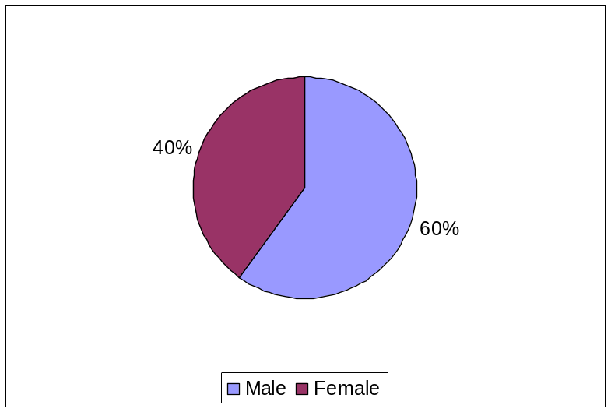

Breakdown by age

As Figure 12 shows, just over half of respondents were aged between 50 and 54 years of age. 37% were between 55 and 59, with only 11% aged over 60. Inevitably, in view of the gender breakdown, men outnumbered women in all age groups but the biggest difference between the proportions of male and female workers was in the 55 to 59 age group, where 63% were male and 37% female. In the youngest age group – 50 to 54 – the proportions were 59% male and 41% female. The smallest gap was between those aged 60 and over, where 55% were male and 45% female.

Figure 12: Age Breakdown of Commission Staff
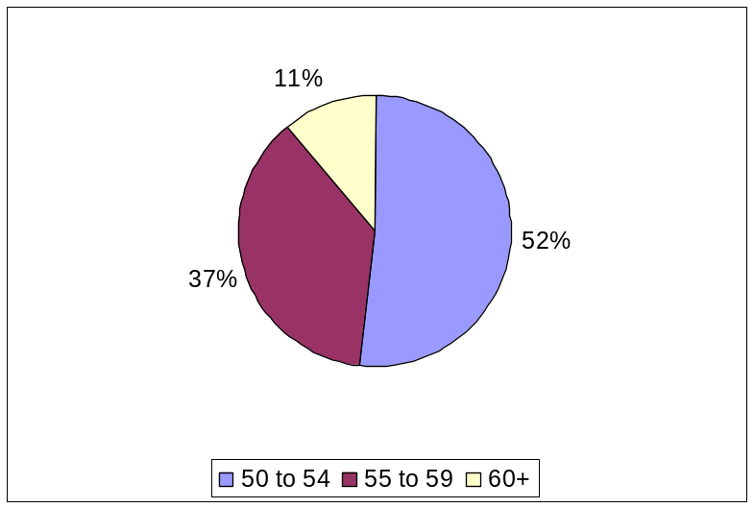

Breakdown by nationality

As Figure 13 shows, the greatest proportions of respondents were from the Older Member States, notably France (15%) Britain (13.5%), Belgium (12%) Ireland (11%) and Holland (10%). As would be expected from the age profile of employees joining from the 12 New Member States, their number was very low (54), which represented 5% of the total.

Figure 13: Commission Staff by Nationality
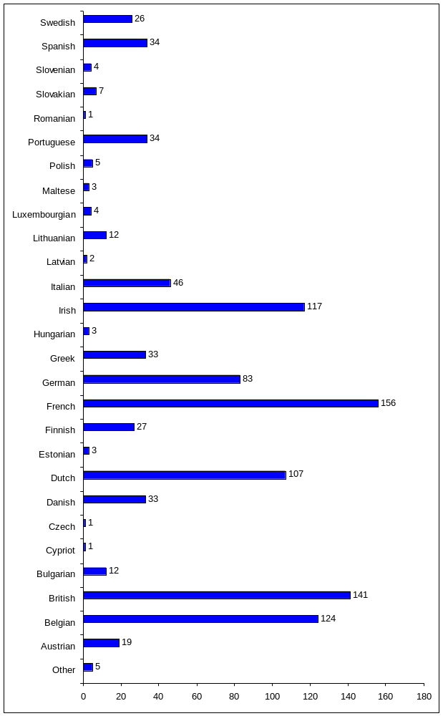

Breakdown by place of assignment

The majority (717) of respondents were located in Brussels (69%), with a further 141 (13.5%) in Luxembourg and 185 (18%) who described their place of assignment as ‘other’ (see Figure 14).

Figure 14: Commission Staff's Place of Assignment
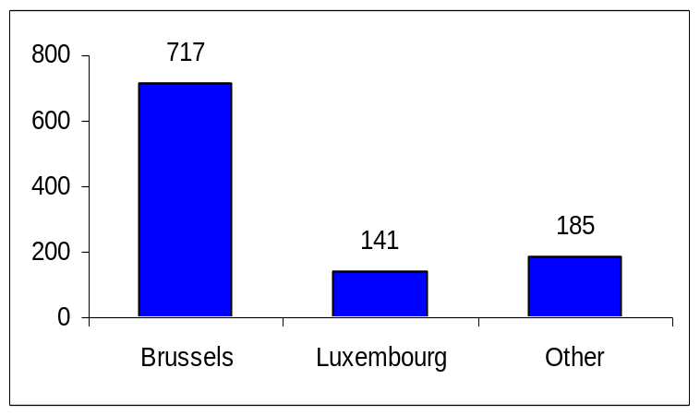

Breakdown by nature of employment

There was a spread among 40 named DGs /services plus 15 departments classified as ‘other’. The greatest number of responses (78) came from DG Translation (7.5% of the total). The Joint Research Centre (77) and DG External Relations (75) each accounted for 7%.

Exploring these by grouped DGs, just under half the responses (49%) came from staff in Policy DGs. Staff working in External Relations accounted for 18%, and those in Internal Services for 17%. General services staff supplied 14% of the responses and the remaining 1.5% were classed as ‘other’.

Of the responding staff, 91.5% were Permanent Officials and 5% were Contract Agents. The remainder were Temporary Agents (2.5%), Local Agents (0.5%) and Auxiliary Agents (0.3%). Three were classified as ‘other’.

In terms of function group, the highest proportion (48%) was in the AD group. AST (ex-B Grade) accounted for 29% of the responses and AST (ex-C and D Grade) 17%. The smallest number (4) came from CA FGIII.

More meaningful analysis of the age groups of staff of various grades is afforded if all CA grades are grouped together, and, similarly, all AST grades. While there is no significant variation between the age composition of the function groups (see Table 10), the age groups of the ASTs most closely mirrored the age groups of the sample as a whole: 52% were aged 50 to 54, 38% were between 55 and 59 and 10% were 60 and over. CA grades had the highest proportions of staff aged over 60 and aged 50 to 54.

Table 10: Function Group (amalgamated) of Respondents by Age
Function group | Aged 50-54 |  | Aged 55-59 |  | Aged 60+ |  | Total
 | No | % | No | % | No | % | No
AD | 250 | 50 | 184 | 37 | 64 | 13 | 498
AST (all grades) | 253 | 52 | 185 | 38 | 47 | 10 | 485
CA (all grades) | 29 | 54 | 16 | 30 | 8 | 15 | 53
Other | 1 | 20 | 4 | 80 | 0 | 0 | 5
Total | 533 | 51 | 389 | 37 | 119 | 11 | 1041

As Table 11 shows, most staff (80%) worked full-time. A further 137 worked full-time with flexi- time (13% of all cases) and 21 did tele-work (2% of all cases). Part-time workers accounted for only 4% of the sample.

Table 11: Working Arrangements of Staff
 | %
Full-time | 79.9
Part-time | 3
Full-time with flexi | 13.1
Part-time with flexi | 1.2
Full-time with tele-work | 2
Part-time with tele-work* | 0.1
Other | 0.8
Base (n) | 1043
* This is not normally allowed within the Commission, although one respondent reported working in this way.

A gender difference was observable in the working arrangements. Full-time work was undertaken by 84% of male staff, with a further 13% working full-time with flexi-time. The same proportion of women worked full-time with flexi-time but a smaller proportion of women (74%) worked full-time without flexi-time. The remaining difference was accounted for by part-time workers: less than 2% of males worked part-time, either with or without flexi-time, while 8% of women did so, 2% of whom were doing flexi-time.

Breakdown by length of service

As Table 12 shows, the majority of staff (60%) had held their present job for five years or less. A further 29% had been in their current post for between 6 and 15 years. The remaining 11% had been in post for 16 years or more, of whom 32 (3%) had had their present job for more than 30 years. The highest proportion of those in post for more than thirty years were the over-60s (6%): this age group also had the lowest proportion (53%) in post for five years or less. In the age group 50 to 54, 63% of respondents had held their present job for five years or less.

Table 12: Length of Time in Current Job
Length of time in post | %
Less than 2 years | 23
2 to 5 years | 37
6 to 10 years | 20
11 to 15 years | 9
16 to 20 years | 3.5
21 to 25 years | 3
26 to 30 years | 2
31 to 35 years | 2
over 35 years | 0.7
Base (n) | 1043

However, in general staff had been working for the Commission for much longer than they had held their present position (see Table 13). Only 8% had been employed for five years or less, while 12% had been employed for more than 30 years. The most common length of time was between 16 and 25 years, which accounted for 41% of all staff responses.

Table 13: Length of Time working for the Commission
 | %
Less than 2 years | 2
2 to 5 years | 6
6 to 10 years | 12
11 to 15 years | 32
16 to 20 years | 20
21 to 25 years | 20.5
26 to 30 years | 15
31 to 35 years | 10
Over 35 years | 3
Base (n) | 1043

skills, coMPETENCES and talents OF OLDER COMMISSION staff

Perceptions of Skills and Competences of Older Commission Staff

A list of 16 skills and competences, derived from the Commission’s own Competency Framework, was included in the surveys for staff, managers and HR managers, from which respondents were asked to identify which they thought were the most important displayed by Commission staff over 50. The results from each data set appear below: staff opinions in Figure 15, managers’ opinions in Figure 16 and HR managers’ opinions in Figure 17.

Figure 15: Employee Opinions of the Top Skills and Competences of Older Commission Staff
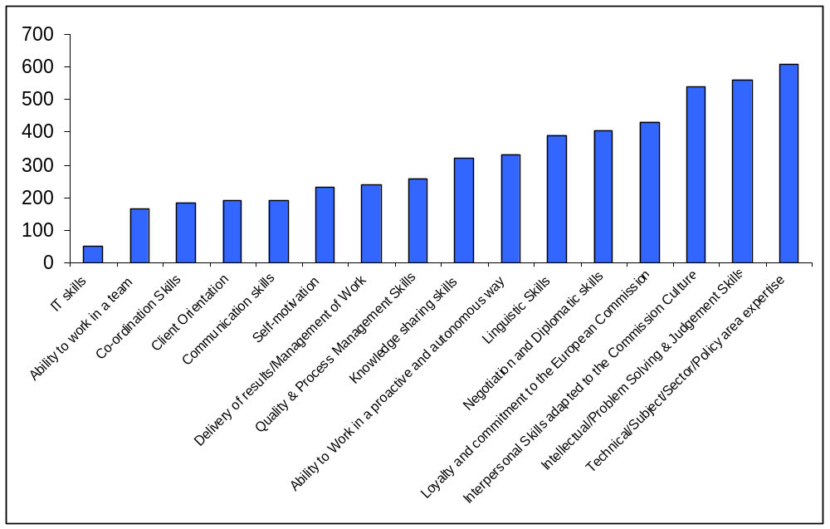

Figure 16: Managers' Opinions of the Top Skills and Competences of Older Commission Staff
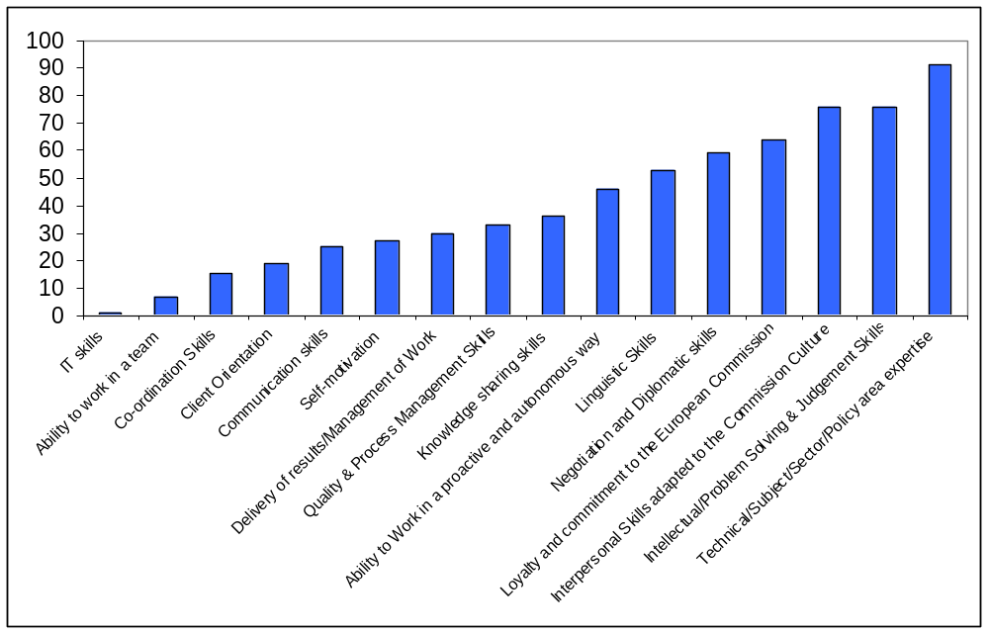

.
Figure 17: HR managers' Perceptions about the Top Skills of Older Commission Staff
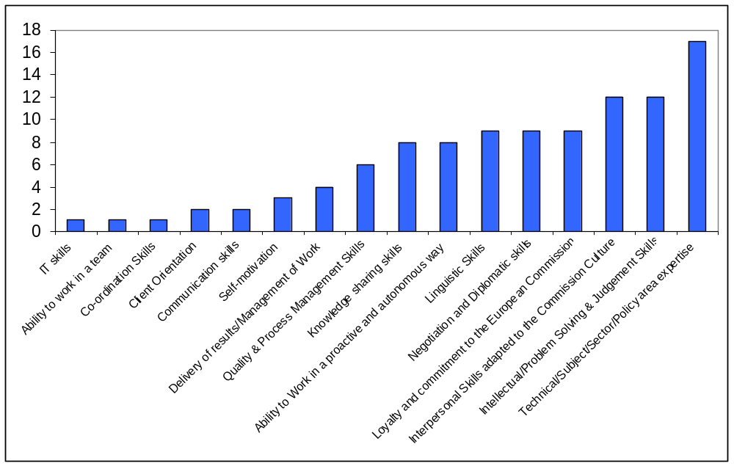

Comparison of views: most important skills and competences
Comparison of the three data sets shows 50+ staff, managers and HR managers have similar, though not completely overlapping, opinions on the main skills of older commission staff. In line with existing theoretical and empirical evidence in other organisations, the quality that staff, managers and HR managers primarily associate with older employees is their in-depth and comprehensive knowledge and expertise in technical, subject, sector and policy areas. This was selected by 65% of managers and 74% of HR managers. Such expertise was also the most widely cited competence that older Commission staff associate with themselves, albeit to a lesser extent than either of the managerial groups. It was selected by 58% of staff many of whom commented in the following way on how they saw this as a valuable attribute.

“20+ years of service inevitably give older people a fund of knowledge and expertise younger colleagues do not yet have.”
(50+ Staff)

“Experience and expertise accumulated over the years provides useful background a well as substantial context against which new events and circumstances can be evaluated.”
(50+ Staff)

“Expertise dans le/s domain/s, initiative, indepéndance,... par rapport aux plus jeunes”
(50+ Staff)

More men (64.5%) than women (49%) considered expertise to be one of the main strengths of staff aged 50 and over.

There was similar agreement about intellectual or problem solving and judgement skills, which were ranked third among all three categories of respondents (51.5% of staff, 54% of managers and 52% of HR managers).

“Older officials have faced already a lot of changes, reforms etc and have got a feeling for solving problems within the Commission and may judge better the relative importance of tasks.”
(50+ staff)

Areas of difference lay in:
- the ability to work in a proactive and autonomous way, which for staff was the second most important, did not feature at all among the main choices of managers or HR managers:
“Better knowledge of the Commission allowing for improved ability to work in a proactive and autonomous way.”
(50+ staff)

- interpersonal skills of staff which are, in view of their length of service in the organisation, adapted to the Commission’s culture ranked more highly among managers (54%) and HR managers (52%) than among staff (41%).

“Compared to younger staff I am more confident, helpful and generous in contacts with other staff. I do not have to prove myself by discrediting others or by bullying them.”
(50+staff)
- Managers were more likely than staff, and much more likely than HR managers, to see older Commission staff’s focus on delivery of results and management of their work as an important competence.

“Expériences acquises et connaissances accumulées permettant une résolution plus rapide des problèmes avec moins de risque d'erreur.”
(50+ staff)
- Both HR managers and managers rated older staff’s increased loyalty and commitment to the European Commission more highly than staff themselves did.
- Negotiation and diplomatic skills featured in the top six choices of managers and HR managers but not of staff. It is, however, worthy of note that considerably more men (37%) than women (21%) saw this as a major strength of this age group.
- Only HR managers included linguistic skills in their main choices.

Comparison of views: least important skills and competences
Significantly, and again in line with both existing literature and our own scoping results, the IT skills of older staff were the least highly rated competence according to all groups of respondents, including staff themselves. Only one manager and 50 staff respondents selected this, rendering it the least frequently chosen option by a considerable margin. ADs in particular saw this as a major area of weakness with only 3% rating it as a top five skill. Stakeholders in the scoping study were of the opinion that staff over 50 learned and adapted to new technology with reluctance and this, in turn, was seen as adversely affecting their chances of mobility within the Commission. However, caution should be exercised in interpreting the staff’s agreement that this was the least important skill that they offered the Commission: it did not necessarily imply that they could not or would not learn new IT skills. Rather, the other options presented to them in this list were those for which years of experience contributed to their expertise but did not require the acquisition of completely new skills. Respondents who added comments to their replies acknowledged that younger staff had greater technical expertise than they did, but argued that older people were willing to learn:

“Les personnes plus âgées veulent apprendre les nouvelles technologies.”

One interview participant pointed out that when he joined the Commission some 25 years ago his first task was data inputting and he had never previously used a computer. He was, nevertheless, now totally competent but he made no claims that this was his main attribute in terms of his skills or competence.

Furthermore, there was a belief among many respondents that the technical wizardry possessed by younger people was not alone sufficient to place them in a superior position to their older colleagues.

“Younger colleagues are clearly better able to cope with the constant technological changes. On the other hand, my experience across a range of activities both at work and outside is clearly broader and deeper than that of younger colleagues.”
(50+ staff)

“Les nouveaux connait beaucoup d'informatique mais non pas ni experience ni connaissance des problémes que affecte notre ‘day life.’"
(50+ staff)

Client orientation of older staff was mentioned by only five managers (5% of the sample). In view of the current focus on good customer service in the Commission, such a finding could be a cause for concern, as could the fact that only 11% of managers associated older staff with team-working skills. Interestingly, among staff respondents, ASTs rated team-working skills more highly than ADs did, with 31% of them choosing this as an option, compared with 18% of ADs. Furthermore, only 14% of managers thought that staff were self-motivated.

Staff’s perceived difference of their skills and competences

A total of 53% of respondents (50+ staff) considered that their own skills and competences were different from those of people in other age groups (see Figure 18).

Figure 18: Perceived Differences in Skills and Competences
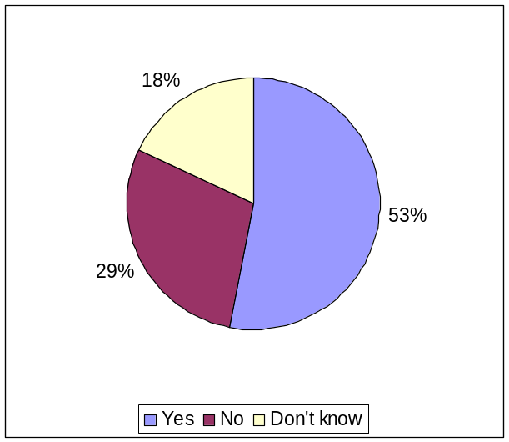
There was little divergence in the responses of men and of women, but there was some variation by age, with perceived differences in skills and competences being likely to increase with the age of the respondent. Thus, 64% of respondents aged 60 and over, as opposed to 57% of those aged 55 to 59 and 49% of those aged 50 to 55 considered that there were differences. There was also a difference according to function group, with 59% of ADs compared with 47% of ASTs considering that their skills and competences were different from those of staff in other age groups. Among DGs, staff in External Relations DGs were more likely than those in other DG groups to think that there was a difference in skills between the generations, with 66% of them stating that they believed this to be the case. In other groups, the proportions were: 53% in Policy DGs; 50% in Internal Services DGs; and 49% in General Services DGS.

In the open-ended responses, where staff were invited to elaborate on the way(s) in which they saw their skills and competences differing from those in other age groups, ‘experience’ was the word most frequently employed. This covered, inter alia, experience of the Commission’s culture in dealing with people, familiarity with situations which had arisen before, and greater awareness of available options – and their consequences – in a given situation, which led to the ability to do their work more efficiently and more effectively.

“Expérience, situations vécues durant l'ancienneté évitent de faire les mêmes erreurs, plus réfléchies, transmission d'un savoir.”
(50+staff)

“Experience is gained with age and may lead to choosing different approaches for solving problems or to resolve issues as compared to younger staff with less experience.”
(50+staff)

“Have accrued more general and job specific knowledge can therefore plan and get results more efficiently as compared to younger staff.”

(50+staff)

“Expériences acquises et connaissances accumulées permettant une résolution plus rapide des problèmes avec moins de risque d'erreur.”

(50+staff)

Coupled with experience was the maturity which older staff could lay claim to:

“Certain qualities improve by age. It is difficult to have the maturity and knowledge gained by experience at a young age.”
(50+staff)

“Plus grande expérience et maturité de jugement qui permet une meilleur coordination et fournie des résultats plus ad hoc.”
(50+staff)

Many respondents pointed out that having worked for the Commission for many years meant that they were the keepers of the organisation’s memory, which was something to be transmitted to new/younger staff.

“Older staff also represent the "memory" of the Unit/DG/Institution/EU.”
(50+staff)

“Expérience et mémoire de la construction européenne, que ne peuvent avoir les générations plus jeunes.”
(50+staff)

“We are the memory of the organization. Our experience and knowledge in depth is of great help to younger colleagues.”
(50+staff)

“La richesse de l'expérience m'amène très souvent à guider les jeunes de 25 à 35 ans dans leur méthodologie et organisation dans le travail d'équipe.”
(50+staff)

“I place memory and knowledge sharing as important skills of older staff. We often know why things are the way they are and the decisions taken that made them so. We can explain to younger staff why X is appropriate in one instance because of something done previously.”
(50+staff)

Talents and Qualities of Commission Staff aged 50+

From a list of seven options, staff, managers and HR managers were asked to select three talents or qualities which they thought that Commission employees over 50 possessed. Figures 19 to 21 show responses from staff, managers and HR managers respectively.

Figure 19: Staff Opinions of the top Talents/Qualities of Older Commission Staff
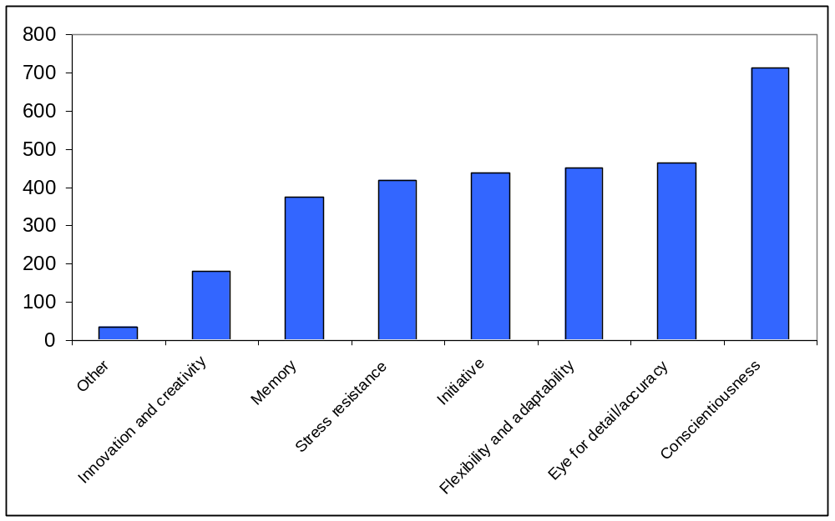

Figure 20: Managers' opinions of the top Talents/Qualities of Older Commission Staff
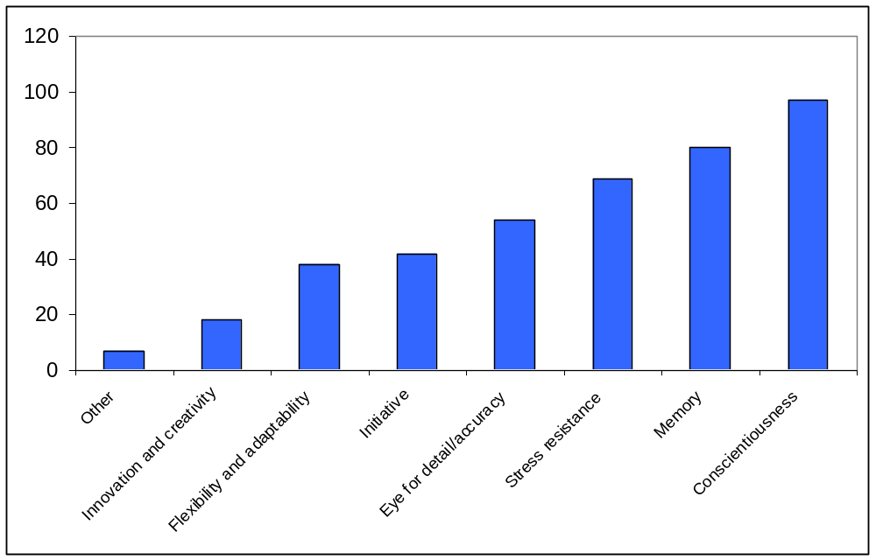

Figure 21: HR managers' opinions of the top Talents/Qualities of Older Commission Staff
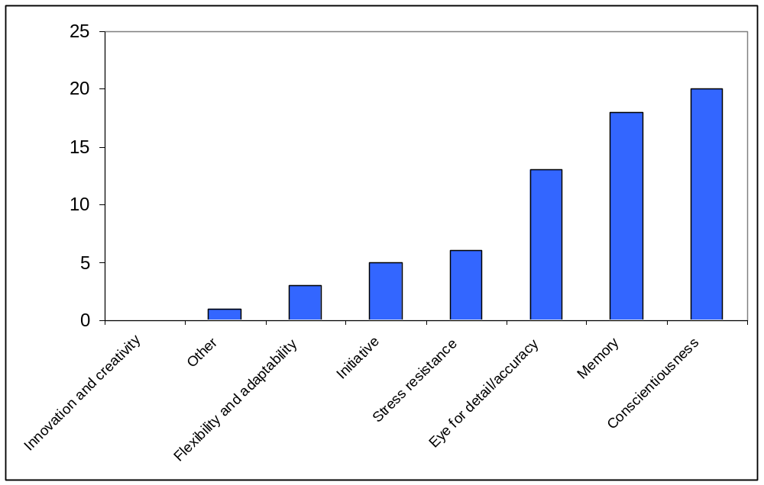

Comparison of views on talents and qualities
There was agreement among all three groups of respondents that conscientiousness was the most important quality that older staff possessed. HR managers were especially likely to rate conscientiousness highly, with 87% opting for it, compared with, 69% of managers and 68.5% of staff. Employees’ own views were that:

“Par rapport aux plus jeunes, la conscience professionnelle est NETTEMENT supérieure.”
(50+staff)

“I think that many younger people (but by no means all!) are less conscientious and less committed to their work.”
(50+staff)

Among staff respondents, conscientiousness was followed by their ability to work accurately and with an eye for detail (44% of responses).

“Compared with younger colleagues, I place greater emphasis on attention to detail.”
(50+staff)

“Les tranches d'âge plus jeunes n'ont plus le souci de la précision et du détail.” (50+staff)

This was appreciated by managers and HR managers, but not to the same extent and appearing in fourth place in their rank order.
According to staff, their flexibility and adaptability (meaning openness towards new demands, new technologies, new ways of working, etc.) was their third most important quality (43% of responses) and initiative was a very close fourth choice (42%).

The picture varies somewhat from the perspective of managers and HR managers. They considered that staff’s memory was the second most important quality they possessed (57% of responses from managers and 78% of responses from HR managers). However, as noted above in respect of how their skills differ from those of younger staff (see section 5.1.3), older staff did consider that they were guardians of the institutional memory, while not attaching as much importance to this as did the other two groups of respondents.

Managers and HR managers both ranked stress resistance third (49% of managers and 56.5% of HR managers) which staff did not rate so highly. This is an interesting difference in perception - older staff did not consider they were especially resistant to stress but managers thought they were – which might lead to staff not being provided with the support from which they might benefit. However, older staff did believe that they handled stress better than their younger colleagues did:

“More competent to manage stress thanks to knowledge and experience.” (50+staff)

“Par rapport aux plus jeunes, aptitude à gérer des situations de stress, acquise avec l'expérience.”
(50+staff)

“To survive this long we have also had to develop our inter-personal skills and stress resistance.”
(50+staff)

Thus, there was general agreement that conscientiousness and an ability to work accurately were valued attributes of older staff. Managers and HR managers valued older staff’s institutional memory and resistance to stress more highly than staff themselves did. Older staff were more inclined to think that their flexibility and initiative were more important than either of these. It might be that working flexibly and showing initiative were not so apparent to managers as they were to staff themselves.

Evolution of Skills and Talents over time

Views of how Skills, Motivation and Performance evolve over time

Older commission staff, managers and HR managers were asked to rate a series of statements about whether they thought the skills, competences, motivation and performance of Commission staff aged between 50 and 65 years deteriorated or improved with age. Their responses are presented respectively in Figure 22, and Figure 24.

Figure 22: Staff's Perceptions about Age-related Evolution of Skills, Motivation & Performance
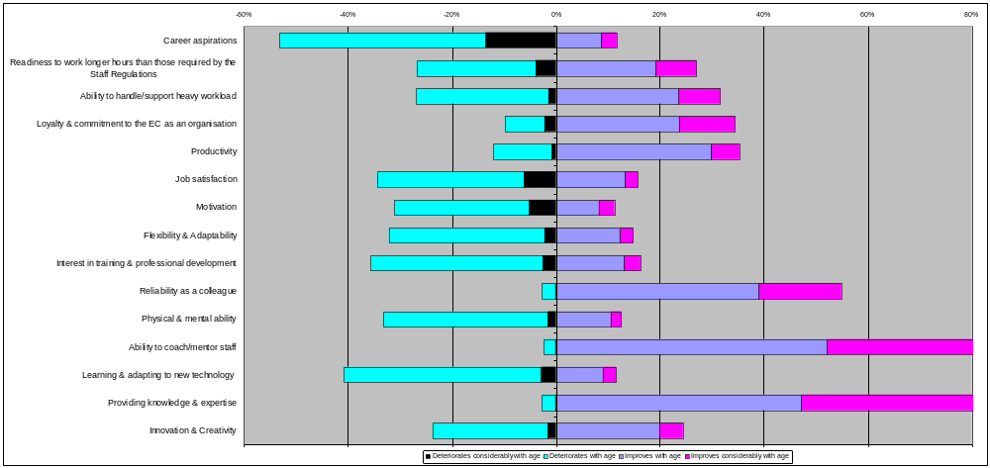

Figure 23: Managers' Perceptions about Age-related Evolution of Skills, Motivation and Performance
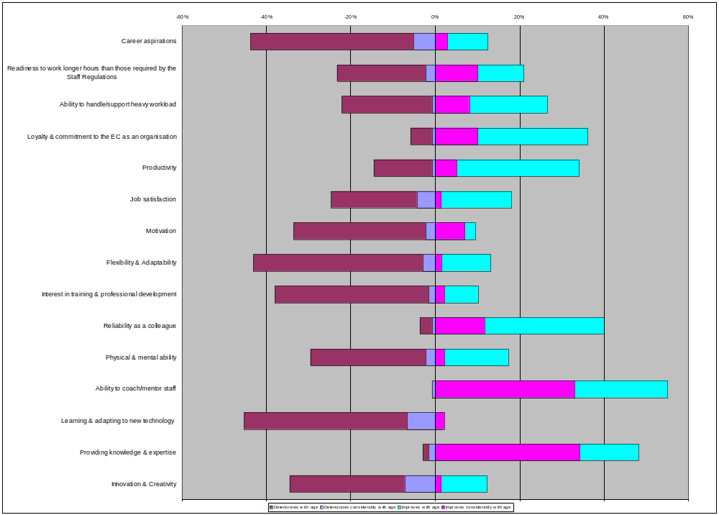
Figure 24: HR managers' Perceptions about Age-related Evolution of Skills, Motivation and Performance

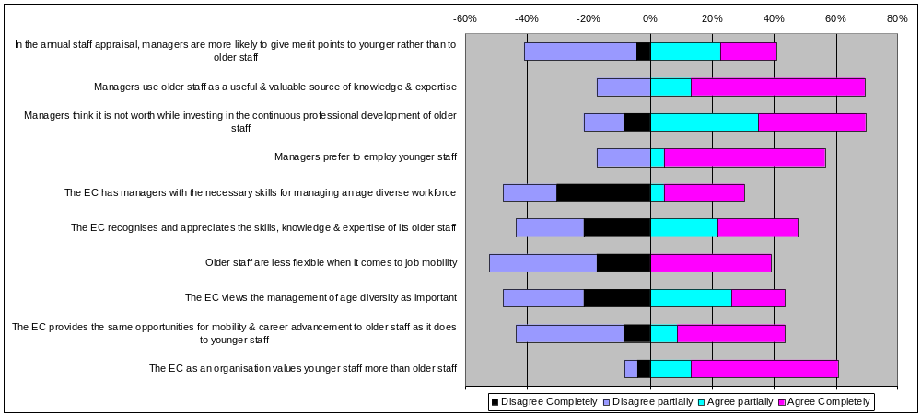

The views of staff

For older staff there were few areas in which there was overwhelming agreement about the evolution of these features. The exceptions were providing knowledge and expertise, ability to coach or mentor, reliability as a colleague, and career aspirations (see Table 14).

Table 14: Perceptions of Change in the Skills, Competences, Motivation and Performance of Commission Staff aged 50+
 | Stays the same | Improves | Deteriorates
According to respondents: | % | % | %
Improves
Providing knowledge and expertise | 10 | 87 | 3
Ability to coach/mentor staff | 13 | 83 | 2
Reliability as a colleague | 40 | 55 | 3
Stays the same/improves
Productivity | 50.5 | 35 | 12
Loyalty and commitment to the Commission as an organisation | 52 | 34 | 10
Ability to handle/support heavy workload | 40 | 32 | 27
Stays the same/deteriorates
Learning and adapting to new technology | 45 | 12 | 41
Physical and mental ability | 50 | 13 | 33
Interest in training and professional development | 46 | 16 | 36
Flexibility & adaptability (openness towards new demands, new ways of working, etc.) | 51 | 15 | 32
Motivation | 54.5 | 11 | 31
Job satisfaction | 45 | 16 | 34
Deteriorates
Career aspirations | 33 | 12 | 53
Improves/deteriorates equally
Innovation and creativity | 48 | 24 | 24
Readiness to work longer hours than required by Staff Regulations | 44 | 27 | 27

Providing knowledge and expertise, the ability to coach/mentor staff and reliability as a colleague were all considered to be most likely to improve, or improve considerably, with age. The proportions answering positively to this question were, respectively 87%, 83%, and 55%.

In terms of productivity, the ability to handle/support a heavy workload and loyalty and commitment to the Commission as an organisation, the majority of respondents thought that there was no change with age, but the larger part of the remainder (about a third of the total) considered that these improved with age. Thus, 32% of respondents thought that the ability to handle or support a heavy workload got better as people got older and 34% thought that loyalty and commitment to the Commission also did so. Productivity was also seen by 35% to be positively affected by age.

Conversely, there were areas where the majority of responses were in the ‘stays the same’ category but, of the remainder, the larger proportion of respondents thought there was deterioration rather than improvement with age. These are listed below, along with the percentages and numbers of those who considered that staff ability stayed the same or declined as they became older. Crucially, among these is job satisfaction, which 45% of staff thought remained the same but 34% thought deteriorated and only 16% thought improved. To a slightly lesser extent, motivation was seen to decrease with age by 31% of staff, while 54.5% thought it stayed the same.

- Learning and adapting to new technology (86%)
- Motivation (86%)
- Flexibility and Adaptability (openness to new demands, new ways of working, etc.) (83%)
- Physical and mental ability (83%)
- Interest in training and professional development (81%)
- Job satisfaction (79%)

The issue of staff over 50 being not as adept as their younger colleagues in learning and adapting to new technology is something of a Leitmotiv among many employees of various ages and grades at the Commission. For respondents providing evidence in the scoping study, this was not infrequently linked to a lack of interest in training generally and less adaptability to new ways of working than younger members of staff. However, many staff over 50 in that sample did not share the view that they were not adaptable and flexible, though it would appear from this sample that a considerable number (328) did think that this ability or inclination declined with age. Nevertheless, such negative perceptions can become a self-fulfilling prophecy and can lead to the lack of motivation which 31% of the staff responding to the online survey considered to be affected by age.

As regards motivation, informants to the scoping exercise, and in particular those aged over 50, felt that perceived or actual age discrimination was instrumental in de-motivating staff and that this was currently heightened by the fact that managerial posts were typically being occupied by younger staff from the New Member States.

The only clear-cut case of perceived decline lay in career aspirations, where 39.5% of respondents thought that these deteriorated and a further 14% thought these deteriorated considerably once staff turned 50. In the scoping exercise, Commission staff over 50 reported feeling that others made (negative) assumptions about their career aspirations, but the evidence here suggests that such assumptions might be influenced by the attitudes of the over-50s themselves. However, there was an interesting variation according to the age group of the respondents. Those aged 55-59 were more likely than those in the younger or older age groups to think that career aspirations deteriorated with age: 57% thought this was the case, as opposed to 51% in the other two groups. Conversely, only 7.5% of the 55-59 year-olds thought that career aspirations improved with age, while 15% of the over 60s and 14% of the 50-54 year-olds thought that they did. This would appear to indicate some element of expectation among those aged between 55 and 59 which is not borne out by the experience of those who have reached 60 years of age.

Finally, there were two areas - innovation and creativity, and readiness to work longer hours than required by the Staff Regulations - where respondents were predominantly of the opinion that nothing changed with age, but the remainder were almost evenly divided as to whether the situation got worse or better. In the case of willingness to work longer hours, this could, in fact, reflect the individual circumstances of staff where, in line with the life-course trajectory, a proportion would have duties caring for elderly or sick relatives which prevented them from being part of the long hours and late working culture of the Commission, whereas others did not. Perhaps surprisingly, this was not a gender-related issue: roughly equal proportions of women and men thought that willingness to worker longer hours did not deteriorate with age, and a slightly greater proportion of women (28%) than men (26%) thought that it improved with age.

The views of managers
Management responses were in line with both the scoping phase findings, the interviews with line managers conducted to date and the prevalent managerial views as presented in both academic and empirical studies. For example, 46% of managers took the view that staff’s flexibility and adaptability deteriorated with age, compared with 11% who thought it improved. Interestingly, over a third of managers (37%) considered that such flexibility and adaptability did not change over time.

Not surprisingly, over half of managers (51%) felt that the ability of staff to learn and adapt to new technologies deteriorates with age, as opposed to only 4% who thought the opposite. That said, 43% thought that such ability stayed the same. Again in line with existing literature and our own scoping findings, we found that almost half of managers (48%) considered that career aspirations deteriorated with age, as opposed to 16% who took the opposite view. A third (33%) of respondents thought that such aspirations stayed the same irrespective of age. As regards interest in training and professional development, almost half of the managers (47%) felt that it stayed the same over time, with a further 12% stating that it improved with age. However, over one third of the sample (39%) thought that such an interest deteriorated with age.

Again in line with the prevalent management view about older workers, 42% of managers believed that innovation and creativity deteriorated with age, as opposed to 14% who took the opposite view. Significantly, quite a high proportion of respondents (41%) felt that innovation and creativity stayed the same over time.

When it came to motivation, job satisfaction and productivity the management survey yielded some very interesting results. With regard to productivity in particular, the Commission managers’ views differed considerably from those of managers elsewhere. Specifically, more than one third (39%) of the sample believed that productivity improved with age, with a further 43% stating that it stayed the same over time. Only 15% of managers felt that productivity decreased over time. Related to the survey findings on productivity are the managers’ views about ability to handle or support a heavy workload and a readiness to work longer hours than those required by the Staff Regulations. In both these areas, managers’ views differed from those found in existing literature as well as from information on management perceptions gleaned by us during scoping. So as far as ability to handle or support a heavy workload was concerned, just over a third of managers (34%) believed that it improved with age, with a further 40% stating that it stayed the same. Just over a fifth of the sample (23%) felt that such ability deteriorated with age.

Similarly, one third of respondents (33%) thought that readiness to work longer hours than those required by the Staff Regulations improved with age, while 38% felt it stayed the same. Again, just over a quarter of the sample (26%) believed that such readiness decreased with age. It is worth noting here that such findings should be seen against managers’ views about how physical and mental ability changes with age. Specifically, about one third of the sample (31%) felt that physical and mental ability deteriorated with age, as opposed to 20% for whom it improved. Even so, 44% of managers saw no change in physical and mental ability over time.

When it came to opinions about motivation, managerial responses were more in line with existing literature, with 37% stating that motivation deteriorated with age (as opposed to 11% who felt it improved). Nonetheless, half of the sample (50%) thought that motivation stayed the same over time. In a similar vein, a large proportion of managers (45.5%) considered that job satisfaction stayed the same over time, with a further 20% stating that it improved. That said, 28% of managers thought that job satisfaction decreased with age.

There are some key skills and qualities of older Commission staff that were considered by the vast majority of managers to improve markedly with age. Again, in line with existing literature and our own scoping findings, older staff’s ability to coach or mentor younger staff was cited by 88% of managers as improving with age, as opposed to 1.5% stating that it deteriorated, and 9% thinking that it stayed the same. An almost equally high proportion of managers (84%) believed that ability to provide knowledge and expertise improved with age, with a further 11.5% stating that it stayed the same and only 3% thinking that it got worse over time. Also in line with existing literature and our scoping findings, more than half of managers (53%) thought that reliability as a colleague increased with age, with a further 40% stating that it stayed the same over time. Only 5% of managers considered that reliability decreased with age. Finally, managers were almost evenly split as to whether loyalty and commitment to the Commission as an organisation improved with age (48%), or stayed the same (44%). Only 7% of managers thought that such loyalty was adversely affected by age.

The views of HR managers

Just under half of HR managers (48%) considered that that innovation and creativity deteriorated with age, as opposed to 9% thinking the reverse, and 33% thinking that they did not change at all over time. Just over half (52%) thought that flexibility and adaptability deteriorated over time, as opposed to 9% who thought that they improved. Just under one third (30%) thought that these qualities stayed the same over time. In line with our scoping findings and with both management and staff survey feedback, the area which HR managers thought most strongly deteriorated with age was that of learning and adapting to new technologies. Specifically, 59% of HR managers considered that this ability deteriorated with age, as opposed to only 4% who thought it improved and just under a third (32%) who thought that it stayed the same.

When it came to training, just over one third (35%) of HR managers also believed that interest in further professional development deteriorated with age, compared with only 4% who took the opposite view. Even so, over half (52%) of HR managers were of the opinion that interest in further training stayed the same over time. Interestingly, in view of their role, just over one third (35%) of HR managers thought that career aspirations deteriorated with age, with a further 39% thinking that they stayed the same and 17% that they improved over time. Asked about the ability to handle or support heavy workloads, just under one third (30%) of HR managers considered that this got worse with age, compared with 13% who were of the opinion that it improved. Nevertheless, over half (52%) of HR managers felt that such ability stayed the same over time. Linked to this was readiness to work longer hours than those required by the Staff Regulations, where again just under one third (30%) of HR managers considered that it got worse with age, as opposed to 22% thinking it improved and 39% thinking it stayed the same. It is worth pointing out that such responses cannot necessarily be linked to a view that physical and mental ability deteriorated over time: only just over a quarter (26%) of HR managers thought that such abilities deteriorated over time as opposed to over half (56.5%) who considered that they stayed the same and a further 13% who considered that they improved with age.

Crucially, when it came to productivity, just under two thirds (65%) of HR managers felt that this stayed the same over time, with a further 17% stating that it improved with age. Only 13% of HR managers thought that productivity decreased with age. There were more mixed responses as regards motivation and job satisfaction. Although just over half (52%) of HR managers were of the opinion that motivation stayed the same, a quite high proportion (43.5%) thought it deteriorated over time and none believed that it improved with age. Such a finding may be construed as reflecting the rather variable knowledge among HR managers of the way job-related motivation changes over time. Similarly, over half (52%) of HR managers thought that job satisfaction got worse with age, with the remaining 43.5% considering that it stayed the same.

On the other hand, there are some skills and qualities which HR managers (in line with management and staff) consistently thought improved with age. Top among these is ability to coach and mentor staff, which for the vast majority (87%) of HR managers improved with age, with a further 9% stating that it stayed the same. An almost equally high proportion (83%) of HR managers thought that ability to provide knowledge and expertise improved with age, again with a further 9% thinking that it stayed the same and only 4% stating that it got worse. In a similar vein, over half (55%) of HR managers considered that reliability as a colleague improved with age, with a further 36% thinking that it stayed the same. Finally, over half (59%) of HR managers thought that loyalty and commitment to the Commission as an organisation stayed the same, with a further 27% feeling that such loyalty improved and only 4.5% thinking that it got worse with age.

Comparison of perceptions about the evolution of skills and talents

In summary, all three groups of respondents were largely – with three exceptions – in agreement about the areas where the increased age of staff brought about improvement and those where it signalled deterioration. In many cases, what was interesting was the degree of difference, i.e., the variation in percentages of respondents who agreed with a statement.

We look first, however, at the three anomalies – ability to handle or support a heavy workload, innovation and creativity, and readiness to work longer hours. As regards ability to handle or support a heavy workload, both staff and managers considered that there was slightly more improvement than deterioration with age. HR managers, on the other hand, were likely to see considerably more deterioration than improvement as staff got older. In fact the difference in opinion between staff and HR managers especially is considerable: 32% of staff thinking that this improved against only 15% of HR. It might well be the case here that HR managers, not being in day-to-day contact with staff and managers, were not aware of the extent to which older staff coped with heavy workloads. In the other two cases it was staff who were out of line with the two other groups. The majority of staff respondents thought that innovation and creativity stayed the same, with the remainder equally divided in opinion as to whether these got worse or better with age. Similarly, the proportions thinking that readiness to work longer hours declined or improved with age were identical. Both managers and HR managers, however, were much more inclined to think that both of these did deteriorate with age, and this was especially so in the case of HR managers. There is, therefore, a discrepancy between how older staff see themselves and how they are seen, particularly by HR, with the former seeing themselves as more innovative, creative, able to handle a heavy workload and willing to work long hours irrespective of their age than HR managers saw them.

All three respondent groups were in agreement that the main areas where staff showed improvement with age were providing knowledge and expertise, ability to coach and mentor staff and reliability as a colleague. However, in all these areas, a far smaller proportion of managers than of staff and HR managers thought this was the case. In a further two areas – productivity, and loyalty and commitment – there was agreement that staff got better as they got older, but this was not to the same extent as in the three areas above. Also, in these two cases the percentage of responses of staff and management were quite close to each other, with those of HR managers being much lower.

In all the remaining areas, staff, managers and HR managers were all more likely to identify deterioration rather than improvement among staff who were over 50. Among staff respondents, the largest proportions agreeing that there was deterioration were in respect of career aspirations, whereas for managers and HR managers it was learning and adapting to new technology (the second highest among staff). HR managers also had a greater proportion of respondents identifying job satisfaction and flexibility and adaptability as getting worse with age than did staff or managers.

In summary, with the exception of providing knowledge and expertise, ability to coach and mentor staff and reliability as a colleague, HR managers were much more likely than staff or managers to see age negatively affecting staff capability and attributes. This might be because HR managers were more likely to be made aware when things were going wrong, rather than when they were going smoothly, and in consequence a more negative than positive overall assessment might prevail. This is possibly an issue for further exploration as the available data, along with the relatively small sample of HR managers, precludes any firm conclusions being drawn.

satisfaction OF OLDER COMMISSION STAFF

Job Satisfaction among Staff aged 50+

The results of the Commission’s 2006 Staff Opinion Survey suggested that the European Commission was seen by the large majority of its staff as being a good workplace in the sense of providing them with high job satisfaction and positive interpersonal relationships. More than 70% of the respondents showed a high level of satisfaction with their job, its content or the job related tasks and the level of job responsibilities in general.

Staff respondents to our survey were asked to select the five options from a list of 15 which they thought to be most important in determining their own level of job satisfaction (see Figure 25).

Figure 25: Older Commission Staff's Motivation Factors
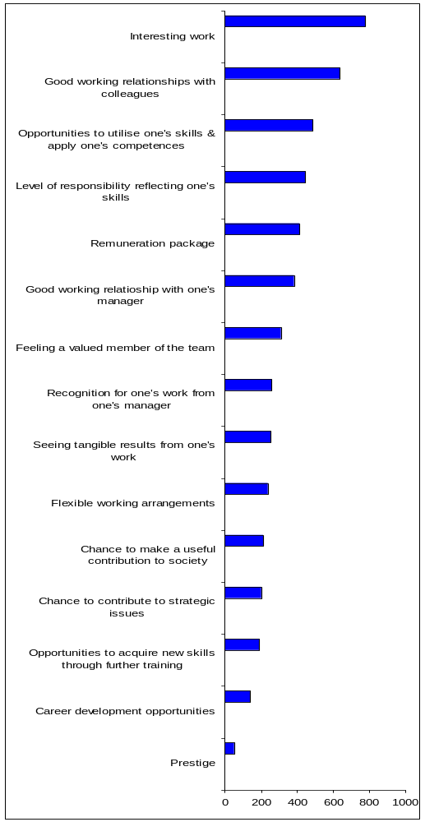

For staff, work that is interesting was by far the most important factor, and this tallies with the findings from the Staff Opinion Survey referred to above, where strong evidence emerged that the core motivator for working for the Commission was interesting, challenging job content. The data showed that this was the case for the large majority of Commission staff. Even among those who were dissatisfied with the relation between their work performance and career development, 66% were still satisfied with their job content and tasks in general. Nevertheless, a conclusion drawn from that study was that that staff motivation and satisfaction at work could be further improved by, inter alia, a positive change in level of staff responsibility in their jobs, better opportunities for using their knowledge and skills, and increased informal acknowledgement of their work.

For respondents to our survey, interesting work was certainly considerably more important than their next choice - having the opportunity to utilise skills and competences – although the absence of this has earlier been noted as source of dissatisfaction for many. Good working relationships with colleagues were also significant for job satisfaction.

Least important to older staff were prestige, career development opportunities and opportunities for the acquisition of new skills through training.

Variation by function group and gender

Exploring the factors contributing to job satisfaction by function group, we see that flexible work patterns are more important to ASTs’ job satisfaction than to that of ADs: 27% of the former, as opposed to 17% of the latter rated flexi-working as an important factor:
Similarly, they counted further training as more important than ADs did (22% as opposed to 17%), as well as feeling a valued member of the team (36% compared with 22%).
Having the opportunity to contribute to strategic issues was more important to ADs’ job satisfaction than that of ASTs (25% compared with 14.5%), as was having the chance to make a useful contribution to society (27% compared with14%).

Men were more likely than women to identify the remuneration package as important to job satisfaction. Overall, the proportion of staff thinking this was important was 39.5% but this hid a gender difference of 45% of men and 31% of women. Similarly, having a chance to contribute to strategic issues affected men’s job satisfaction more than women’s: the difference was between 24% of men and 15% of women. On the other hand, women looked to the acquisition of new skills as an element of job satisfaction more than men: the proportions selecting this were respectively 23% and 15%. Women also considered that flexible working was a more significant contributory factor: 29% of women as opposed to 19% of men opted for this.

HR Managers’ views of staff job satisfaction

HR managers were also asked their views of the main job satisfaction factors for older Commission staff. As 6 shows, the top five factors that in their view contribute to their job satisfaction were: (i) the need to be provided with interesting work (selected by 65% of HR managers); (ii) the need to be given a level of responsibility that would reflect their skills and expertise (selected by 61% of HR managers); (iii) the need for recognition for one's work from one's manager (mentioned by 52% of HR managers); (iv) opportunities to utilise one's skills and apply one's competences (chosen by 43.5% of HR managers); and (v) feeling a valued member of the team (also selected by 43.5% of HR managers).

All of these were in the top half of the staff’s own priorities. However, the choice of interesting work (1st) was the only one which coincided in rank with staff’s own view of what contributed to their job satisfaction. Staff also had opportunity to utlilise skills and apply competences and level of responsibility reflecting skills in their top 5 but these were respectively third and fourth.

HR managers saw as least important the opportunity to acquire new skills through training, the chance to make a useful contribution to society, and seeing tangible results from one’s work. All of these were in the bottom half of staff’s selection, but only the first one – acquisition of new skills – was in their bottom three.

Figure 26 provides the whole range of job satisfaction factors in order of preference by the HR managers.

Figure 26: HR Managers' Views of Older Staff's Job Satisfaction Factors
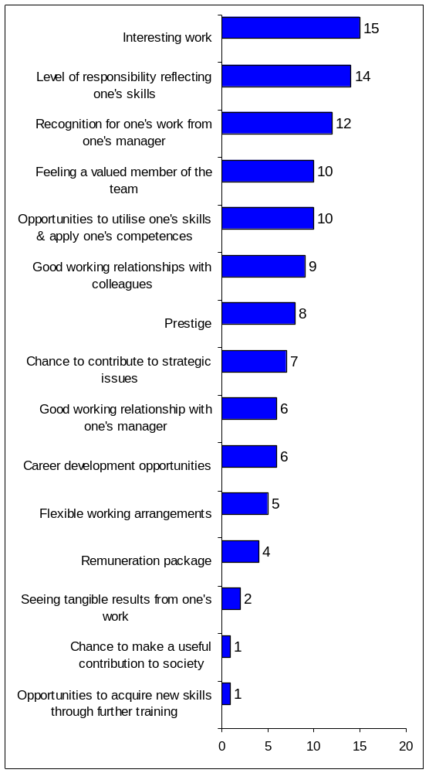

Commitment of Older Commission Staff

Current commitment
The vast majority of staff respondents (81% - n818) claimed to feel involved in and /or committed to their current job, with nearly half of them (403) stating that they felt very involved/committed. Only 63 respondents described themselves as feeling alienated and a further 22 as very alienated (9% in total). Please see Figure 27 below.

Figure 27: Older Commission Staff's Personal Involvement
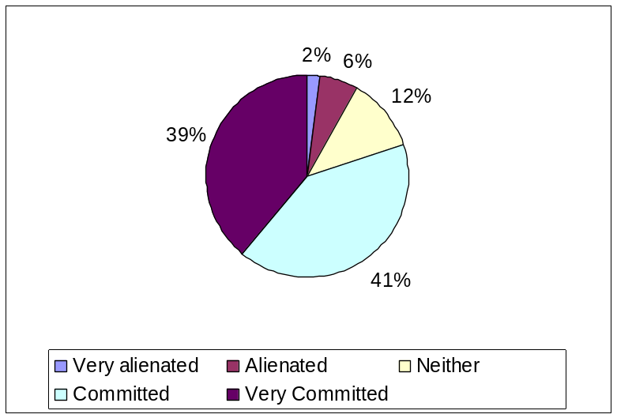

Examining this by grouped DG, we see that General Services DGs had the largest percentage of respondents (84.5%) stating that they felt committed or very committed and Internal Services DGs the lowest (78%). Policy DGs had the highest proportion (10%) stating that they felt alienated or very alienated and General Services DGs the lowest (5%).

Changes in commitment

For 639 respondents (63%), their level of commitment had not changed since earlier in their career (see Figure 28). Almost the same proportion of men (60.9%) and women (61.8%) felt the same commitment as earlier in career despite differences in perceptions of age discrimination, although a slightly higher proportion of men (31%) than women (28%) thought it had changed. A slightly higher proportion (65%) of AST staff reported the same level of commitment, compared to 61.2% of AD staff.

Figure 28: Older Staff Commitment the same as earlier in career
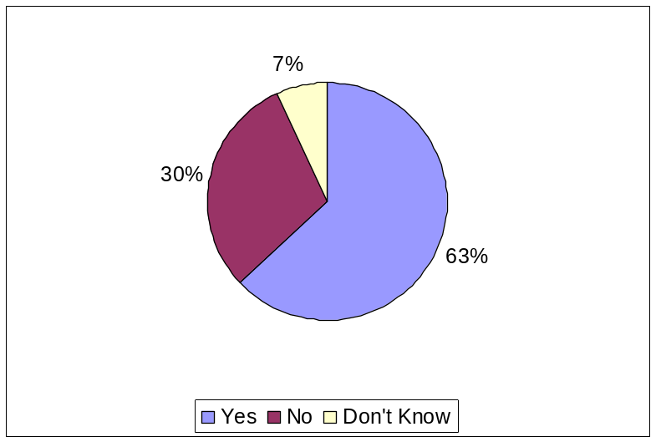

Of those whose level of commitment had changed, a small number (41) felt that it had improved, with the highest proportion being in General Services. The reasons for this positive change were mainly because they felt that the work they were given matched their experience and skills and that their contribution was appreciated and valued by their manager.

Of the remainder experiencing some change, 285 considered themselves less committed than in the past. Among these were 87% of men and 78% of women. Looking at the DGs of those feeling less committed, we see that the proportions were highest among those employed in Internal Services DGs (89%) and Policy DGs (85.5%). As noted above, staff in these two DG groups did not feel as committed or involved as staff in the other grouped DGs.

Reasons for change in level of commitment

Among all staff who felt less committed than previously, the main reasons are set out below in Figure 29.

Figure 29: Reasons for Staff feeling less committed
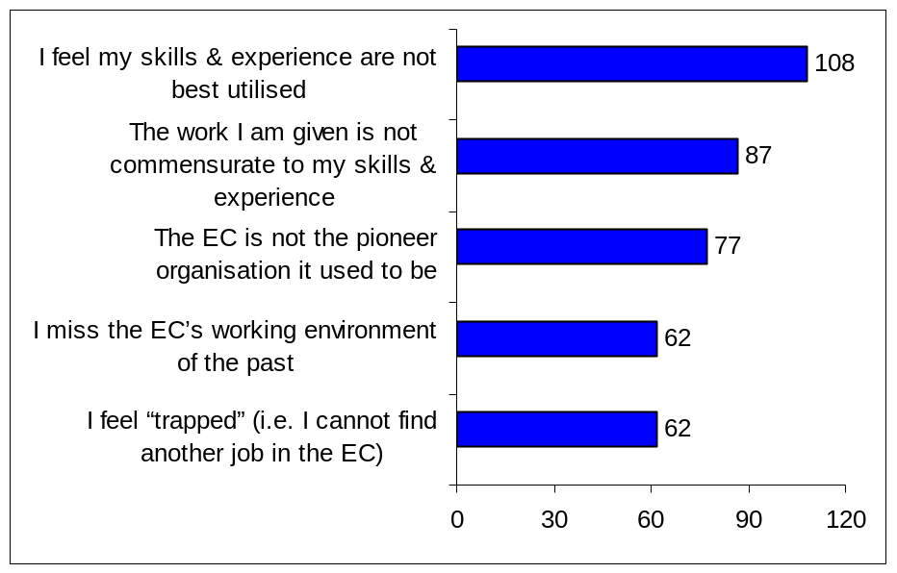

These fell into two categories The first category related to current employment: these respondents (predominantly at AD and AST grade) considered that their skills and experience were not being best utilised (43%), that they did not feel a valued member of the organisation (22%) but they were unable to find another job in the Commission (25%). For a further 20% of respondents, knowing that it was very unlikely that they would now become a manager led to their feeling less committed: three-quarters of these people were at AD grade. The second category was structural: they believed that the Commission itself had changed, being no longer the pioneer organisation it used to be (30.5%), and respondents missed the previous working environment (25%). Staff at AST grade were most likely to select these structural reasons as a cause of their diminished level of commitment.

The report of the scoping study commented on the view of some long-serving staff that the respect they had willingly shown for the founding fathers of the Commission had been replaced by the pragmatic need to accept orders from young people whom they did not hold in such high esteem. However, the issue related more to the way in which the Commission itself is changing, as highlighted in the Staff Opinion Survey, where one respondent remarked that

“The Commission won’t occupy the key place it did in its early years, when people worked for the organisation ‘to build Europe’. People will now have to change their sights as to what the Commission can achieve.”
(Staff Opinion Survey, 2006: 51).

A number of informants to our scoping study stressed the importance of the Commission as a political instrument. Specifically, they pointed out that the Commission is at the disposal of political appointments, and that this tends to dictate the way staff are seen. Senior management, who are most involved with politicians, will be, it was argued, most at the mercy of changing dynamics dictated by public opinion in the various member states.

“There is a widespread feeling that Member States value the EC officials less and less. The media is also increasingly hostile. There is a rise in legal cases, where the EC officials’ views are being challenged by the Member States.”
(AST Focus Group, ReLOP)

Those close to the politicians (i.e. senior managers) are also likely to be driven by short-term pragmatic issues rather than longer-term issues such as nurturing the capability and motivation of the Commission workforce, which may be seen as expendable. This acts against the interests of staff aged 50+.

“The political nature of the Commission, where things depend on the Commissioner pleasing the citizen, suits young people who believe the new measures will effect dramatic change because they have no comparators. Things get very polarised in the Commission, which excites young people who are pleased to see new things. The older people will have experience of several different regimes.”
(ReLOP 50+)

Motivating factors

The Commission’s 2006 Staff Opinion Survey compared the statements on a set of eight core motivators provided by staff employed before May 2004 with those from staff employed after this date and found no significant difference in the opinions of the two groups. Notwithstanding this finding, responses to the open questions suggested that there was some discrepancy in views between the two groups.

In our online survey, respondents did not generally see the Commission’s overall attitude and approach to older staff in a positive light. Figure 31 shows their responses to a set of statements exploring their perceptions of how older staff are seen in the Commission. Half the respondents considered that opportunities for mobility and career advancement were not provided to older staff in the same way as they were to younger staff, and nearly as many (48%) believed that younger staff were valued more highly by the organisation. Of these, more staff (51%) working in Policy DGs thought that the Commission valued younger staff more than older employees, followed by 46% in General Services DGs, 45.5% in External Services DGs, and 42% in Internal Services DGs.

Nearly half of the older staff respondents (48%) also thought that the Commission failed to recognise or appreciate the skills, knowledge and expertise of older Commission staff. Only 40% of staff responding (n407) considered that the Commission viewed the management of age diversity as important, with just 19% agreeing strongly that they did so. Among these, AD staff (50%) were much less likely to believe that age diversity is important to the Commission than AST staff (30%).

There was a belief, according to more than half of respondents (52%) that the Commission lacked managers with the necessary skills for managing an age-diverse workforce. This reflects observations described in the earlier scoping study that many managers – and especially middle managers and/or those who were younger – did not possess the necessary skills or experience to deal with staff in the older age groups.

As many as 61% of respondents thought that the managers (Heads of Unit, Directors, etc.) preferred to employ younger staff, with 38% considering that managers thought investment in the continuous professional development of older staff was not worthwhile. The value to managers of older staff was seen as being a useful and valuable source of knowledge and expertise, with half of respondents agreeing partially or completely that this was how staff aged 50+ were used by managers.
Figure 30: Staff's Perceptions on how the Commission views Older Staff 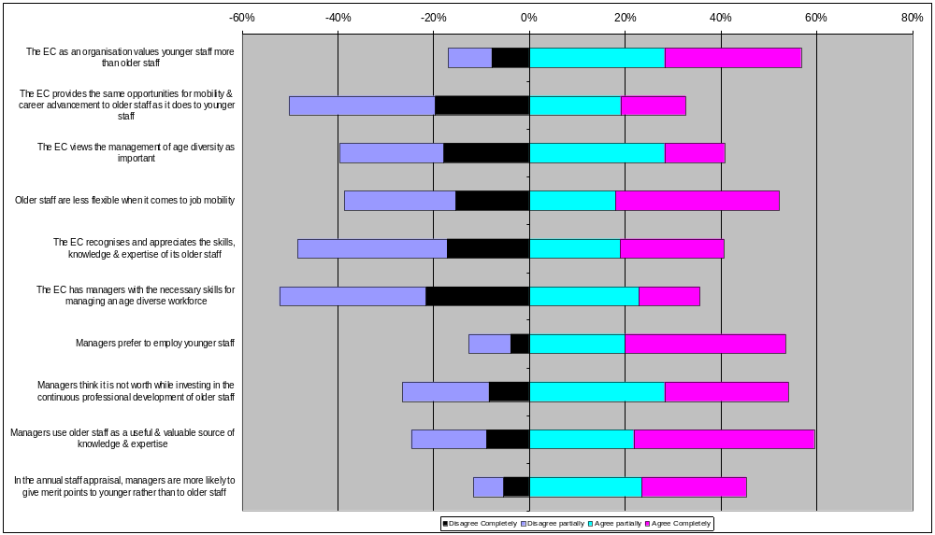

Utilisation of Skills
When asked to rate how they felt about the way their own knowledge, skills and competences were being used in their current job within the Commission, 43% of staff (n 456) considered that their knowledge and skills were being used well (28%) or very well (15%). A further 27% (n264) felt that their knowledge and skills were being sufficiently well used. However, this did mean that 295 respondents (27%) considered that they were being used either poorly (19%) or very poorly (8%) (see Figure 31).

Figure 31: Older Commission Staff’s Perceived Use of their Knowledge and Skills

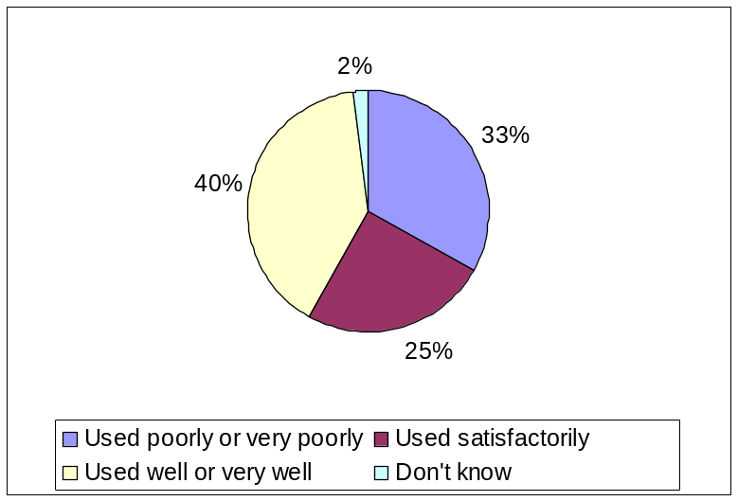

Men were slightly more likely than women to feel that their knowledge, skills and competency were not being well used: 30% of men and 25.5% of women thought that this was the case. Additionally, dissatisfaction with how these attributes were used appeared to increase with age. While there was very little difference among the age groups as to the former response (used poorly), respondents aged 60 and over were more inclined than those in the other two age groups to reply that their knowledge and skills were used very poorly: 12% of them replied to this effect, compared with 8% of those aged between 50 and 59. They were also less likely than their (slightly) younger colleagues to consider that their knowledge and skills were sufficiently well used, and slightly more likely to think that they were being used well (though not very well). The group apparently most satisfied with the use being made of their knowledge and skills was the 55 to 59 year-olds, though the difference between them and the other groups was marginal – 17%, as opposed to 16% of 50 to 54 year-olds and 15% of the over 60s. It would appear, therefore, that the main issue lay with the perception of some individuals in the oldest group that their knowledge and skills were not being put to good use.

Respondents working at AD grade were more likely than those at AST grade to feel dissatisfaction with the way in which their skills were being used. Of the ADs in the sample, 21% thought that their knowledge and skills were used poorly and 9% thought they were used very poorly. Among all AST grades, 19% thought these attributes were used poorly and 8% thought they were used very poorly (total 27 %). Conversely, 46% of the AST grade staff thought their knowledge and skills were used well or very well, as opposed to 43.5% of the AD grade staff.

In terms of the (grouped) DGs of respondents, Internal Services DGs had the highest proportion (54%) of staff thinking that their knowledge and skills were well used and External Relations DGs had the lowest (37%). External Relations DGs (33%), closely followed by Policy DGs (32%), had the largest proportion of staff feeling their skills were used poorly (21% and 23% respectively) or very poorly (12% and 9% respectively).

Structural issues and their effect on motivation
Paradoxically the very good terms and conditions offered by the Commission can also be a structural barrier to staff motivation. In general, judging from the documentary review, the job tenure regime and the very low staff turnover rates, staff tend to stay with the Commission even when they are de-motivated because the whole package of terms and conditions remains very good.

The Commission policy of offering ‘Jobs for Life’ inevitably tends to create bottlenecks for promotion within the pyramidal structure of the Commission. This is understood and accepted so long as promotion is seen to be fair and transparent. This is not always the case according to the informants in our scoping study or to the documentary review, in particular the Progress Report on Mobility. An associated problem is that expatriate staff who have relocated to Brussels for a long career might feel cut off from job and promotion prospects in their country of origin. Where such staff have brought up families in Brussels, they might feel trapped in their jobs at the Commission, with limited alternatives. However, in current society a job for life is a comparative rarity and as such can constitute “a golden cage”, especially for those whose home economies are relatively difficult.

Given the attractiveness of a job for life and relatively high salaries, the Commission is able to demand ever-higher qualifications from its staff (elite qualifications). This creates difficulties for older staff, especially those perceived to be inflexible or those facing the “barrière de diplôme”. On the other hand, this also creates difficulties among other, younger staff groups. This was of particular concern in the AST focus group of our scoping study. The Commission’s almost ‘caste’ system in differentiating AD and AST streams was seen as over-rigid by many in this group.

“… people overqualified for secretarial posts can apply and take the competition. If these people are then recruited to do jobs not commensurate to their skills and qualifications, they very quickly become frustrated and disillusioned and my office is inundated with such people. I have come across people with PhDs who have passed competitions for secretaries and of course they are not happy doing such work when they are in. Still they have to stay in the post for at least two years before moving… The same problem applies for category D staff. The EC has taken on over-qualified staff for quite mundane tasks.”
(SCOP)

The current situation was contrasted with the past when those with university degrees were prohibited from taking the AST stream.

well-being at work

Many of the measures in the Commission’s new policy on well-being at work, adopted in 2006, were a direct effort to meet staff's needs and wishes, with an emphasis being put on issues such as health, family matters, and work-life balance (including the possibility of flexitime and teleworking).

Figure 323 sets out the responses of older staff to our online survey on the contribution made by the Commission to staff well-being.

In considering whether the Commission promoted a healthy working environment, the majority of respondents (41%) thought that it did not. However, as many as 364 (37%) thought the opposite, with the remainder stating that they did not know (19%), or not responding at all (4%).

One reason for this might be that staff were inclined to think that their managers did not encourage and support staff sufficiently to achieve a reasonable balance between professional life and private life. While 31% thought that managers did encourage them in this direction, 41% thought they did not, and a slightly higher proportion of men (42%) than women (39.5%) thought this was the case. Among DGs, the work/life balance was least satisfactory for those in External Relations DGs where just over half (51%) of respondents thought that managers did not support them in this. The proportions of respondents in other DGs who thought the same were: Policy – 42%; Internal Services – 36%; and General Services – 31%. Other evidence from this survey points to greater levels of commitment and job satisfaction among employees in General Services.

Working arrangements

Two-thirds of staff thought that the Commission provided sufficient possibilities for flexi-time working: more women (23%) than men (19.5%) thought that it did not. A much smaller proportion (43%), thought that the Commission provided sufficient possibilities for part-time working, but 19% had no opinion on this and a further 15% did not give an answer. However, women appeared to feel more strongly than men about the fact that opportunities to work part-time were limited: 28% of women compared with 20% of men did not think there were sufficient possibilities to work part-time.

There was a connection between the work-life balance and the ability to do part-time or flexi-time work. Of the 424 respondents who felt that they were not helped to achieve a reasonable balance between professional life and private life, 38% also thought that staff did not have sufficient possibilities to work flexi-time and 36% thought that there were insufficient possibilities to work part-time.

Retirement

Forty-five percent (45%) of the responding staff agreed that the Commission provided guidance to workers nearing retirement to prepare them before they left the organisation. However, again a reasonably high proportion (22%) did not give a reply and a further 21% neither agreed nor disagreed. This was, perhaps, because they had as yet no reason to be aware of the issue: staff in the lowest age group (50 to 54) had the highest proportion responding that they did not know or had no firm opinion one way or the other. They accounted for 49% of the responses as opposed to 27% in the 60+ age group. Respondents in the most senior age group were the ones most likely to agree, partially or completely, that the Commission did provide guidance to workers nearing retirement from the organisation (52% compared with 44% in the other two age groups).

Medical services

The availability and use of medical services can have a bearing on the well-being of staff at work, as well as on the extent to which they believe the employer is concerned about their well-being. The 2006 Staff Opinion Survey suggested improvements to the Commission’s social and medical policy. However, most of our survey respondents had a good opinion of the Commission’s medical services and of the information about them.

- 55% agreed that the Commission's medical service provided good annual health check-ups for staff
- 47% agreed that the Commission's medical service could be consulted by staff needing information on personal health issues related to work
- 36% agreed that the Commission's medical service provided useful information and references on the "Personnel and Administration" pages on the Intranet.

Many respondents seemingly could not pass an opinion on the availability of social workers and psychological assistance for staff facing difficulties at work: 29% did not respond to the question and 28% neither agreed nor disagreed. However, 28% did agree that such assistance was on hand for those who needed it.

Focusing the Commission's medical service’s activities and investment on older Commission staff was considered to be a positive idea by 33% of respondents, although the proportion who were ambivalent about this was higher at 35.5%.

Figure 32: Staff's Perceptions about Well-being at Work in the Commission
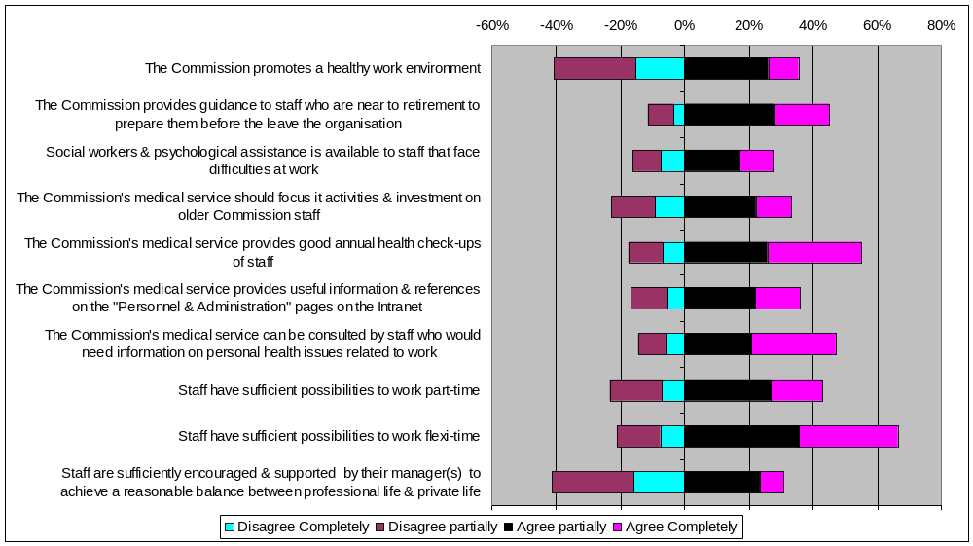

MOBILITY, PROFESSIONAL AND cAREER DEVELOPMENT OF OLDER COMMISSION STAFF

Professional and Career Development of Older Commission Staff

Survey Response: Career Development
Responses to the Commission’s Comparative Study on the Career Development of Male and Female AD Officials show some interesting opinions about various aspects of the career policy. On the whole, there was considerably more dissatisfaction than satisfaction from both men and women, as can be seen from the figure below. The only area where this was not the case was management training courses, which most respondents considered to be good, and a small proportion of men thought were very good. The career policy in general was not held in high regard by either men or women, though a slightly higher proportion of men than of women thought it was good. Similarly, recognition and emotional reward were mainly seen as poor or very poor, especially by women. A very small proportion of women considered the opportunities for mentoring or coaching to be very good, but the majority of them, and the majority of men, found them poor or very poor.

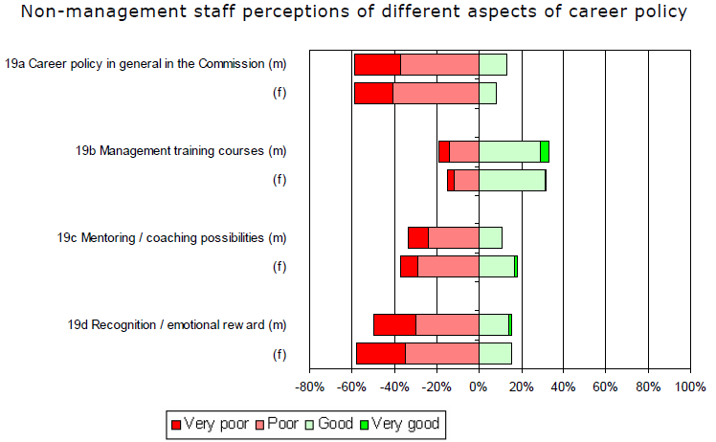

(Source: Comparative Study on the Career Development of Male and Female AD Officials Final report, p45)

Staff Perceptions about their career progression

In our study, there was an even divide between those older staff who were satisfied or very satisfied with their career progression to date and those who were dissatisfied or very dissatisfied (38%). However, the degree of satisfaction/ dissatisfaction varied, with 11% of those who were not happy with their career progression professing themselves very dissatisfied, as opposed to only 5% who felt very satisfied, suggesting stronger feelings were attached to discontent (see Figure 33).

Figure 33: Employee Satisfaction about Career Progression of Older Commission Staff
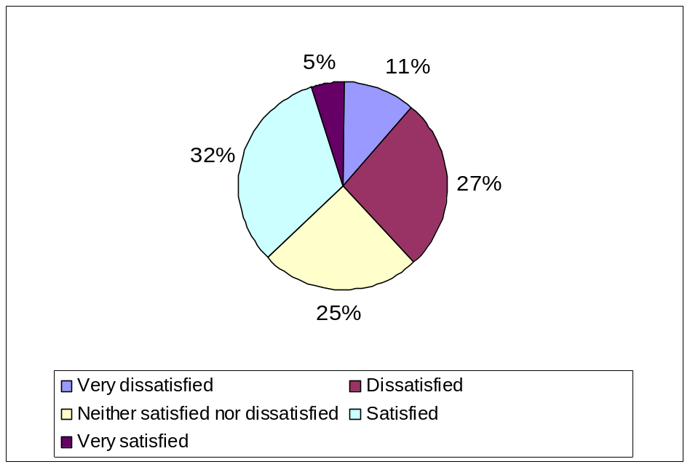

Managers’ perceptions of staff career progression
Among managers, a smaller proportion of respondents (32%) expressed themselves as being satisfied or very satisfied about the career progression opportunities for older staff (see Figure 34). However, a smaller proportion (27%) also stated that they were either dissatisfied or very dissatisfied. A relatively high proportion of managers (39%) were neutral in their response.

Figure 34: Managers' Satisfaction with Career Progression Opportunities for Older Staff
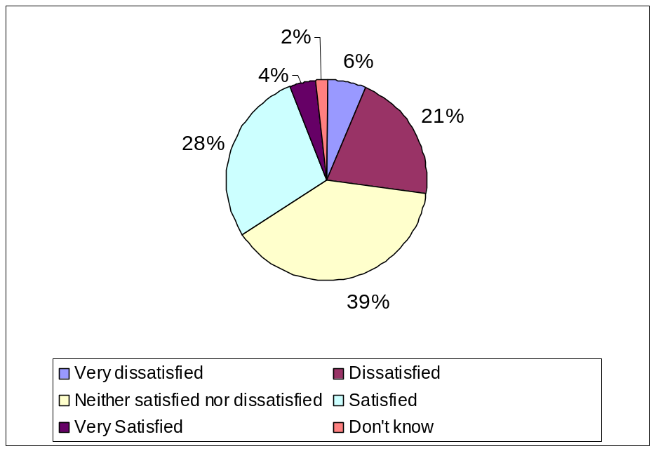

Table 15 shows the level of manager satisfaction with the career progression of older Commission staff broken down by the age group of the managers. As the numbers in each cell are small, the responses have been grouped. Only among managers aged 60+ were more respondents satisfied than dissatisfied.

Table 15: Managers' Satisfaction about Career Progression Opportunities for
Older Commission Staff (by Manager Age Group)
 | Up to 49 | 50-54 | 55-59 | 60+
 | % | % | % | %
Dissatisfied/very dissatisfied | 36 | 22 | 33 | 8
Neither satisfied nor dissatisfied | 25 | 31 | 33 | 11
Satisfied/very satisfied | 23 | 33 | 23 | 21
Base (n) | 36 | 38 | 39 | 18

Changes in opportunities for career progression

The views of staff
In considering whether older staff now had the same opportunities for professional development as they did in the past, a very high percentage of staff respondents (42%) stated that they did not know. Thirty percent (30%) of respondents (n311) thought that they did, but almost as many (28%) thought they did not (see Figure 356). These negative views were considerably stronger among AD staff (34%) than AST staff (23%) and men (31.5%) as opposed to women (23%). Staff working in External Services DGs (34%) and Policy DGs (31%) were more inclined than staffing other DG groups to think that they did not have the same professional opportunities as younger staff. The proportions in General Services DGs and Internal Services DGs were respectively 20% and 18%.

Figure 35: Staff Perceptions as to whether older staff have the same opportunities for professional development as previously
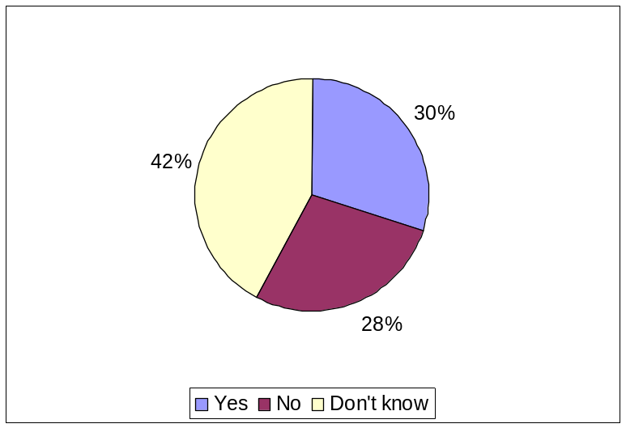
However, there were more negative than positive comments made by staff when they were asked to elaborate on their answer. Among the more affirmative ones were the following:
“They [professional development opportunities] are now BETTER than in the past.”
(50+staff)

“I think that in the past, there were less opportunities for professional development and that the Commission policy on this respect has very positively evolved. In my opinion, the Commission has become a reference as an employer.”
(50+staff)

“Since the introduction of the obligatory training, the development opportunities have grown.”
(50+staff)

The negative comments included the following:

“When I started at the Commission more than 20 years ago you had to be A3 to become a manager. Since the grades for that have decreased (which I think it is good!), chances for a career that were not available when I was younger due to my lack of seniority and my female gender are not open now due to my age: for one I was too early (I was told that I was still very young at mid-forty for management advancement) for the new policy I am now too old.”
(50+staff)

“Depuis la réforme de 2004 et les nouvelles procédures mises en place, les possibilités de développement de carrière se sont détériorées et sont a contrario bien moins transparentes que dans le passé. A 60 ans, c'est la voie de garage!”
(50+staff)

“In addition, the equal opportunity policy does only address the problem for female colleagues to succeed in middle management positions, but not the problem of colleagues of advanced age to be promoted.”
(50+staff)

The views of managers
Managers were asked whether they felt that older Commission staff had the same professional development opportunities as younger staff. As Figure 36 shows, almost half of the sample (48%) responded affirmatively that both older and younger staff enjoy the same professional development opportunities. However, one third of the sample (33%) stated that older staff are not given the same training and professional opportunities as younger staff.

Figure 36: Managers' Responses as to whether Older and Younger Staff
have same Professional Development Opportunities
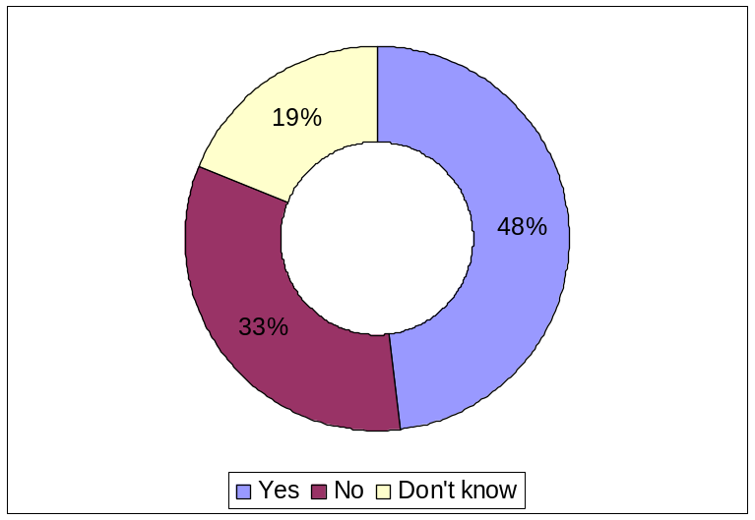

Table 16 shows the managers’ perceptions as regards the professional development opportunities offered to older Commission staff broken down by age. The largest difference between those who thought they did have the same opportunities as younger staff and those who thought they did not is in the 60+ age group, where three times as many respondents considered that they did have the same opportunities as considered that they did not. As we noted above, this age group also expressed themselves more satisfied with older staff’s opportunities for career progression than did their younger colleagues.

Table 16: Managers' Perceptions as to whether Older Commission Staff have the same
Professional Development Opportunities (by Manager Age Group)
 | Under 49 | 50-54 | 55-59 | Over 60
 | % | % | % | %
No | 34 | 36 | 33 | 22
Yes | 50 | 43.5 | 38 | 72
Don't know | 16 | 20.5 | 28 | 5
Base (n) | 38 | 39 | 39 | 18

When asked about their views as to why they felt that older Commission staff did not have the same professional opportunities, the main reason provided by managers was that older staff were not seen as a good investment, especially in comparison with younger staff. As many as 38% of managers thought that it was not worthwhile investing in the continuous professional development of older staff, while 26.5% thought that it was.

“La COM préfère investir sur du personnel plus jeune avec les plus anciens en support.”
(Manager)

“[older staff] can be passed over for someone younger who may be seen as being a better long term investment.”
(Manager)

“Objectivement non. Le personnel de plus de 50 a au plus une douzaine d'années de carrière devant lui, alors que le personnel de 30 ans en a une bonne trentaine.”
(Manager)

“Often they face a bottleneck (end of career) and development/training investment on them may be limited.”
(Manager)

There was also reference to the current trend in the Commission of placing emphasis on specialist as opposed to generalist skills. In other words, since the Commission is acquiring the specialist skills it requires (mainly by the recruitment from NMS and use of contract agents), older staff (who tend to be more generalists) are not given new training opportunities.

“The Commission is increasingly staffed by specialists. I don't think the Commission is willing to invest in older staff to enable them to specialise in a new field.”
(Manager)

Asked about their level of satisfaction with the professional development opportunities provided to older Commission staff, almost half of managers (45%) were satisfied or very satisfied, with about 17% being dissatisfied or very dissatisfied (see Figure 37). A relatively high proportion of managers (38%) were neutral in their response.

Figure 37: Managers' Satisfaction with Professional Development
Opportunities of Older Commission Staff
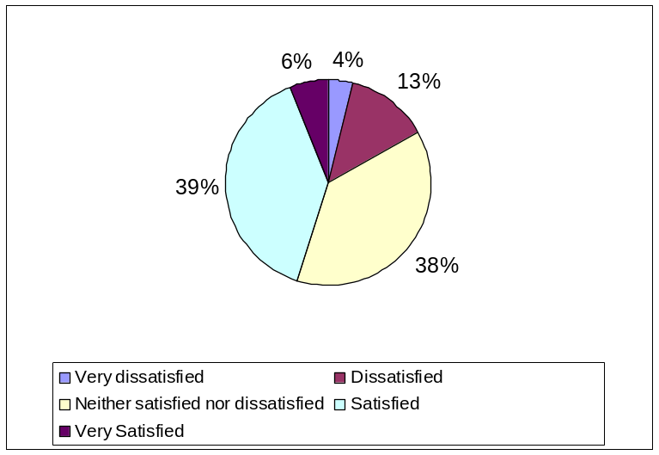
shows the level of manager satisfaction with the professional development opportunities of older Commission staff broken down by age. Since the numbers in some cells are small, dissatisfied/very dissatisfied and satisfied/very satisfied have been amalgamated. As before, it is the oldest age group who are most likely to profess themselves satisfied about the opportunities for older Commission staff. Most managers in the youngest age group had no strong feelings either way.

Table 17: Managers' Satisfaction about Professional Development Opportunities for
Older Commission Staff (by Manager Age Group)
 | up to 49 | 50-54 | 55-59 | 60+
 | % | % | % | %
Dissatisfied / very dissatisfied | 10.5 | 13 | 26 | 17
Neither satisfied nor dissatisfied | 58 | 41 | 26 | 22
Satisfied/ very Satisfied | 31.5 | 46 | 49 | 61
Base(n) | 38 | 39 | 39 | 18

The views of HR managers

Turning to the opinions of HR managers about the availability of professional development opportunities for older Commission staff, well over half (59%) of them felt that such staff had the same professional opportunities as in the past. (See Figure 38). This is a much greater proportion than that of management staff who responded to a similar question (48%) and of staff (30%). However, just under one third (32%) thought the opposite, and this is almost the same as the proportion of managers and staff. Some indicative HR manager comments include the following:

“I feel they [older staff] have less opportunities than younger people not less opportunities than in the past.”
(HR manager)

“Ils n'ont pas le même accès ni peut être parfois la même appétence pour la formation.”
(HR manager)

“Le temps relativement court restant ne motive pas pour le développement professionnel.”
(HR manager)

“Ayant plus de responsabilités, une unité plus grande à gérer, il dispose de moins de temps pour ce développement professionnel.”

(HR manager)

Figure 38: HR Managers' Responses as to whether Older Staff have the
Same Professional Development Opportunities as Younger Staff
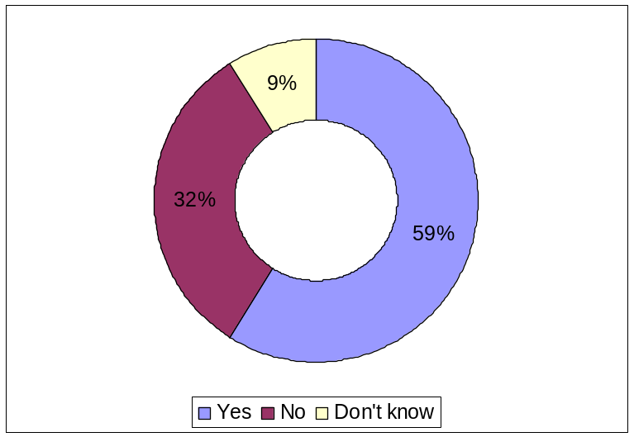

Figure 39 shows HR managers’ levels of satisfaction with the professional development opportunities provided to older Commission staff. The proportion declaring themselves satisfied with such opportunities (35%) was smaller than the proportion of managers (45%) who did so (see section 8.1.4.2). However, only 4% were dissatisfied, and this is much lower than the 17% of managers who expressed dissatisfaction. Significantly, almost two thirds of HR managers (61%) were neutral as to the availability of such opportunities to older Commission staff.

Figure 39: HR managers' Satisfaction with Professional Development
Opportunities of Older Commission Staff
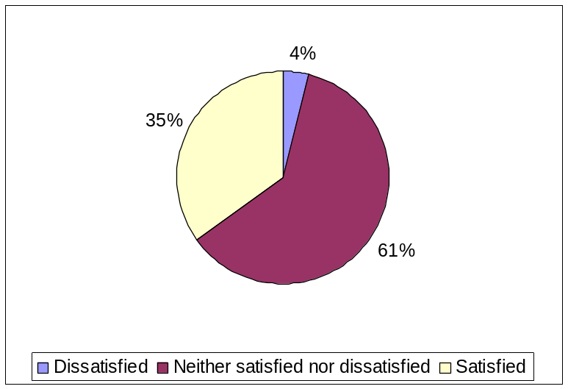

Ambitions of Older Commission Staff

The views of managers
As Figure 40 shows, two-thirds (66%) of managers agreed partially or completely with the statement that AD staff who reach the age of 50 without having held a managerial post are very unlikely to gain one in the future.

Figure 40: Managers' Agreement with the Statement ‘AD staff who reach the age of 50 without having held a managerial post are very unlikely to gain one in the future’.
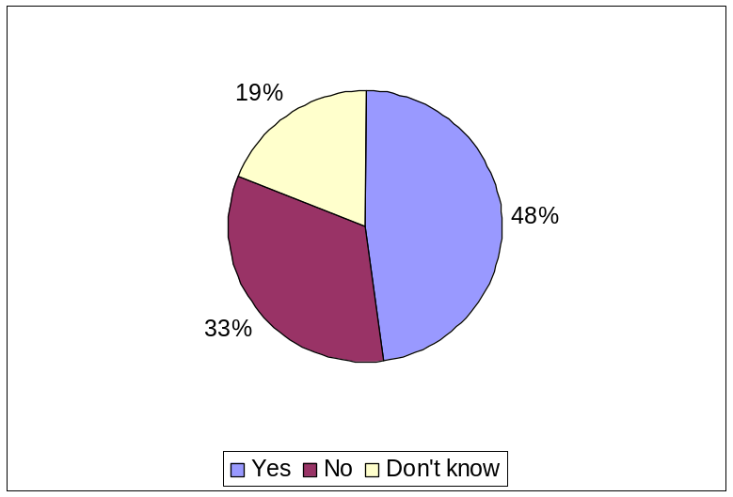

Table 18 shows that there are no major age differences in managers answering affirmatively to this statement, although those in the oldest age group were least inclined to think that such staff were unlikely to gain a managerial post.

Table 18: Managers' Responses to Statement ‘AD staff who reach the age of 50 without having held a managerial post are very unlikely to gain one in the future’ (by Manager Age Group)
 | up to 49 | 50-54 | 55-59 | 60+
 | % | % | % | %
Dissatisfied / very dissatisfied | 24 | 15 | 20.5 | 39
Neither satisfied nor dissatisfied | 8 | 8 | 18 | 11
Satisfied/ very Satisfied | 68 | 77 | 61.5 | 50
Base(n) | 38 | 39 | 39 | 18

The views of HR managers

HR manager responses bear out comments made during our scoping exercise and in our recent face-to-face interviews with HR managers about the likelihood of AD staff over 50 who have never held a managerial post before getting a managerial post in the future. Specifically, as Figure 41 shows, the overwhelming majority (87%) of HR managers agreed either partially or completely with the statement that “AD staff over 50, who never held a managerial post before, are very unlikely to get a managerial post in the future”.

Figure 41: HR managers' Perception of the Likelihood of AD Staff
holding Managerial Posts if not already a Manager
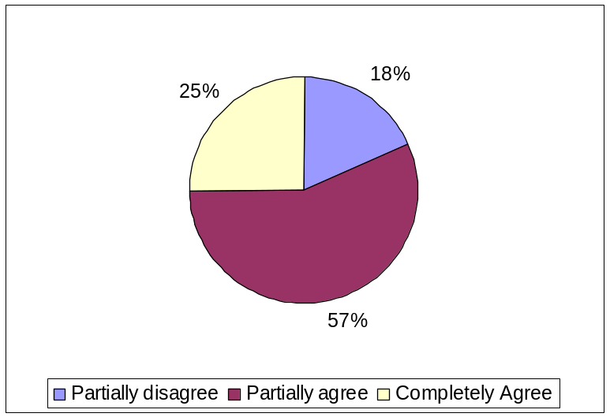

The views of staff

Staff also agreed with the above statement.

“Appointment in management positions like head of unit/delegation becomes more difficult if this level has not been reached by a certain age.”
(50+staff)

“Apres de nombreuses tentatives, à ma demande d'être pris en compte pour le management (Chef d'Unité) on m'a répondu que à partir de 45/50 ans on été trop vieux pour que les RH des DG puissent envisager une carrière dans le management à la Commission.”
(50+staff)

“Les plus de 50 ans qui n'ont pas atteint le niveau du Senior Management sont considérés, consciemment ou non, comme des "vieux cons", et démarrent avec un handicap sérieux dès qu'ils postulent à un emploi d'encadrement, sauf nationalité déficitaire.”
(50+staff)

“Les sélections de premier poste chef d'unité se font rarement après 50 ans. En particulier si l'on ajoute l'"égalité des chances" qui donne un avantage aux femmes et la préférence pour les EU10, il devient très improbable à un homme de plus de 50 ans d'accéder pour la première fois à ces postes.”
(50+staff)

Age versus performance

A note of caution, however, should be inserted here in that a number of HR managers (and Heads of Unit) pointed to the danger of conflating the issue of age with that of performance and suitability for a managerial post. Specifically, a number of HR managers and HoUs mentioned that some older staff are disappointed and/or frustrated from not having secured an end-of-career managerial post. However, although this might be due to the fact that their profile, skills and expertise were unsuitable for such a post, they are more likely to rationalise their failure to secure such a position on grounds of age rather than performance especially if, as some interviewees reported, staff are not always given feedback after an unsuccessful interview. Also according to some of our interviewees, the fact that some managers in the Commission tend to eschew confrontation and avoid managing under-performance (mainly by either ignoring the person concerned or encouraging them to move) may exacerbate the situation, in that some older staff may not have been given a true assessment of their capabilities. One of the conclusions of the Commission’s 2006 Staff Opinion Survey was that management should continue the effort to provide clear feedback on the work of staff.

Moreover, as we were also told during scoping exercise, career success in the Commission has historically been associated mainly with reaching a managerial post. As a result, in the eyes of some managers older Commission staff who have not achieved such a trajectory have not been successful, which makes them less likely to invest in their career progression.

“Older personnel, NON-management are seen as not successful.” (Manager)

“It’s assumed that these [older] staff members will never become (sub)managers and they are to an extent 'black-listed' by middle and senior managers.”
(Manager)

However, there was also a view that some staff aged 50+ were themselves often rather unwilling to adapt and could be seen as not open to learning. This was expressed especially in relation to applying for new jobs, consequent on the Mobility policy.

“Not only are they not open to mobility, but once they accept the concept of mobility, they are not used to the idea of lifelong learning and continuous development, even if this means learning something completely new.”
(ReLOP)

Alternative Careers

Manager respondents to our survey identified an issue highlighted during our scoping phase, i.e. the frustration among older Commission staff who for whatever reason have not reached a managerial position coupled with the (perceived or real) lack of alternative career paths which would recognize and value the considerable knowledge, expertise and experience of such staff.

“Problems of over-50s seem to be related rather to frustrated expectations of those who don't make it to management grade and to the unfortunate Commission culture that identifies those people as "failures to become managers" rather than good experts.”
(Manager)

The role of advisor
In the staff survey, creating and implementing “alternative career paths (other than managerial career paths)” was the most popular recommendation, with 42% of older staff believing this was important or very important. Although it was recognised by staff that there is the mechanism of an alternative career path as a recognised expert until one reached AD13 (in line with the New Staff Regulations), if and how this mechanism is implemented depends on the local HR services and management at each DG. For example, in DG Competition the management was supportive of this mechanism because there was a business case for keeping experts in this alternative career path. To this end, there were supervised Career Development Review (CDR) exercises. However, it was pointed out that, as with career guidance services and other initiatives, e.g. mentoring, mobility practices and so forth, the implementation of this alternative career path varies considerably between DGs. In contrast to DG Competition, it was reported that in DG INFSO there is no such path, while in DG AGRI, priority is always given to HoUs. Finally, as the Career Guidance Officers’ Working Group on the Management of Commission Senior Staff reported, the fact that there is a very small number of non-managerial posts with a high profile and commensurate responsibilities offered to staff aged 50+ also led to the relative lack of motivation.

Moreover, of the staff we talked to who were engaged in the advisor role, all showed dissatisfaction with how the role is currently articulated, seeing it as a waste of their talent. Reflecting a comment made by SCOP representatives at the kick-off meeting, those over 50 who have been (usually involuntarily) moved to an advisor’s position expressed particular levels of alienation, disengagement and de-motivation. These positions lie outside the hierarchy and, in view of the Commission’s highly hierarchical system, seem to their incumbents (and the rest of the organisation) as being of lesser value and worth to the organisation. As one informant put it:

“Friends of mine in other DGs, including former Heads of Unit, have been put on the side, made Advisors, have beautiful offices, but their potential is being wasted for political reasons.”
(AD, 50+)

This sense of political motivation reflects the sense that they have been sidelined when in the role. One participant went as far as to say:

“The function of the advisor is the ‘elephant cemetery’.”
(AD, 50+)

The fact that a number of these advisors used to be part of management, e.g. HoUs, and in their new capacity are now considered outside the management structure contributes to these feelings of disengagement and alienation. Nevertheless, the idea of alternative careers remains very popular. However, in light of the above comments, the alternative career path as it currently exists would need to be greatly revised to give more responsibility and a great sense of engagement with the Commission as a whole to make full use of this resource.

Mobility of Older Commission Staff

The Commission has a culture of mobility among its officials, who on average change jobs almost every 5 years. (Implementation of the Mobility Policy in the Commission: Progress Report for the Year 2006.) One quite striking and consistent finding of our survey is the fact that managers and staff were of the opinion that there are potentially serious issues around older Commission staff and internal mobility. Such a finding bears out anecdotal evidence collected by key HR managers, e.g. SCOP and its network of ReLOPs as well as by our own staff focus groups during the scoping phase of this study.

Interestingly the questions around career progression, mobility, and related (perceived) barriers elicited the largest number of comments across the three groups of survey participants, i.e. staff, management and HR managers. Crucially, all three groups thought that there were indeed barriers to internal mobility. This appeared to be part of the bigger picture in which large proportions of respondents thought that older people were not on an equal footing with younger Commission staff in respect of the internal job market, vacancies and mobility.

Barriers to internal mobility

Staff views of mobility

Among the staff in our survey, just over half of all respondents (526) thought that there were barriers to internal mobility in the Commission. Only a quarter (n256%) considered that there were no barriers and 23% (n244) said that they did not know (see Figure 42).

Figure 42: Staff Perceptions as to whether there are Barriers to Internal Mobility
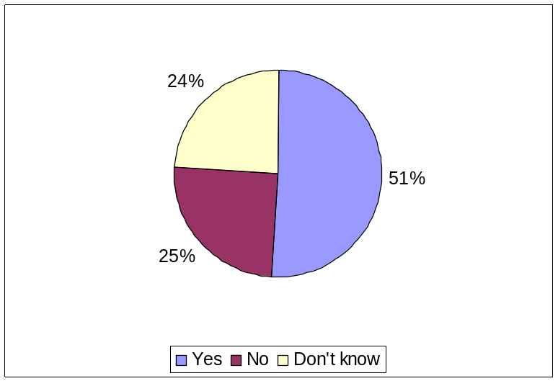

In terms of function groups, a considerably higher proportion of AD staff (61.5%) thought that there were internal mobility barriers, as opposed to 40% of AST staff. More AD staff also thought that being a man was a barrier to internal mobility, reflecting the historical gender evolution in the Commission when previously more men than women were recruited, especially for AD posts.
When DG grouping was taken into account, the largest proportion (63.7%) of staff reporting mobility barriers worked in External Services DGs, followed by staff in Policy DGs (51.1%), General Services DGs (44.5%) and Internal Services DGs (43.7%). Not surprisingly, since delegations form part of that DG grouping, 13.3% staff working in External Services DGs included “Being labelled after delegations” among the top three barriers to mobility. Integration and mobility problems for those returning from Delegations were also reported to us by both staff and HR staff during scoping.

Staff were asked to select from a list the main factors that they considered to act as barriers to mobility, and these are shown in Figure 43.

Figure 43: Staff Opinions of the Main Barriers to Internal Mobility
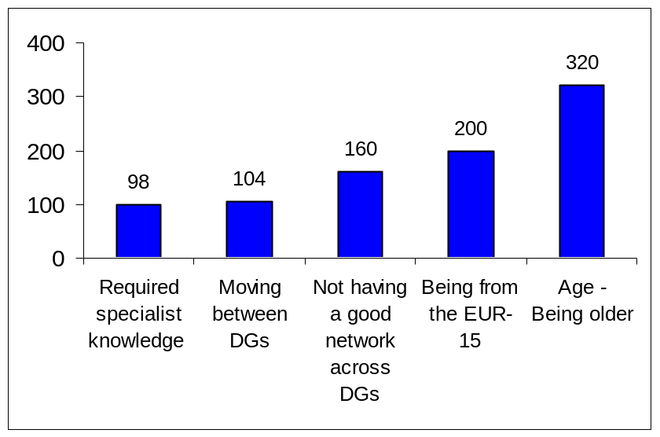

Being older was by far the main reason for this according to 61% (n320) of the 526 who answered positively to the question. Of these 320, 64% were men and 36% women. A second reason was being from one of the older Member States, identified by 38% (200 respondents). Attention to this fact has already been drawn in the earlier report of the scoping study where informants accepted that the recent quota system for the numbers of posts per Member State was a barrier to mobility for staff from the Older Member States, but they nevertheless experienced a sense of injustice at the potential damage to the promotion prospects of staff from the Older Member States. Older and male staff from these countries were viewed as being particularly disadvantaged. This was endorsed by respondents to the online survey.

“Female, younger and new MS staff are given preference.”
(50+staff)

“Several job-applications were not successful even if all requirements were fulfilled and the interview was positive. Reasons: wrong gender, too old, not from a new Member State.”
(50+staff)

“One particular group, into which I fall, that is ‘old white males from old EU MS’ have little or now chance of being promoted to a Head of Unit position.”
(50+staff)

“The Commission suffers from the recent enlargements in that both at administrator level and at the level of more political appointments new member states have occupied far too many posts to make any further professional development of older staff possible. Add to this the fact that women have priority and you will find that at the bottom of the pile are officials who are: (1) male, (2) over 50, and (3) from old member states.”

(50+staff)

The third main barrier to mobility, according to 30% of respondents (160), was caused by not having a good network across the DGs. Again, this was brought up in the scoping study, where networking skills were seen as vital for career survival and mobility within the Commission, as staff were expected to be able to manage internal mobility themselves without assistance. If they had not been able, for whatever reason, to establish good links with other DGs they were at a considerable disadvantage in the mobility stakes, which carry a high premium in the Commission.

Managers’ views of mobility
Turning now to the responses of managers, it can be seen that an even higher proportion of managers than of staff (70%) answered affirmatively to the question whether they believed that there are barriers to internal mobility in the Commission (Figure 44). Only 20% considered that there were no barriers.

Figure 44: Managers' Perceptions as to whether there are Barriers to Internal Mobility
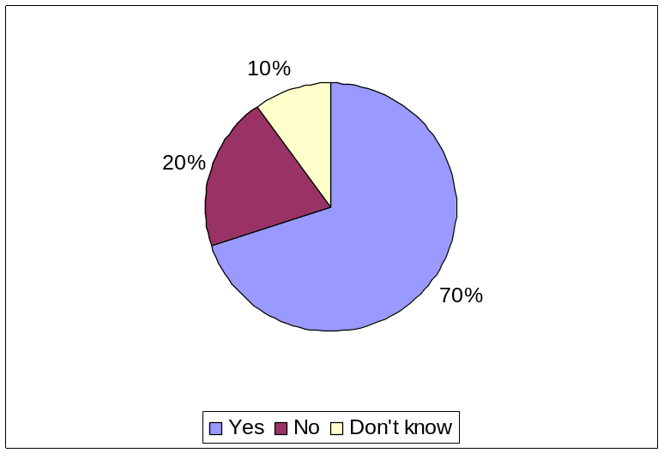

As Figure 45 illustrates, the youngest age group of managers had the highest proportion thinking that there were barriers to mobility, while the oldest age group (those over 60) had the lowest proportion.

Figure 45: Managers stating that there are Mobility Barriers in the Commission (percentage of Manager Age Group)
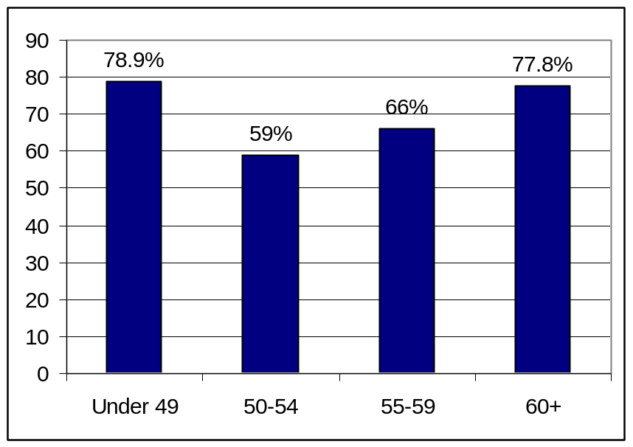

As with staff respondents, age (being older) was the barrier most commonly identified by managers (34%) – see Figure 46. In fact, managers’ top five choices were almost identical to those of staff, with the exception of ‘indicative targets for NMS’ which in the case of staff was replaced by ‘being from the EUR-!5’. In effect, these mean the same thing and merely represent the difference in perception of those on the receiving end of a policy and those tasked with implementing it.

Figure 46: Managers' Perceptions about Barriers to Internal Mobility
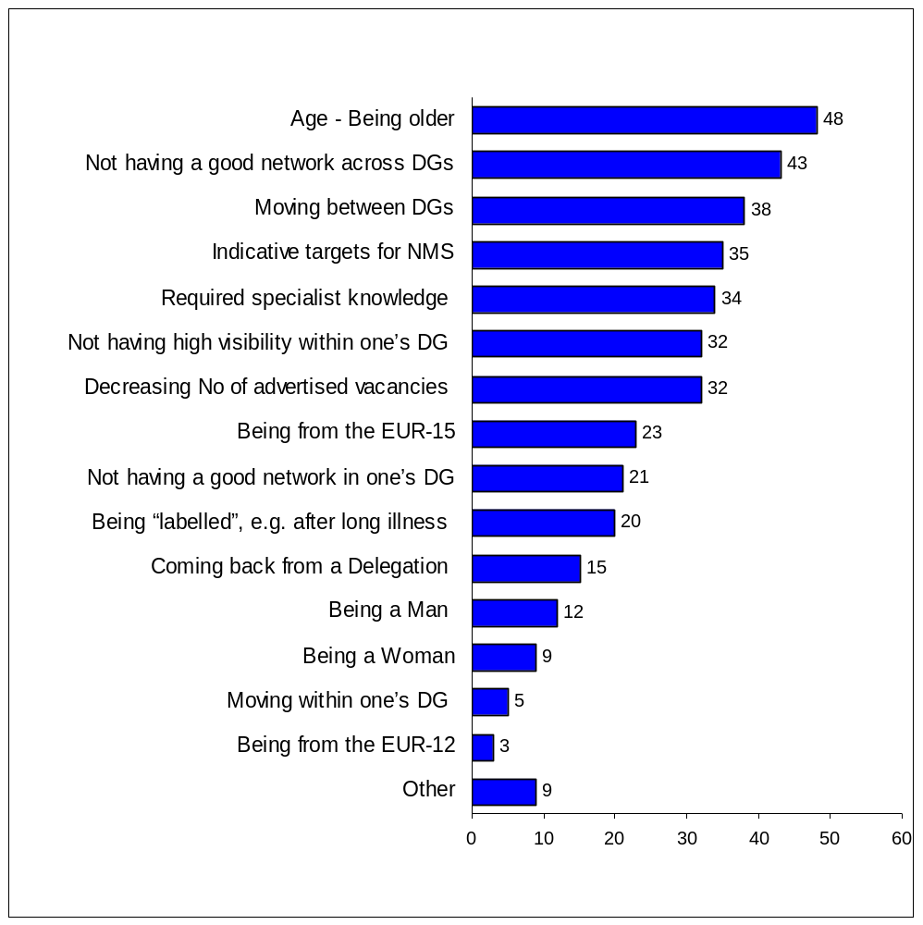

HR managers’ views of mobility

HR managers were even more likely than either older staff or managers to consider that barriers to internal mobility did exist. Figure 47 shows that only 13% considered that they did not but the vast majority (78%) of HR managers thought that they did. This is considerably higher than the proportions of either staff (51%) or managers (70%) who thought barriers existed.

Figure 47: HR managers' Perceptions as to whether there are
Barriers to Internal Mobility
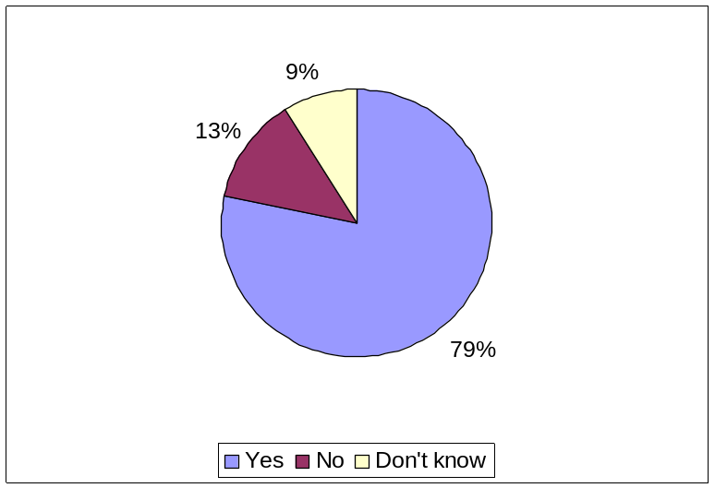

HR managers identified not having a good network across DGs as the most important barrier, selected by 35%. Age (in terms of being older), the need to recruit someone with the required expertise, and a relatively lower number of vacancies advertised internally each elicited responses from 30% of HR managers. It is interesting that the limited number of advertised vacancies was not a major issue for staff or managers but it was important from the HR perspective.

Summary of views

Across the three groups of respondents, age featured as the most widely chosen barrier to mobility by both management (34%) and staff (31%) and was ranked as the second most important barrier by HR managers (30%), who instead ranked not having a good network across DGs as first among mobility barriers. On the other hand, just under a third (31%) of managers ranked this as the second most important barrier, while for staff it was the third most commonly selected obstacle (15%). For almost one fifth (19%) of staff the second most important barrier was being from the 15 “old” Member States, but this did not have priority for managers or HR managers who instead saw the issue as meeting indicative targets for NMS.

Treatment of staff aged 50+ in respect of job mobility

The views of staff about their treatment
Exploring first the responses of staff, Figure 48 shows that 45% considered that the treatment they received in terms of job mobility was not the same as that received by their younger colleagues.

Figure 48: Treatment of staff aged 50+ as regards job mobility
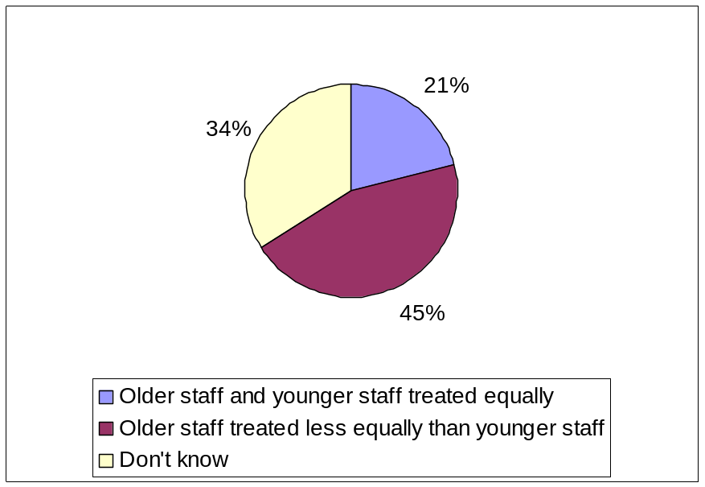
AD staff were slightly more inclined to believe that the way they were treated was not the same as the way younger staff were treated, with 59% (compared with 48% of AST staff) holding this opinion. When DG grouping was taken into account, the External Services DGs, closely followed by the Policy DGs, have the largest proportion of older staff who reported that such staff receive unequal treatment in the Commission. Specifically, half of staff in External Services DGs, and just under half (49%) of those in Policy DGs, stated that older staff were not treated equally. Among staff in General Services DGs, 43% held the same opinion, as did 33% in Internal Services DGs.

Many respondents elaborated on how they considered that this unequal treatment manifested itself.

“From the time of my arrival at the Commission at 45 years of age I was told I was considered ‘carrière lente’, meaning that I was discriminated against in terms of assessment scores and promotions.”
(50+staff)

Another complaint was that the Commission did not value the experience and expertise which older staff bring, preferring instead the attributes which younger people offer.

“The culture of appointing/promoting young and supposedly dynamic people - which is a 'trendy' motivation for rewarding people close to the power centres of the appointing authority - results in the silent sidelining of more experienced officials.”
(50+staff)

“In applying for a post I was rejected despite my qualifications being admitted to have more than met the published job description since it was felt that a younger less-experienced colleague with greater dynamism was suited to the job.”
(50+staff)

Also, over half of the staff respondents (51%) agreed that in the annual staff appraisal, managers were more likely to give merit points to younger rather than to older staff viewed as nearing retirement. Of these 528 respondents, the majority (57%) were in complete agreement that this was the case. Interestingly, this view of unequal treatment was shared by a third of managers.

The views of managers about the treatment of staff
Managers also thought – but to a greater extent than staff - that the way in which older staff were treated in terms of internal mobility within the Commission was inferior to the way in which younger staff were treated.

Figure 49 shows that over half of managers (53%) considered this to be the case.

Figure 49: Managers' Perception about Treatment of
Older Commission Staff as regards Internal Mobility
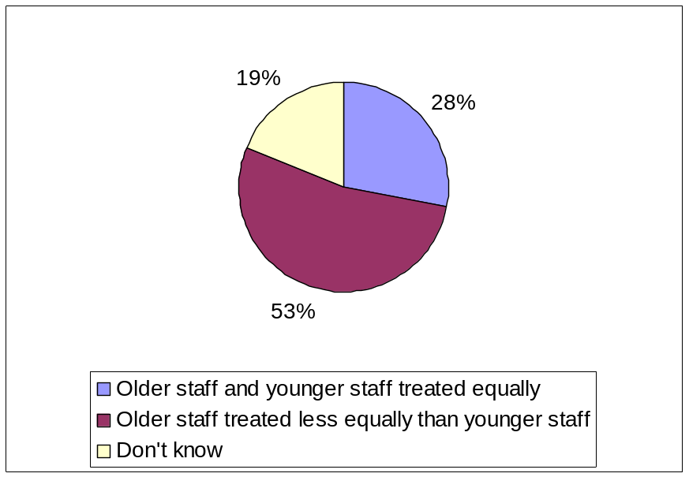

Interestingly, the managerial responses as to the way older Commission staff are treated as regards internal mobility do not seem to vary considerably between different age sub-groups (Table 19). However, managers in the oldest age group were more likely than those in the other age groups to think that older staff were treated less fairly than their younger counterparts.

Table 19: Managers' Perceptions as to the Treatment of Older Commission Staff as regards
Internal Mobility (by Manager Age Group)
 | up to 49 | 50-54 | 55-59 | 60+
 | % | % | % | %
Older staff and younger staff treated equally | 32 | 23 | 33 | 22
Older staff treated less equally than younger staff | 47 | 54 | 51 | 61
Don’t know | 21 | 23 | 15 | 17
Base (n) | 38 | 39 | 39 | 18

The views of HR managers about the treatment of staff
Finally, looking at the opinions of HR managers, they confirmed the information provided to us in our seven (7) in-depth face-to-face interviews with Heads of HR in different DGs and Commission Services in identifying the fact that older staff did not get the same treatment as younger staff when it came to internal mobility (Figure 50). However, among HR managers in the survey, the discrepancy between those thinking they did not get the same treatment (45%) and those thinking that they did (32%) was not as great as it was among managers, where the proportions were respectively 53% and 28%. HR manager responses as regards unequal treatment were much more in line with those of older staff, 46% of whom thought that staff of their age were unequally treated. However, a lower proportion of staff (21%) than of either HR managers or managers thought that the opposite was true and that older staff were treated fairly as regards job mobility.

Figure 50: HR managers' Perception about Treatment of Older Commission Staff
as regards Internal Mobility
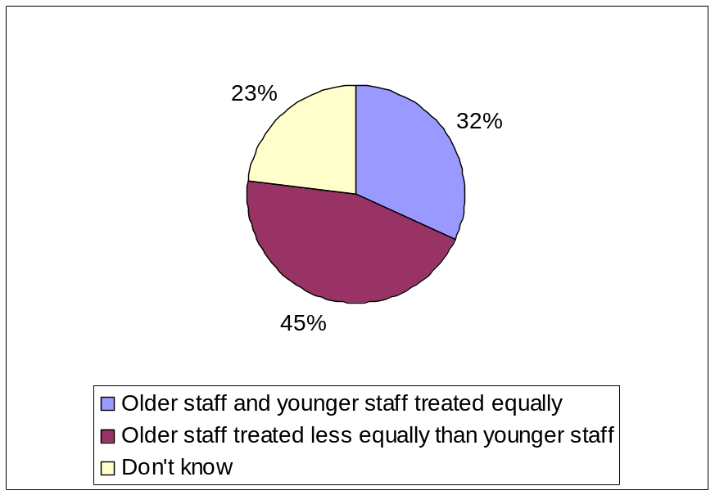

When HR managers were asked how such unequal treatment was manifested, the main responses could be grouped as follows:

- Fewer promotion and career opportunities offered to older staff:

“Forcément plus gradé que les plus jeunes, le senior management n'ayant plus de moyens pour le récompenser, préfère récompenser (promouvoir) des plus jeunes moins grades.”
(HR manager)

- Linked to this is the current career structure in the Commission which is quite hierarchical and has historically put the premium on managerial positions:

“The rigid organisational structure of the Commission where the only career path is official => HoU => Director => DG. No other possibilities to evolve, grow.”
(HR manager)

“All staff above 45 years old start to understand that they won’t get any higher- there’s a serious problem of motivation commission wide. We are landlocked, not a normal civil service where in a national civil service people can move into secondments. There are too many people aiming for the same high-level post. ”
(HR manager)
- Greater difficulties in mobility

“Plus de frilosité des "recruteurs" à engager une personne +55.”
(HR manager)

“Mobilité obligatoire - On leur demande de bouger et quand ils postulent, on leur fait sentir que leurs compétences ne sont plus à jour, qu'ils pourraient être des gens difficiles à manager, et pas question d'utiliser l'article 7 pour les imposer, c'est un cauchemar!”
(HR manager)

- (Implicit) Age discrimination

“Pour certaines fonctions, une préférence sera donnée au personnes plus jeunes.”
(HR manager)

“Le personnel âgé, comme pour le personnel féminin, doit en faire beaucoup plus
pour prouver qu'il peut rester dans la course.”
(HR manager)

- Being considered a threat by a Head of Unit

“J'ai constaté une méfiance injustifiée dans leurs capacités d'intégration ainsi d'une crainte de la part de certain Chefs d'U vis à vis de leur position dominante dans l'Unité.”
(HR manager)

“Oldies are clearly frightening for HoU and recruiting managers.”
(HR manager)

Experiences of staff

The qualitative data from our survey afforded evidence that, at least in their eyes, older staff considered that, compared with younger staff, they have fewer promotion and career opportunities as well as greater difficulties in mobility.

“There is statistical evidence in my DG that over- fifties not in management posts have been systematically discriminated against in both merit and priority points.”
(50+staff)

“Younger staff is preferred when they apply for a new job. It is extremely difficult for somebody over 55 to find a new job.”
(50+staff)

“Mobility: even if not said officially, DGs prefer to invest in younger people.”
(50+staff)

In line with HR manager comments, staff also felt that some managers preferred to employ younger rather than older employees, either because they were more flexible or because they would not undermine them in the way that older staff might.

“There is a tendency to prefer younger colleagues considered as more flexible and adaptable than older colleagues.”
(50+staff)

“Younger managers do not like to recognise the fact that older people in their staff know the content better than themselves, they may feel threatened.”
(50+staff)

In many cases this was tantamount, in their eyes, to age discrimination of either an implicit or explicit nature.

“It is not rare to hear Directors and HoUs saying informally that they do not want recruitments over 45/50 (A part of my job is to deal with recruitments). This has been particularly true since the arrival of young colleagues from new Member States”
(50+ Staff)

“On m'a clairement dit que j'étais trop âgée et que je n'aurais aucune chance mêle si je postulais officiellement”
(50+ Staff)

“I was told that they preferred a younger candidate, more motivated as they had to make career”
(50+ Staff)

Just under a quarter (24%) of the staff who responded stated that they had personally experienced age discrimination (see Figure 51). Although the proportion is not excessively high, the fact that this amounted to 247 members of Commission staff over 50 in this sample feeling that they had been discriminated against on the grounds of age merits consideration.

“Dernière promotion avant la réforme Kinnock (complètement ratée), avantage a été donnée à 2 collégues à peine 4 ans d'ancienneté dans leur grade alors que moi-même j'en avais 11. De plus, les 2 collègues sont plus jeunes de +/-10 ans!”

Additionally, there is corroborating evidence of discrimination from the scoping exercise where older respondents cited incidents of their being discouraged from applying for managerial positions, and one manager informant admitting a preference for appointing young people to his team because they were more likely to work longer hours, be more adaptable, have IT skills and remain in post for longer than older staff.

Figure 51: Staff experiencing Age Discrimination
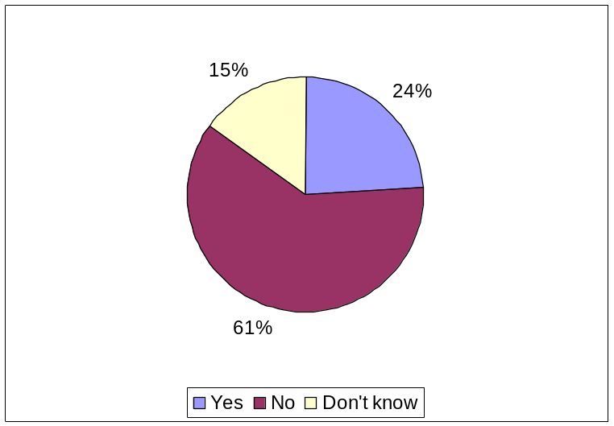

Of the online survey respondents, there was a greater tendency for men rather than women to state that they had experienced age discrimination themselves: 27% of men as opposed to 20% of women said that they had. This fits with previous comments about the disadvantage of being an older male in the Commission. Within function groups, more AD staff (30%) than AST staff (19%) claimed to have faced discrimination on the grounds of their age. Over a quarter (27.1%) of staff working in Policy DGs and just under a quarter (23.3%) working in External Services DGs have experienced age discrimination, followed by 21% of staff in Internal Services DGs and 19% in External Services DGs.

Job applications

Notwithstanding these opinions about the difficulties of obtaining a new post when older, in the two years preceding the survey, 393 older staff (38% of the total responding) had applied for another job in the Commission, with 70% of those who applied making an application for between one and three jobs. AD staff were the group most likely to be looking for another job, with 43% of them applying. Of the AST (ex- B Grade) employees, 34% had applied for another job, along with 32% of the AST (ex-C and D Grades). Many more staff working in External Services DGs applied for a job in the last two years than in any other DG grouping.
The view of some Commission staff, referred to in the earlier report of the scoping study, was that older people were reluctant to apply for new posts because this involved a commitment to further learning and training. Furthermore, it was thought that when they did make an application, it was not as sophisticated as those made by younger staff (and this might especially be the case with applicants from the New Member States) who were more attuned to being assertive in selling themselves to potential employers. This belief was not borne out by the evidence here as the majority of those who had applied (87%) had been shortlisted and interviewed on at least three occasions, which suggests that their applications were sufficiently good to get them to the interview stage. Among the ADs who had made job applications, 89% had been short-listed and interviewed on at least three occasions. This is slightly higher than the proportions for the ASTs (ex B Grade) (85%) and for the AST (ex C and D Grades) (80%).

However, not all potential candidates reached the interview stage. One respondent wrote:

“Having applied for a post, for which my profile was adequate, in my view, and having regard to my previous professional experience, I was not even called for an interview!”
(50+staff)

In other cases, applicants were interviewed but were then unsuccessful, despite the recognition that they were eminently well qualified for the post. In some cases, however, this acted against them.

“J'ai postulé plusieurs postes. Bien que je possède les qualifications (confirmé pendant l'interview) requises un/e autre candidat/e a été choisi/e.”
(50+staff)

“Plusieurs sélectionnée sur des ‘shortlists’ après interviews à de nouveaux postes mais chaque fois, c'est le candidat le plus jeune qui a été retenu. Raisons invoquées lorsque j'ai cherché à en savoir plus : ‘vous êtes trop qualifiée pour le poste’”.
(50+staff)

The data collected from respondents to the online survey focused on whether they felt motivated and/or encouraged to apply for other jobs within the Commission. It did not include information on whether they were, in fact, recruited to these posts, and consequently it is outside the remit of this report to comment on the success rate of older staff in obtaining a new post.

Evidence supporting survey respondents’ views

The Progress Report for 2006 on the Implementation of the Mobility Policy in the Commission confirms reports from staff aged 50+ of increasing difficulty with mobility. This report also refers to the difficulty, which was identified by HR managers in particular, of fewer middle management posts being published. The reduction in transparency in the process of mobility was seen by respondents as discrimination against staff aged 50+. SCOP informants both at the kick-off meeting and during the scoping exercise also mentioned this perception of age discrimination against older workers, especially in relation to mobility.

This, in turn, throws up a wider challenge for both the Commission staff and management as well as HR professionals, i.e. making the transition from a vertical career system based on seniority and length of service to one that involves lateral/horizontal career moves. For example, the Career Guidance Officers’ Working Group on the Management of Commission Senior Staff reported that the 50+ feel de-motivated because they find it difficult to think of a rewarding career if it does not entail a managerial post.

“There are issues for both ADs and ASTs. For the ADs, their aim for professional fulfilment is to become HoU. Not being able to achieve this creates a lot of frustration among the ADs.”
(ReLOP)

In addition, for many staff aged 50+ there is no more progression in the end-of-career grades which, when combined with the shrinking size of the internal market, can result in a lack of motivation among that particular age group, as was indeed reported by the same Career Guidance Officers’ Working Group. Informants at the kick-off meeting pointed out that the reduction in size of the internal job market is due to a number of factors, not least the compulsory mobility of jobholders of managerial and/or sensitive jobs (e.g. those dealing with money, personnel, financial responsibility). Specifically, it was explained that when the concept of “sensitive jobs” was first developed, although the aim was to cover about a few hundreds jobs, it has now come to apply to 3,865 jobs, i.e. 16.4% of all 23,543 permanent Commission jobs.

Yet another factor is that, unlike in the past when the Commission had generalists working at AD level, the current tendency is to have more specialists, e.g. HR, not least because increasingly more staff are involved in implementation. This current tendency towards increased specialisation sits uncomfortably with the profile of many staff aged 50+, who are more generalists because of legacy recruitment patterns which attracted such type of employees.

Not surprisingly, mobility is definitely dependent on supply and demand for a particular job and at a particular grade. According to some informants there is growing demand for financial experts, secretaries and others at AST level.

“ASTs, e.g. secretaries, financial people, etc. can move across the DG and between DGs more easily because their skills are more generic and easily transferable. Moreover, positions at AST level tend to be similar. On the other hand, if you have a career tied up to a particular subject, e.g. bio-technology, you have less scope to move across the Commission.”

(AST, ReLOP)

Indeed, the above anecdotal evidence is borne out by the findings of the 2007 Progress Report on the Implementation of the Mobility Policy in the Commission. This found that the AST group shows the highest mobility (18.1%) among the various function groups. This was further enabled by the fact that many more vacancies were advertised (published according to Article 29) for this function group than for ADs. Specifically, in terms of mobility the ratio of Article 29 to Article 7 (reassignment in the interest of the service) is three times higher for ASTs than for ADs.

Conversely, those staff aged 50+ who were seen as having acquired specialised experience in an area proved more difficult to place when it came to compulsory mobility.

“Most of them are experts and are not used to versatility.”
(HRM and ReLOP)

“…In DG RTD, DG INFSO and where there is a need for research and/or IT expertise there are a lot of specialists. These tend to be much more difficult to move about.”
(AD, 50+)

This difficulty was also raised in the 2007 Progress Report on the Implementation of the Mobility Policy in the Commission, which reported problems of compulsory mobility for truly specialist staff.

Some of these problems might be resolved now that the Commission has more detailed job specification. A much clearer view of the person-job fit should be available at the recruitment phase.

Self-management in a Commission environment which is perceived as turning away from experience to youth also poses specific questions about specialising versus maintaining generic skills, moving across DGs or staying within single DGs.

“… changing DGs is very negative.”
(AD, 50+)

Moreover, it was made clear to us that mobility between DGs varies considerably, with some DGs faring better than others. As the recent Progress Report on the Implementation of the Mobility Policy in the Commission pointed out, there is a cluster of DGs (e.g. MARKT, TAXUD, DIGIT, etc.) that use Article 29 (publication of vacancy) for mobility much more substantially than others. At the other end there are a number of DGs which have consistently been using Article 7 (reassignment), e.g. DEV, OIL, DGT, etc.

Linked to the above is the view expressed by a number of informants on the reduced scope (perceived or real) for moving between DGs as opposed to within the same DG. This was, in turn, believed to have a negative impact on the mobility prospects of all staff, including these over 50. Below we present some of these views:

“Internal mobility in a DG is 80% of mobility.”
(ReLOP)

“…there is a lot of intra-DG mobility as opposed to inter-DG mobility.”

(SCOP)

“Mobility in the Commission has become more difficult for all because of the enlargement and the fact that some DGs want to have specialists as opposed to generalists - even DG ADMIN run an HR professionalisation programme. The upshot of this is that inter-DG mobility is difficult.”

(DG ADMIN)

‘Mobility’ vacancies for applicants may be limited due to some DGs wanting specialist staff (e.g. DG RTD, DG INFSO, etc.) and a lack of open advertisement, increasing the need for staff to create their own ‘visibility’ or self-advertisement. In view of the rather limited inter-DG mobility, this means that, if for whatever reason, a person has been “labelled” in a DG, e.g. because of an illness, he or she will find it very difficult to move.

“The factors that would help the 50+ to move on include (i) good reputation, i.e. not to be labelled after an illness or a family problem; (ii) having a good network. You have to have your own network to stay employable in order to hear about job vacancies.”
(ReLOP, 50+)

Overall, regarding the link of age with mobility, our respondents confirmed both the client feedback gathered by SCOP and the findings of the Progress Report on the Implementation of the Mobility Policy in the Commission. In other words, prospects of mobility are negatively affected by age. Indeed, as the Progress Report stated, for those aged over 50, mobility based on Article 29 (published vacancy) decreases with age.

Older Commission Staff Recommendations

Selecting from a list of 13 options, respondents were asked to choose the three most important actions which the Commission could take to address better the needs and aspirations of Commission staff aged 50 and over.

The action considered most important was the implementation of career paths other than managerial ones. The Inception Report (p33) noted, and we have mentioned in this report, that one of the main issues which most concerned employees over 50 was their difficulty in securing a last (i.e. managerial) post before retirement. This was something of a holy grail for staff as it was the only visible, and financial, reward available to them, but it was considered difficult to attain once they had passed the age of fifty. One HR manager pointed out in his interview that staff generally believed that the only way to evolve in the Commission is by becoming a manager and suddenly, at the age of 45 to 50 they begin applying for Head of Unit posts for which, very often, they are not suited. They consequently fail the interview and become frustrated. This manager recognised that this constituted a problem – and a growing one with the advent of the New Member States – and that there was need for the Commission to find other ways to recognise the ability of such people.

It is interesting to note that, although staff attached importance to the need to examine policies to ensure that they did not discriminate on the grounds of age, they were much less inclined to think that management and staff were in need of training on ageing and intergenerational issues. Given the responses to previous questions about managers’ attitudes towards older staff, it might have been expected that more staff would be in favour of their receiving training to make them more aware of how ageism did not fit with equal opportunities.

A further finding worthy of note is that respondents were generally not in favour of having a support group specifically for older staff. This might imply that they were not looking for segregation but rather seeking integration into an inter-generational workforce.

10 Commission mANAGEMENT

Demographic Profile of Management

Management Sample

Initially there were 140 management responses out of 392 (initial response rate of 35.7%. As mentioned earlier we had to readjust the sample as far as the Bulgarian sub-group was concerned. This, in turn, meant that instead of the seven (7) initial responses from Bulgarian managers we had to include one (1) in the readjusted management sample. As a result, the management sample comprises 134 responses (response rate of 34.2%). Below we present the demographic profile of the management sample.

Gender Breakdown of Management Sample

As Figure 52 shows, of the 134 managers who responded, 106 (75%) were male and 34 (25%) female.

Figure 52: Gender Breakdown of Management Sample
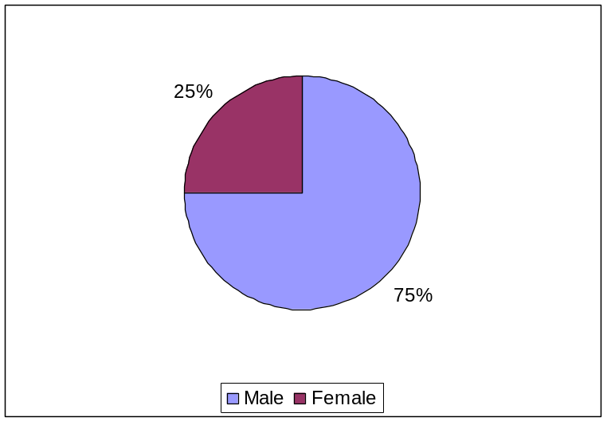

Age Breakdown of Management Sample

As expected given their role, the overwhelming majority of manager respondents were between 40 and 59 years old (98%). Figure 53 presents a more detailed breakdown of the managers’ age groups. Interestingly, 96 out of the 134 managerial respondents were over 50 (72% of the sample).

Figure 53: Age Breakdown of Management Sample
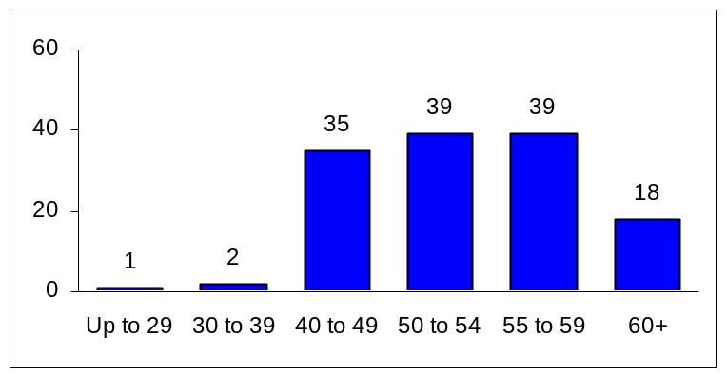

Breakdown of Management Sample by Length of Service in the Commission

Not surprisingly, Table 20 shows that the vast majority of the managers (86%) had been working in the Commission for more than 10 years.

Table 20: Managers' Length of Service in the Commission
 | %
Less than 2 years | 4.5
2 to 5 years | 1.5
6 to 10 years | 8.2
11 to 15 years | 17.2
16 to 20 years | 20.1
21 to 25 years | 25.4
26 to 30 years | 14.9
31 to 35 years | 5.2
Over 35 years | 3.0
Base (n) | 134

Breakdown of Management Sample by Length of Service in current Managerial Job

As Table 21 shows 30.6% of respondents have been a manager for 6 to 10 years, with 22.4% holding a managerial post for 2 to 5 years.

Table 21: Length of Time of Being a Manager
 | %
Less than 2 years | 14.9
2 to 5 years | 22.4
6 to 10 years | 30.6
11 to 15 years | 16.4
16 to 20 years | 10.4
21 to 25 years | 2.2
26 to 30 years | 2.2
31 to 35 years | 0.7
Base (n) | 134

Breakdown of Management Sample by Nationality

Figure 54 shows the breakdown of the management sample by nationality.

Figure 54: Management Sample by Nationality
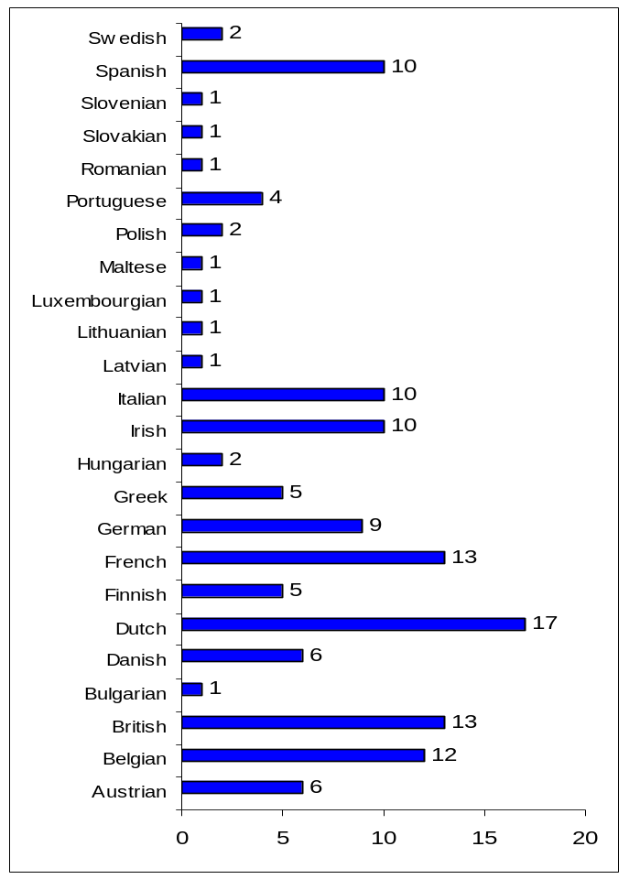

Breakdown of Management Sample by DG

Of the 134 valid management responses only 43 gave the DG of a particular manager (see Figure 55).

Figure 55: Management Sample by DG (N=43)
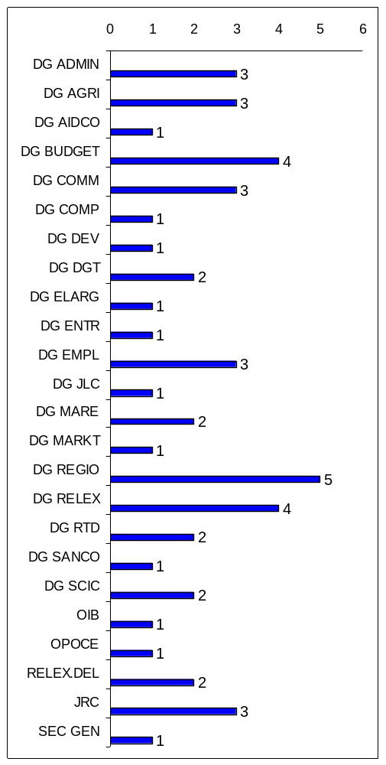

Breakdown of Management Sample by Place of Assignment

The majority of managerial responses (78%) came from managers based in Brussels (see Figure 56). Among the 21 “Other” responses, 12 were from delegations.

Figure 56: Managers' Place of Assignment
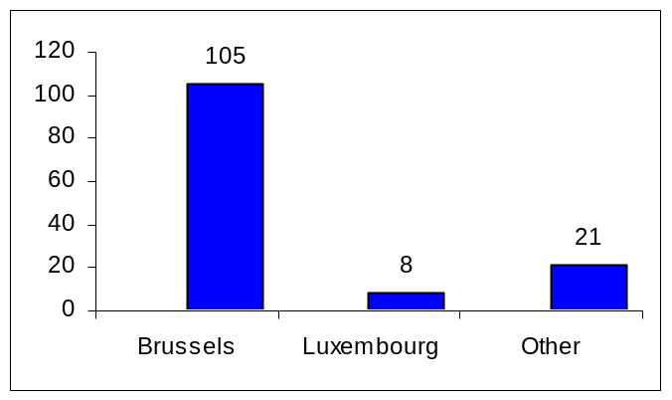

Management’s Skills, Satisfaction and Motivation/Involvement

50+ Managers’ Own Competencies

Managers over 50 (96 in total) were asked whether their skills were different from managers in other age groups. As shown in Figure 57, although over half of them (54%) felt that there was no difference in their particular skillset, almost one third of them believed that their skills were indeed different.

Figure 57: 50+ Managers' Perception as to whether their Skills are
different from Managers in other Age Groups
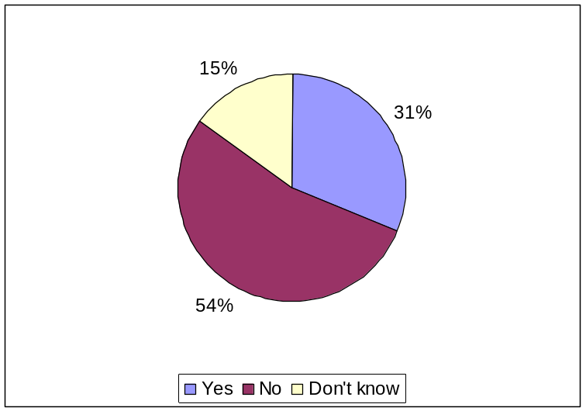

Figure 58 shows the 50+ managers’ perceptions as to whether their skills were different from managers in other age groups, broken down by their age group.

Figure 58: 50+ Managers' Perception as to whether their Skills are different from Managers in other Age Groups (by Manager Age Group)
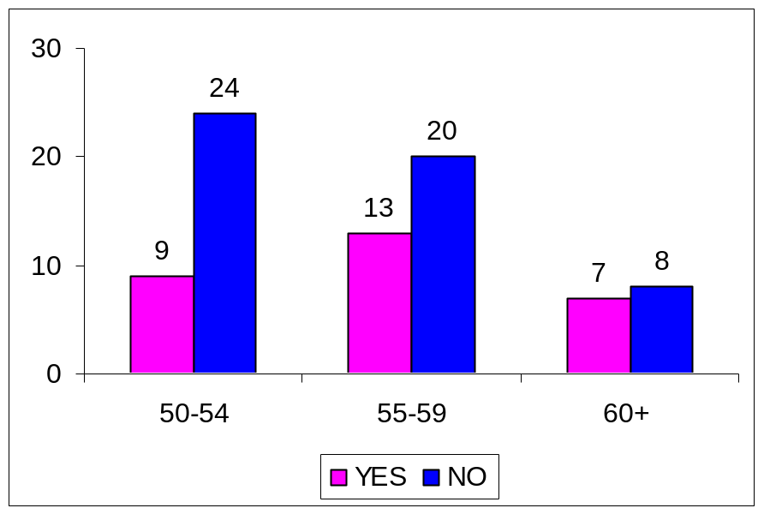

The main areas where older managers felt that their skills were different can be summarised as follows:

- More and varied experience (than younger managers)

“Older managers have more experience” (50+ Manager)

“The experience makes the difference with younger colleagues”
(50+ Manager)

“Comparison with younger group: longer and deeper experience, cumulative knowledge, memory of the past and lessons learnt from experience”
(50+ Manager)

“Davantage d'expérience en matière de multiculturalisme. Meilleures connaisssances de la maison et de ses procedures”
(50+ Manager)

“I have a longer, more diverse work experience than people who are younger” (50+ Manager)

- Greater maturity

“more mature and with greater knowledge of how to go about in the EC”
(50+ Manager)

“maturité; meilleures capacités interpersonnelles; patience”
(50+ Manager)

- Better judgement

“Pour les fonctions d'encadrement: expérience varié, maturité, recul et jugement sont un plus dans la tranche 50 ans et plus”
(50+ Manager)

“…capacité de jauger correctement les risques…” (50+ Manager)

- Good and more extended networks

“Réseau plus étendu” (50+ Manager)

“le réseau de contacts permettent une action plus économe de moyens”
(50+ Manager)

- Better at managing human resources

“L'expérience, les facultés de management, la gestion des ressources humaines, la culture Commission, ...augmentent avec l'âge”
(50+ Manager)

“In relation to younger groups: I have more experience in the COM and in particular more experience in "managing" people, in general a better overview and a stronger sense for the importance of the team to achieve results”
(50+ Manager)

“more respectful of people and diversity; more understanding and empathy than younger managers”
(50+ Manager)

“les jeunes managers ont trop souvent la tendance à négliger les aspects humains et les facteurs de motivation personnelle”
(50+ Manager)

50+ Managers’ Own Involvement and Motivation

Managers over 50 were asked how involved/committed they felt. As Figure 59 shows the overwhelming majority of managers over 50 (95.8%) feel involved or very involved.

Figure 59: 50+ Managers' Level of Involvement
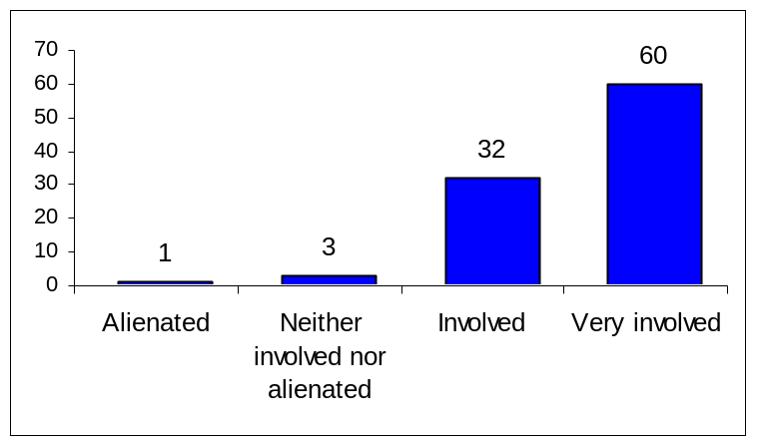

Managers over 50 were also asked whether they felt the same commitment as in the past. As Figure 60 shows, well over two thirds (77%) of those managers who are over 50 felt the same commitment as before. Of the 17% (16 managers in total) who felt that their commitment had changed over time, 12 (75%) indicated that they now felt less committed than in the past. The main reasons mentioned as to why their commitment was now lower included (i) the perceived lack of vision in today’s Commission combined with (ii) the changed nature of the work (more focus on administration rather than policy development. The third most common reason was an increase in their workload and/or responsibilities. Interestingly, very few of those managers who felt less committed attributed this decrease in feeling blocked in their career progression by younger managers.

Figure 60: 50+ Managers' Responses as to whether they feel the same
Commitment as in the Past
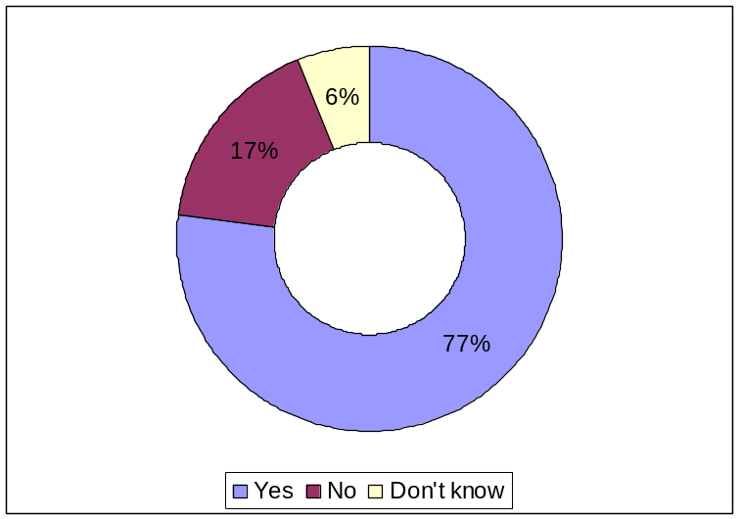

It is worth underlining the strength of feeling concerning the (real or perceived) changed Commission’s vision and culture that our survey has uncovered among both staff and management. Specifically, managers tend to think that today’s Commission (as a result of well documented historic reasons, e.g. the fall of the Sander Commission), is lacking vision, ambition and a pioneering spirit that used to characterised it in the past. Crucially, this development is ranked at the top among the reasons why they feel less committed than in the past.

“la nature du travail actuel - manque d'ambition de la Commission et sa marginalization”
(Manager)

“Absence de grands projets européens” (Manager)

“the Commission is loosing sight of his original mandate. Internal and external actors are working to reduce its competence (more temporary staff, less paid staff, but most of all less motivated) and, in the longer term, its capacity to act as a guardian of the Treaties”
(Manager)

As mentioned in Section 6.2.2 such management views were shared with a significant proportion (30.5%) of staff respondents. Feedback from all three focus groups (exploratory, AD and AST) held as part of this study also pointed to such feelings of nostalgia, which were further confirmed by anecdotal evidence provided to us by HR staff, especially SCOP and ReLOPs.

Linked to this is a (real or perceived) greater bureaucratisation and “proceduralisation” of the Commission internal operations and relations combined with an increased and more complex workload.

“Pour une bonne partie cela est lié au sentiment que l'UE est moins dynamique que par le passé (années 1985-1995) mais surtout qu'elle est devenue trop axée sur des questions de gestion et de bureaucratie”
(Manager)

“augmentation de la lourdeur administrative et de la complexité du travail”
(Manager)

“Less scope for initiative and policy development”` (Manager)

Again such views were also reflected among staff either surveyed on-line or interviewed in our focus groups.

“The focus on technical and procedural rigour instead of real policy stifles the knowledge and skills that could be brought to bear”
(50+ Staff)

The Commission needs more and more staff on procedures and logistics with less experience in policy development”
(50+ Staff)

“The Commission has also changed in size and in scope of activities. I think that we should rethink most of the functions and roles in this organisation, which have become far too bureaucratic and rigid”
(50+ Staff)
Figure 61 shows the age breakdown of managers’ responses as regards the evolution of their level of commitment over time.

Figure 61: 50+ Managers' Responses as to whether they feel the same
Commitment as in the Past (by Manager Group)
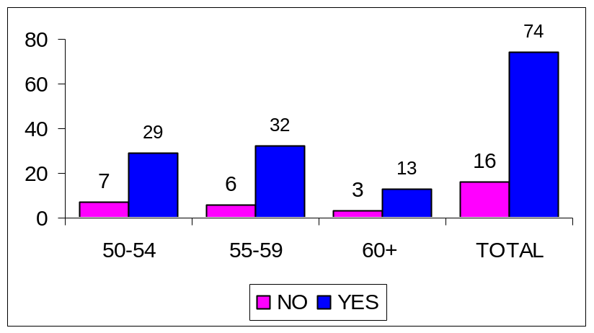

Of the 16 managers who were over 50 and felt that their commitment had changed over time, 12 (25%) felt less committed than in the past (see Figure 62).

Figure 62: 50+ Managers' Responses as to whether they feel the same
Commitment as in the Past (By Manager Age Group)
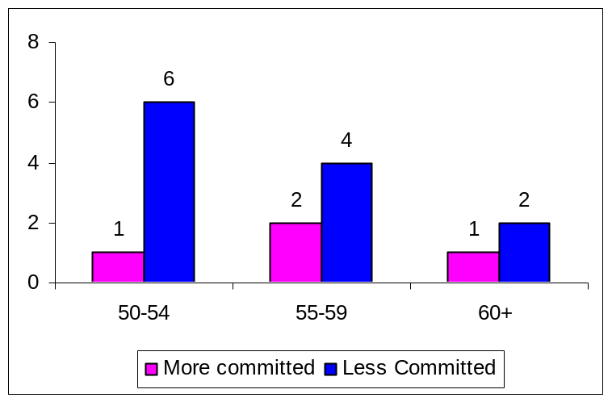

All managers were asked to select the main motivating factors for them. Figure 63 presents the whole range of these factors as selected by managers in order of preference.

Figure 63: Managers' Motivation Factors
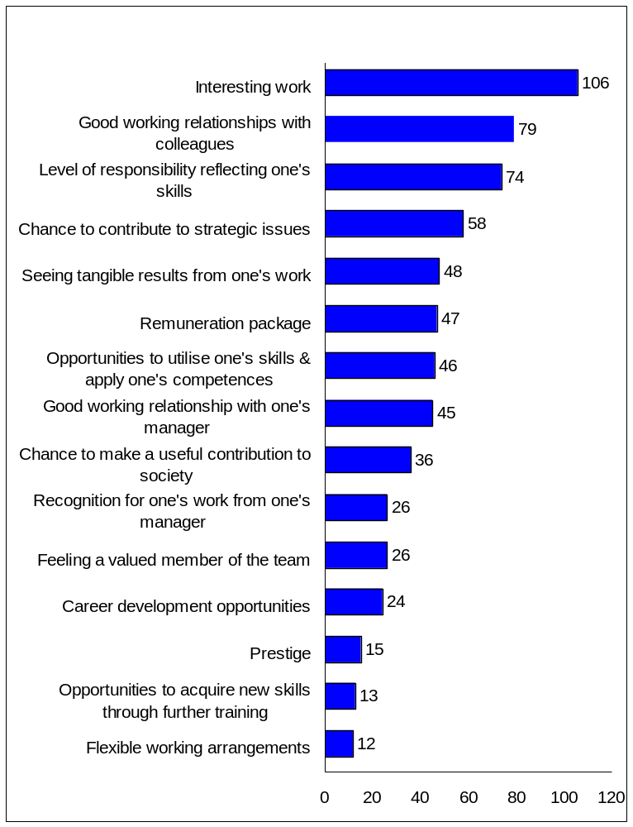

Management’s Attitude towards Older Commission Staff

In line with staff, 45% of whom stated that older staff, compared to younger staff, are not treated equally in the Commission (see Section 8.4.2.2), 53% of managers also held the same view. Below we present some illustrative managers’ comments on how such an unequal treatment may manifest itself.

:
“Blocage au profit de plus jeunes” (Manager)

“dans le cadre des vacances d'emploi on préfère en général la tranche plus jeune et expérimentée 30-45 ans”
(Manager)

“Younger staff preferred during job interviews” (Manager)

Interestingly, managers felt that, in some cases, younger candidates were more likely to be successful for managerial positions.

“YOUNGER CANDIDATES HAVE BEEN MORE SUCCESFUL”
[emphasis in original] (Manager)

Views such as the above about the current (real or perceived) management attitudes and behaviour towards older Commission staff were also stated by different types of informants during scoping. Crucially, such informants saw management attitudes to staff aged 50+ as opposed to younger staff as key to the issue of neglect and de-motivation of these staff groups.

“50+ people are discounted as team leaders of young teams…There is an idea that young people need young leaders – as if people want clones of themselves. Some empathy is useful. But I feel some Heads of Unit want peace in the team and not competitors. And this is not necessarily productive.”
(HR Staff)

“Before attending this Chambre d’Ecoutre one had to fill in a form in which he/she could name three Units in the new organigram where he/she felt they could make a useful contribution. I myself put seven Units on my application. I was then asked to join another Unit that was not on this seven. When I complained, my Director told me, ‘Well it did not matter where you were going because you are about to retire’ “
(50+ Staff)

“Heads of Unit think that I am going to retire soon, so they are reluctant to employ me when they can recruit a younger person who will be with them longer.” (50+ Staff)

When asked about the reasons why mobility among older Commission staff tends to be lower, managers put forward a number of explanations. Among the most popular ones was the perception that younger officials are more productive and able to cope with an increased workload.

“People prefer to recruit younger officials in the expectation of higher productivity”
(Manager)

“WITH HIGHLY INCREASED PRESSURES AND WORK LOADS, YOUNGER STAFF BECOME MORE PERFORMING AND ARE GIVEN PRIORITY” [emphasis as in original]
(Manager)

“WITH INCREASING WORK LOADS AND STRESSES, OLDER STAFF WILL HAVE MORE AND MORE DIFFICULTIES TO COPE WITH THEM”
[emphasis as in original] (Manager)
“Older staff is often seen as not being able to adapt to a changing environment, or to take innovative initiatives”
(Manager)

“[older staff are] Less ready to take up new challenges” (Manager)

Linked to the above is a fear that, due to older staff’s lower mobility, if they recruit such staff the latter will not be able to leave in due course.

“the chances on the mobility market are more limited as managers fear that "they may get stuck" with older staff so they will more cautious to hire them” (Manager)

“Older staff tend to be less prone to mobility, which reduces their opportunities. Where older staff are available to change, they can profit from similar opportunities than others” (Manager)

Other managers commented that as one comes nearer towards the end of their career (as is the case for some older Commission staff), one has fewer career opportunities offered to them.

“Because there are obviously fewer options open for the development of a career which is approaching a time-limit” (Manager)

“Promotion/further career development opportunities are significantly less for older staff” (Manager)

“moins d'opportunités de mobilité horizontale intéressante” (Manager)

“…younger staff enjoy more horizontal mobility…” (Manager)
(Manager)

“Older staff tend to have an excessively heavy workload which limits possibilities for training or mobility…” (Manager)

Difficulties in mobility that can be ascribed to lack of relevant expertise were also mentioned (as a distinct departure from the past when the Commission was more in favour of generalist skills):

“There is a strong tendency to restrict staff to their area of experience/expertise. So - for example - Finance personnel have difficulty in transferring to other areas of activity such as HR or policy areas”
(Manager)

Managers also alluded to the well-documented mobility difficulties between DGs:

“There are two key aspects, training and mobility. While there seems only marginal disadvantage in terms of training, recruitment to a different DG seems very difficult for an older person”
(Manager)

At a more general level, it was also pointed out that:

“Dans la réalité, toutes les opportunités sont là mais elles ne sont pas toujours offertes par l'encadrement (recrutement ou formation)”
(Manager)

Effectively Managing Staff Aged 50+

Managers’ Understanding of Staff Motivation linked to different Life Stages

Managers were asked how well they felt they understood the fact that at different life stages one is motivated by different factors, which should be taken into account when managing staff. As Figure 64 shows, the overwhelming majority of managers (74.7%) reported that their own understanding of how staff motivation and related factors can change over time is either good or very good.

Figure 64: Managers' Understanding of Life-Stage Related Staff Motivation
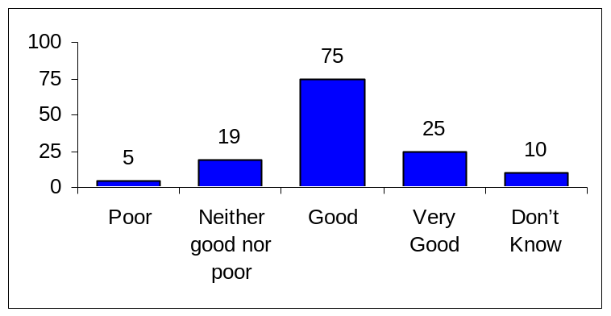

This shows a strong belief among managers about their ability to understand and address the different motivating factors that assume relative greater importance at different stages of one’s life (and career). That said, a much lower proportion (30.1%) of managers agreed with the statement that the Commission has managers with the necessary skills for managing an age diverse workforce. So obviously (and not surprisingly) managers rated their own personal level of understanding of and competence in managing age diversity much higher than that of the organisation as a whole.

This contrasts with both staff and HR responses about managers’ ability to understand and manage age diversity in the Commission (see Figure 65). Specifically, over half of both staff over 50 (52.1%) and HR staff (60.9%) stated that they did not believe that managers at the Commission had the necessary skills and competences for managing an age diverse workforce. The proportion of HR staff should be treated with caution given the low number (23) of survey responses from that group.

Figure 65: Perceptions about Commission Managers' Ability to Manage an Age Diverse Workforce (By type of Respondent)
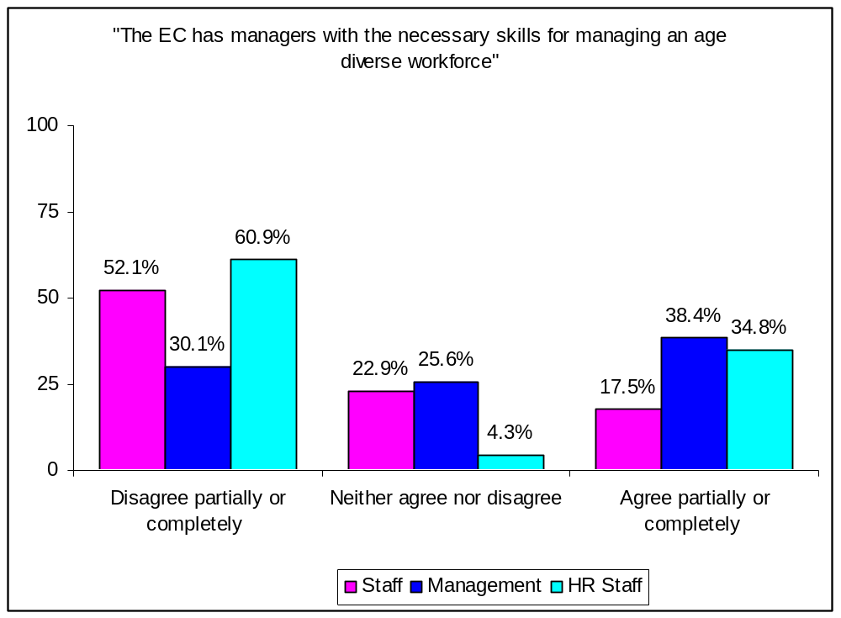

However, even with this caveat, Figure 65 reflects observations made by both older Commission staff and HR staff during our scoping exercise for this study. As was pointed out, many managers – and especially middle managers and/or those who were younger – did not possess the necessary skills or experience to deal with staff in the older age groups. This should be of particular concern since such lack of skills among managers, especially middle managers which are most involved in man-management, can result in alienating older staff, thus depriving their Unit and the Commission as a whole from making optimum use of their extensive knowledge and expertise.

“La Commission devrait veiller à ce que son personnel d'encadrement ait des qualités d'humanisme, ce que l'on trouve de moins en moins”
(50+ Staff)

“The Commission should make sure that middle management has the competences to be so, in particular that they have management competences and preferably also human/human relations ones. This is not the case today. Also it should make a 360° evaluation of middle management (also asking the opinion of their staff)”
(50+ Staff)

Such inability to manage age diversity can also lead managers to label/stereotype some older staff as ‘difficult’, which in turn can exacerbate their proper utilisation and mobility difficulties.

“[Middle] Managers and Senior Managers in the Commission are quite unrealistic in their self-assessments. All of them say in Leadership and Management Training that they are good at managing difficult people. But in truth they are not. … Trying to sell these (50+) ‘difficult’ people to Heads of Unit is extremely difficult, even if an additional post is offered.”
(HR staff)

“Younger staff with less skills than older staff is advantaged because prejudice/stereotypes prevent impartial assessment of skills”
(50+ Staff)

“There are probably so called managers that prefer younger staff because they are "easier" to handle”
(50+ Staff)

The above discussion pegs the question of both management selection and training. Although progress has been made in relation to improving the recruitment and selection procedures for both senior and middle management, findings such as those reported above point to the need for a review of the management development programmes with particular reference to people management, including the management of an age diverse workforce.

“…at the moment management courses are offered to Heads of Unit after they have been (promoted) and not before. As a result, Heads of Unit are not screened for people management skills in selection procedures …At the moment Heads of Unit are in a ‘sandwich’ position. There are no people management skills among Heads of Unit and there seems to be not time to develop such skills. Having a good Head of Unit is a case of hit and miss in the Commission.”
(HR Staff)

Managerial Challenges when Managing Older Staff

To a large extent, the challenges faced by Commission managers in dealing with older staff are similar to the ones reported in both academic and business circles. So the second most commonly managerial challenge, selected by just about half of managers (49.3%), was the (perceived) difficulty of some older staff to adapt to and cope with a rapidly changing work environment. Such a perception is in line with what managers report as a key challenge in other academic and empirical studies. Similarly, the third and fourth most commonly challenges selected by managers are also is in line with what managers in other organisations consider to be key issues as regards older staff. Specifically, 44% managers reported that compared to younger staff, some older staff may, sometimes, appear less enthusiastic and motivated, while 38.6% stated that some older staff may be inflexible as regards their assigned tasks.

Crucially, as shown in Figure 66, the most common managerial challenge (selected by 50.7% of managers) may apply to the Commission in particular, since it is closely related to its distinctive culture, which has tended to associate career success with holding a managerial post. Indeed, this aspect of the Commission culture has been cited by the Executive Summary of the Career Guidance Officers' Working Group on the Management of Commission Senior Staff as one of the main reasons of older staff’s relative frustration and was repeatedly mentioned to us during the scoping phase. Closely linked to this is the fifth challenge (selected by 34.3% of managers), i.e. the fact that some older staff seem nostalgic about the past (“the good old days” syndrome). Again such nostalgia among older Commission staff was anecdotally cited to us during scoping as a possible de-motivating factor, while crucially such feeling were cited as being among the main reasons for lower commitment among older staff. Specifically, of the 252 older staff who said that they are now feeling less committed than in the past, 30.5% stated that they felt that the Commission is not the pioneer organisation it used to be”, while 24.6% missed the Commission’s working environment of the past.

Figure 66 presents the full range of managerial responses as regards the challenges they face when managing older staff.

Figure 66: Management Challenges when Managing Older Commission Staff
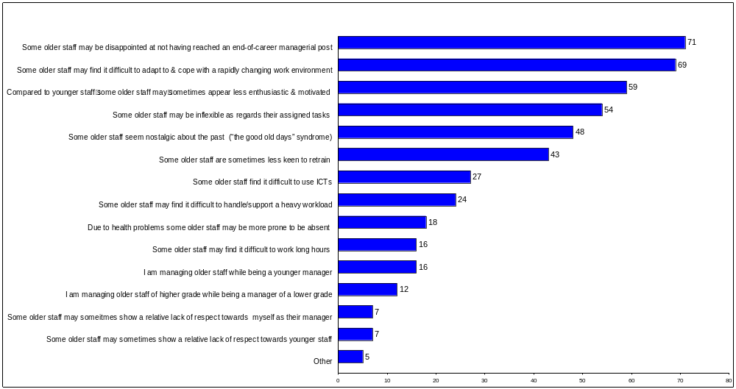

Whether Managers have dealt with Age-Related Problems

Managers were asked whether they had dealt with an employee problem that was solely age-related. As can be seen from Figure 67 the vast majority of managers (77%) reported that they had not dealt with a solely age-related employee problem. However, almost one fifth (19%) of managers stated that they had dealt with such a problem.

Figure 67: Managers' Responses as to whether they have dealt with
a solely Age-related Problem
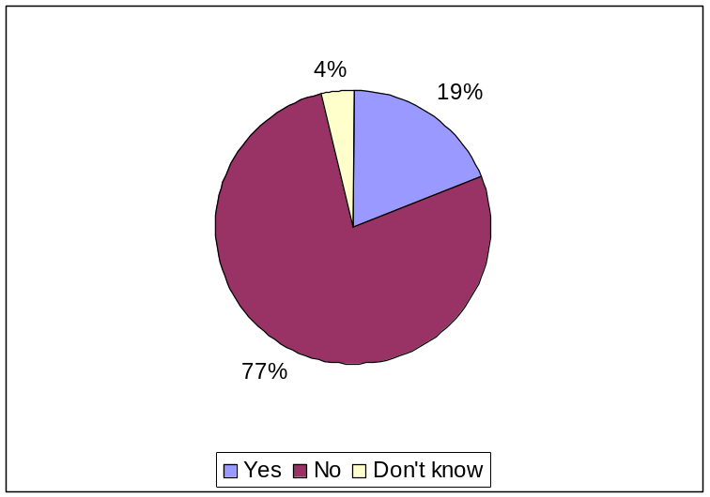

The main age-related problems that managers had to deal with concerned (perceived) lack of motivation among older staff, especially those over 60 and inter-generational issues. Specifically, 9 out of these 25 managers (36%) mentioned that motivation of older Commission staff was an issue for them.

“démotivation et amertume lors des toutes dernières années, au delà de 60 ans” (Manager)

“Motivation problem expressed through high level of absenteeism”
(Manager)

“Manque de motivation et baisse de productivité...” (Manager)

“I had to deal with a number of frustrated colleagues, who were unable to adapt to change because of their age”
(Manager)

“in two cases, near total absence of motivation…” (Manager)

The above comments notwithstanding, a number of managers that had to deal with an age-related problem put the lack of motivation of older staff in a wider context. For example, in some cases the forced mobility for staff nearing retirement was seen as causing problems.

“forced mobility close to retirement until now COM is not handling the mobility issue in the most intelligent way - regret to say that it often led to big frustration and demotivation” (Manager)

In terms of inter-generational issues, these usually related to older staff being managed by younger managers or team leaders.

“lors de ma première nomination comme chef d'unité, un administrateur senior (20 ans plus agé que moi approx) me rendait la tâche difficile”
(Manager)

“A colleague nearing retirement having a young official as team leader”
(Manager)

Significantly, this difficulty related to inter-generational relations tallies with the majority to staff responses (either surveyed or interviewed) on the subject.

“Because I'm passed by my younger superior together with a younger technician and often I see clearly, that I would have more experience and knowledge but I'm not consulted in solving the problem(s)...”
(50+ Staff)

Interestingly, when managers asked whether they themselves had experienced age discrimination, 13.6% responded affirmatively (see Table 22). That said, the overwhelming majority of managers (78.8%) have not experienced age discrimination.

Table 22: Managers' Personal Experience of
Age Discrimination
 | %
NO | 78.8
YES | 13.6
Don’t know | 7.6
Base (n) | 132

Of the 18 managers who have personally experienced age discrimination, as Table 23 shows, just about two thirds (73%) of them were over 50 (see Table 23).

Table 23: Managers' Personal Experience of Age Discrimination (by Manager Age Group)
 | up to 49 | 50-54 | 55-59 | 60+
 | % | % | % | %
NO personal experience of age discrimination | 76 | 87 | 77 | 71
YES to personal experience of age discrimination | 14 | 8 | 15 | 24
Don’t know | 11 | 5 | 8 | 6
Base (n) | 37 | 39 | 39 | 17

Interestingly, when asked about the main reasons why managers themselves having experienced age discrimination, opinions were split at to whether one was considered too young or too old for the job. Specifically, 4 out of the 18 managers felt that they had been discriminated against due to their younger rather than older age (“too young for job or for promotion to a higher level”).

“by being often seen as "too young for the job"!” (Manager)

“considered too young for promotion to higher level” (Manager)

“[considered too young] In applying to Director's position” (Manager)

“When in junior posts, the younger staff are preferred. When in senior posts, being young can be a disadvantage”
(Manager)

Among such respondents the feeling is that the Commission’s promotion system is based on seniority (as opposed to merit and performance). In a similar vein, they believe that by taking age into account in any promotion exercises, the Commission is inadvertently discriminating positively in favour of older staff.

“De manière générale, prise en compte de l'âge dans le cadre des exercices de promotions (discrimination positive des plus âgés au détriment des plus jeunes) et système fondé de facto, non sur le mérite et les performances, mais sur l'ancienneté”
(Manager)

“Réticence à certaines nominations/promotions en raison d'un age insuffisant...” (Manager)

On the other hand, a higher number (7 managers) stated that they had been discriminated against because they were considered to be old. Among these managers the feeling was that younger candidates are usually preferred for interviews; that the Commission’s promotion system lacks transparency; and that the current emphasis on innovation and new approaches tended to exclude them from various taskforces under the misconception that older staff have little to contribute.

“Younger staff preferred during job interviews” (Manager)

“Manque de transparence dans des promotions” (Manager)

“Being excluded from certain task forces on grounds that new, innovative approaches were needed, and older staff would not be able to deliver on that” (Manager)

“many vacancies are already "gone" i.e. not real vacancies”
(Manager)

“jobs at management level are virtually never open to fair competition”
(Manager)

“Publication of "open" jobs is too often a mirage while "preferred son" has already been pre-selected!”
(Manager)

HUMAN RESOURCES STAFF

Demographic Profile of HR Staff Sample

This section includes the survey responses of 23 HR staff and the in-depth qualitative information elicited in a number (7) of interviews with heads of HR in various DGs. As with both the staff and management sample we had to readjust the HR staff sample as regards the number of Bulgarian responses. So in the readjusted sample we have 23 instead of the original 28 HR staff responses. Since 96 questionnaires were sent to HR staff this means that the survey response rate among HR staff is 24%. However, when the seven (7) in-depth HR staff interviews are included, the response rate among HR staff rises to 31.2%. The graphs and tables relate to the online survey results, while we have incorporated the qualitative information from our face-to-face interviews in the main text, including quotes. In view of the rather small number of HR staff responses in the online survey, we also sought confirmation of these findings by comparing them to those of both management and staff.

Gender Breakdown of HR Staff Sample

As Figure 68 shows, of the 23 HR staff who responded to the survey, 10 (43%) were male and 13 (57%) female. Of the seven (7) HR staff that we interviewed face-to-face, five (5) were male and two (2) were female.

Figure 68: Gender Breakdown of HR Staff Sample
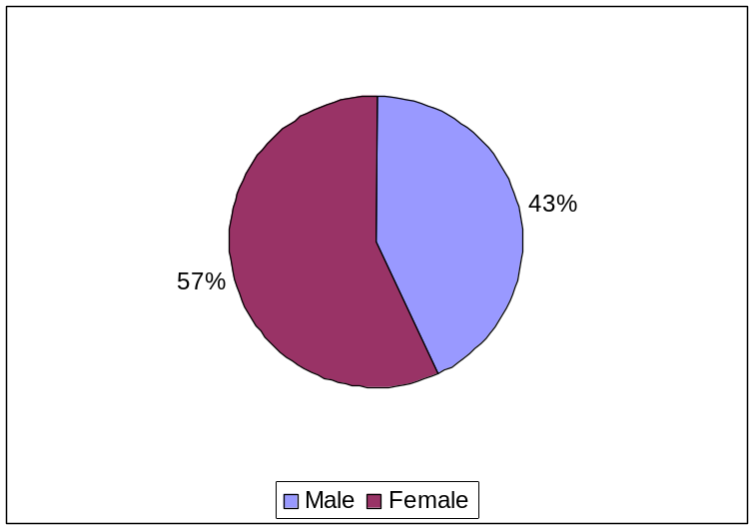

Age Breakdown of HR Staff Sample

As Figure 69 shows the age of most (60.9%) HR staff was within the 40-49 age bracket, followed by those in the 50-54 group (26.1%).

Figure 69: Age Breakdown of HR Staff
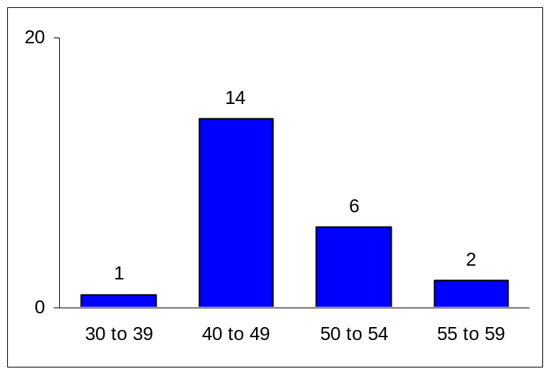

Breakdown of HR Staff Sample by Length of Service in the Commission

Over half (52.2%) of the HR staff have been working in the Commission between 2 and 10 years (see Table 24).

Table 24: HR Staff's Length of Service in the Commission
 | %
2 to 5 years | 26.1
6 to 10 years | 26.1
11 to 15 years | 21.7
16 to 20 years | 8.7
21 to 25 years | 8.7
26 to 30 years | 4.3
31 to 35 years | 4.3
Base (n) | 23

Breakdown of HR staff Sample by Length of Time in Working in HR in the Commission

As Table 25 shows the majority (60.9%) of the HR staff have been working in HR in the Commission between 2 and 10 years.

Table 25: HR staff's Length of Time of Working in HR
in the Commission
 | %
Less than 2 years | 4.3
2 to 5 years | 34.8
6 to 10 years | 26.1
11 to 15 years | 13.0
16 to 20 years | 13.0
21 to 25 years | 4.3
26 to 30 years | 4.3
Base (n) | 23

Breakdown of HR Staff Sample by Nationality

The breakdown of the HR staff sample by nationality is shown in Figure 70.

Figure 70: Breakdown of HR Staff Sample by Nationality
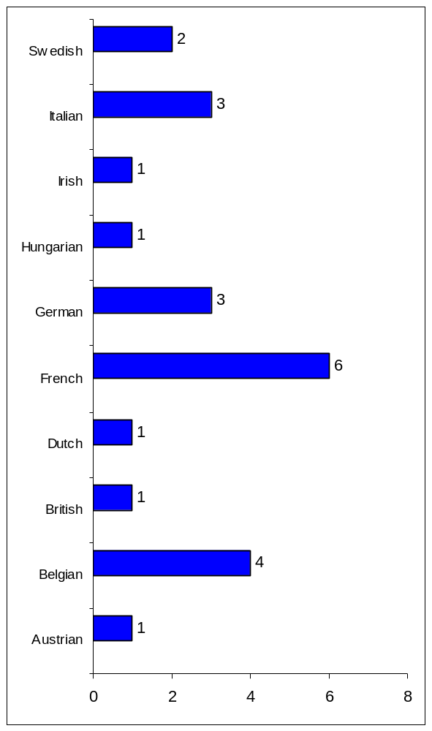

Breakdown of HR Staff Sample by Place of Assignment

As Figure 71 shows the vast majority (78.3%) of HR staff are based in Brussels. Similarly, all seven (7) HR staff interviewees were based in Brussels.

Figure 71: HR Staff's Place of Assignment
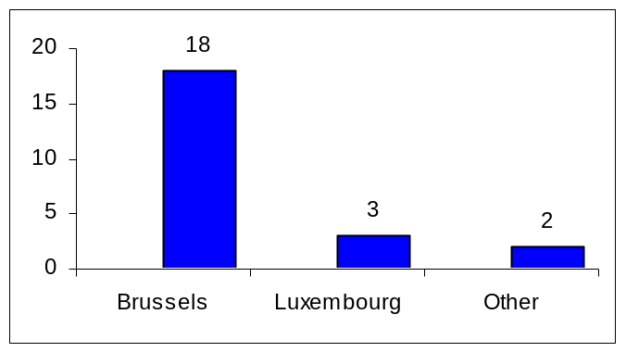

HR Staff’s Skills, Activities and Knowledge

HR Staff’s Familiarity with Life Course Approach to Managing Human Resources in the Commission

HR staff were asked about their familiarity with the life course approach to managing human resources. As shown in Figure 72, HR staff were evenly split between those who are familiar with this approach (44%) and those who are not (43%).

Figure 72: HR Staff's Familiarity with Life Course Approach to HR
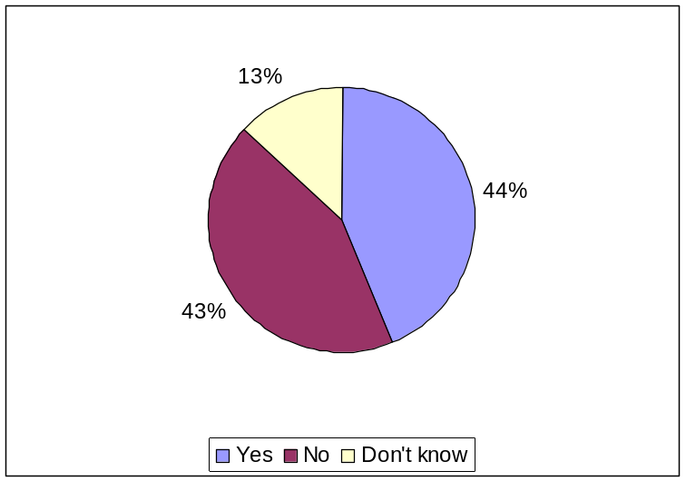

The HR staff’ own understanding of how one’s motivation changes at different life stages, which means that the range and type of motivators have to be appropriately adapted to one’s particular life stage seems to be variable (see Figure 73). Specifically, half (50%) of HR staff stated that they had a good understanding of the life stage motivation model, compared to 27% who were neutral and 9% whose understanding was poor.

Figure 73: HR Staff's Understanding of Staff different Life-Stage Related Motivation
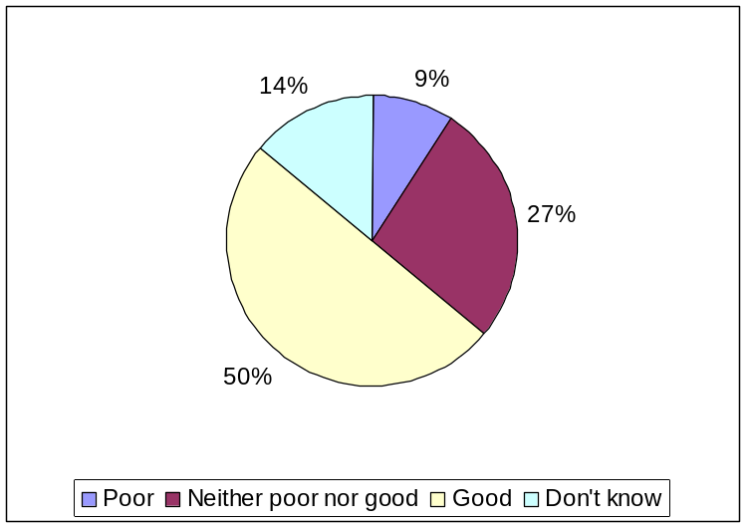

HR Staff Role and Function

The vast majority (91%) of HR staff saw and advised clients (see Figure 74).

Figure 74: HR Staff's Responses as to Whether they See and Advise Clients
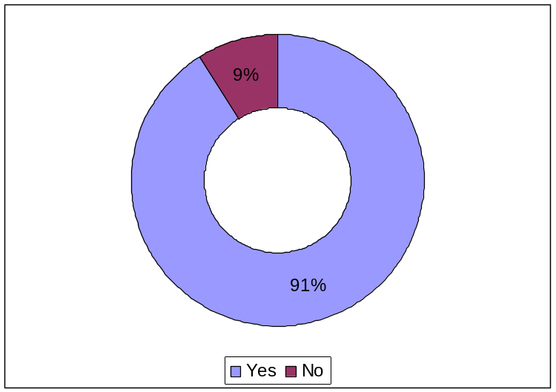

HR staff were also asked about the three main age groups that tend to consult them. As Figure 75 shows younger staff (within their 30s and 40s) are among the largest groups that consult HR staff, with older staff being the third largest group. The 2006 Executive Summary of the Career Guidance Officers' Working Group on the Management of Commission Senior Staff also reported that those clients over 50 who consulted them came in third position after the 40-49 and 30-39 age groups. Even more, on figured provided to us by SCOP between January 2004 and March 2007, the second largest group to seek career guidance and advice from SCOP were aged over 50 (264), after those between 40-49 (432), and slightly ahead of the 30-39 age group (248).
Figure 75: Main Client Groups which Consult HR Staff (By Age)
6
3
2
1
0
10
20
30
up to 29
50+
30-39
40-49

HR staff were asked about the main areas where they see and advise clients. Figure 76 presents the entire range of responses provided by the HR staff.

Figure 76: Main Areas where HR Staff See and Advise Clients
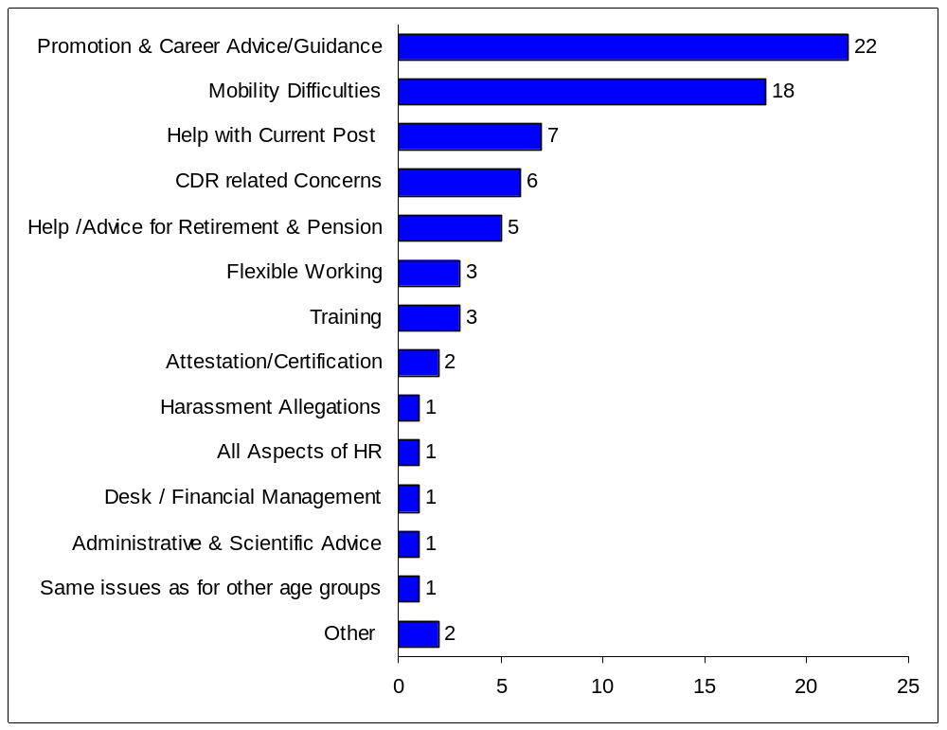

Whether HR staff have dealt with Age-Related Problems

HR staff were asked to describe the issues about which they are consulted by their older clients. As Figure 77 shows, the main issues for older clients that consult HR staff were difficulties in internal mobility, closely followed by feelings of lack of recognition by management and of their skills and competencies being underutilised.

Figure 77: HR staff's Responses about the Main Issues of their 50+ Clients
10
13
14
15
0
4
8
12
16
Lack of
professional
development
opportunities
Feeling that
their skills &
competences
are being under-
utilised
Lack of
recognition by
management
Difficulty in
mobility to other
jobs

Figure 78 presents the whole range of issues about which older Commission staff consult HR staff.

Figure 78: HR staff's Responses about their 50+ Clients' Issues
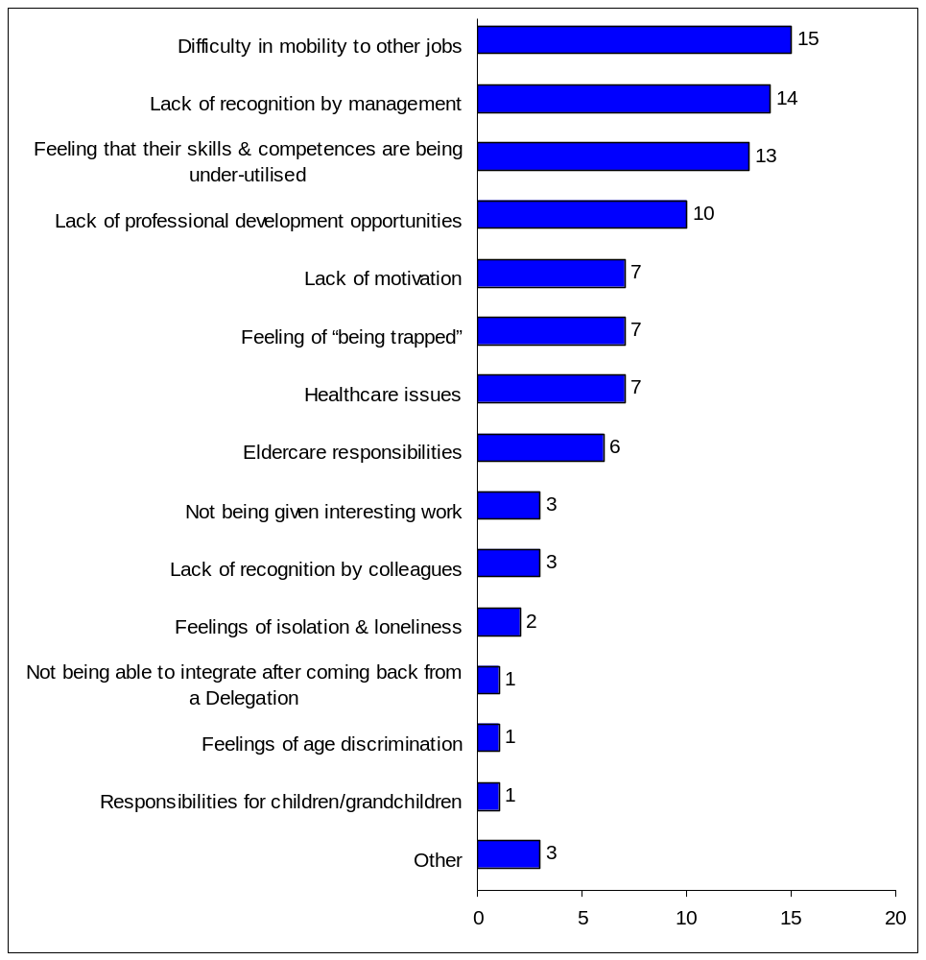

HR staff were asked how often they have dealt with a formal grievance concerning age discrimination of older staff. As Figure 79 shows, the overwhelming majority (87%) of HR staff have never dealt with such a formal grievance, as opposed to 13% who had faced such a situation a few times.

Figure 79: How often HR Staff have dealt with a Formal Grievance
concerning Age Discrimination of Older Commission Staff
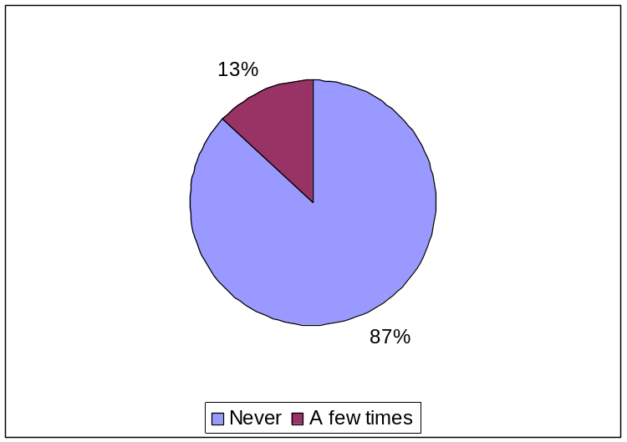

HR staff were also asked how often they have dealt with older staff complaining that they were being harassed due to their age. As Figure 80 shows well over two thirds (72%) of HR staff had never faced such a complaint as opposed to 5% who have often dealt with similar complaints and 9% who have dealt with age-related harassment complaints a few times.

Figure 80: How often HR Staff have dealt with Older Staff
complaining of being harassed due to their Age
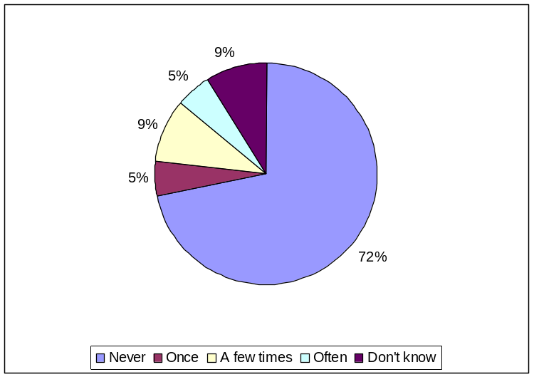

Finally, HR staff were asked whether they have dealt with an employee problem that was solely age-related. As FFigure 81 shows, the overwhelming majority (81%) of HR staff had never faced such a problem, with only 5% having dealt with an employee problem that was solely related to age.

Figure 81: Whether HR staff have dealt with a solely Age-related Employee Problem
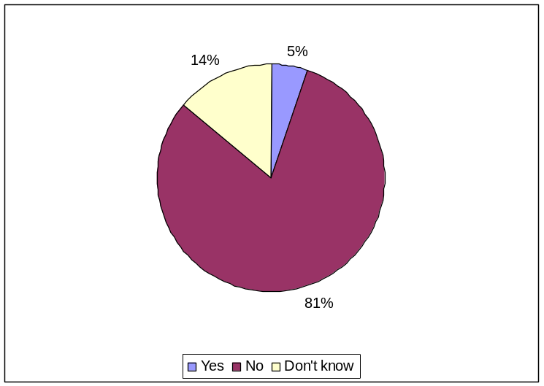

Effectively Managing Older Commission Staff

HR staff Perceptions about the Importance of Age Diversity in the Commission

HR staff were asked about the importance of age diversity as an issue in the Commission. As Figure 82 shows just under two thirds (65.2%) of HR staff felt that age diversity is either an important or very important issue.

Figure 82: HR staff’s Perceptions on How Important is Age Diversity as an Issue in the Commission
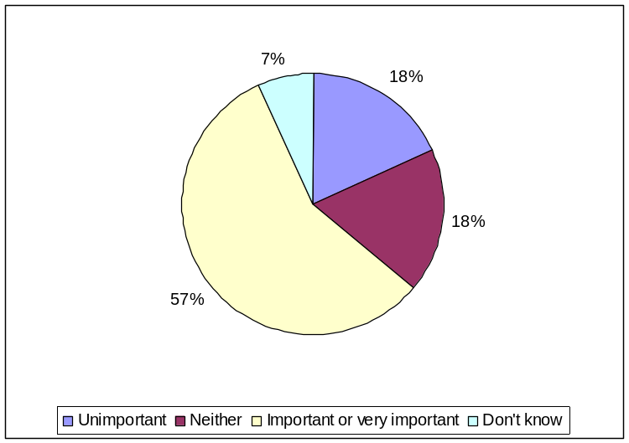
Although most HR staff consider the issue of age diversity to be important or very important for the Commission, their views as well as those of both staff and management as to how important the management of such diversity is seen by the organisation show a significant dissonance. As Figure 83 shows, for over one third of older Commission staff (39.6%), over half of management (52.3%) and just under half (47.8%) of HR the Commission does not see the management of age diversity as important.
Figure 83: Perceptions about the Importance of Age Diversity Management in the Commission
(By Respondent Group)
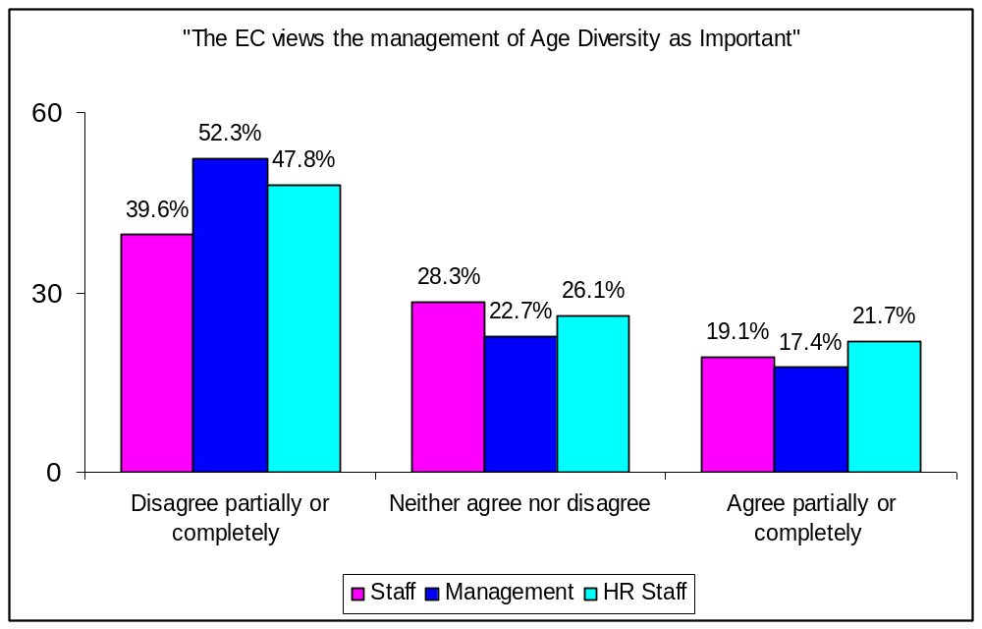

It is worth noting that some older Commission staff commented on the absence of an official Diversity (including Age Diversity) policy in the Commission as a sign that this aspect of HR management is not as yet being taken seriously by the Commission, especially in relation to the issue of age.
“Interestingly as part of 2007 being the Equal Opportunities year, one celebrated in the Commission on particular days particular aspects of equal opportunities, e.g. gender, disability, ethnicity, etc. But there was no day for age!”
(50+ Staff)

Furthermore, a large proportion of HR staff (60.8%) agreed with the statement that the Commission as an organisation values younger staff more than older staff, as opposed to 8.6% who disagreed and 30.4% who were neutral. This resonates to some extent with staff and management feedback whereby just under half of staff (47.7%) and just under one third (32.4%) of managers also agreed with this statement (see Figure 84).

Figure 84: Perceptions about Commission's Culture as regards Older vs. Younger Staff (By Respondent Group)
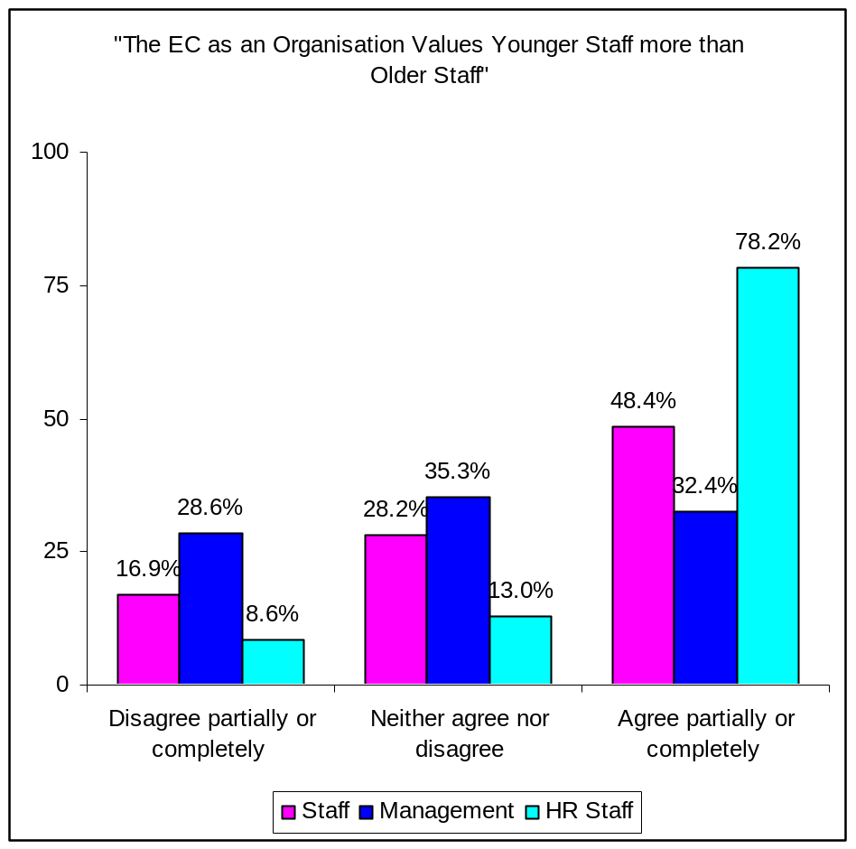

Similarly, over half (56.5%) of HR staff agreed with the statement that managers prefer to employ younger staff, with less than a fifth (17.4%) disagreeing). Interestingly, these stakeholder responses almost mirror management views, with 53.5% of managers agreeing with the statement as opposed to 19.8% who disagreed. Staff responses follow the same pattern, with 60.2% agreeing with the statement, compared to 12.6% who disagreed (see Figure 85)

Figure 85: Perceptions about Managers' Preference for Younger Staff (By Respondent Group)
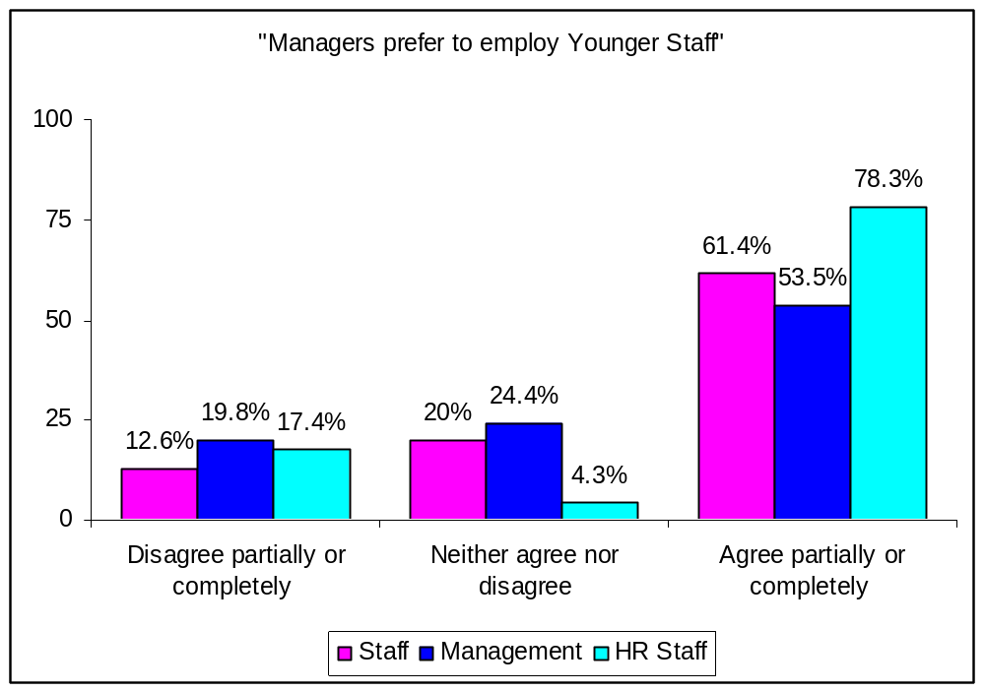

Equal Opportunities Policy
The Commission has been implementing an equal opportunities policy for a considerable period of time, with particular emphasis on gender equality. One of the main reasons for giving priority to gender equality and balance was the fact that, when compared to national administrations, women in the Commission, faced difficulties in their career progression and appointment to middle and senior management posts.
In view of this, it is not surprising that the way the Commission’s Equal Opportunities policy is experienced by older, especially male, staff to date reinforces the perception that gender takes precedence over age-related issues. As mentioned earlier in this report, such views compound the issue of the pyramidal barrier for male employees approaching management posts and can create a feeling that such staff are being discriminated against.
Interestingly, HR staff showed a relative lack of awareness of the implementing rules (specifically targeted at older staff) of the non-discrimination and equal opportunities legal base in the Staff Regulations. Specifically, 50% of HR staff were not aware as opposed to only 5% who were (see Figure 86). We feel that, although there is non-discrimination, the fact that there is not positive action policy for age, might have led some of the HR staff to respond negatively in this question.

Figure 86: HR staff's Responses as to Whether the Commission
has a Formal Policy on Age Discrimination
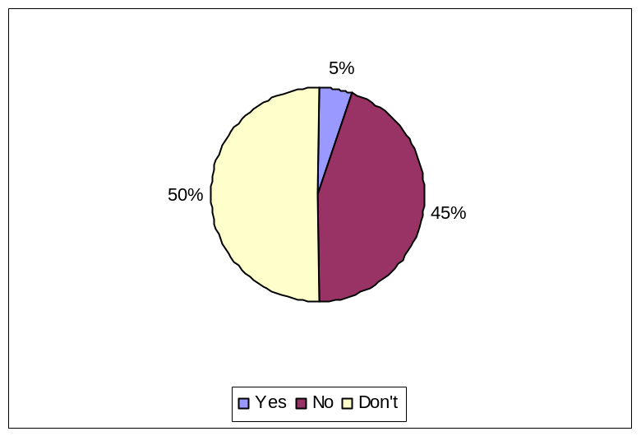
Notwithstanding the above discussion, it was also recognised that the Commission has already taken steps to address a number of “ageist” policies. The abolition of an age limit for competitions and the more “neutral” phrasing of internal vacancy notices were the examples most commonly cited in that regard.
“I am not aware of a "formal" policy on age discrimination. However, since several years the age limits for applying to open competitions have been abolished. Also, internal vacancy announcements inviting "young" officials to apply have disappeared”
(HR staff)

In addition, HR staff also felt that age-related discrimination issues were addressed in the Staff Regulations as part of the wider diversity agenda (and related training).
“I do not know of such a formal policy but I expect that it is covered under the general diversity issues”
(HR staff)

“Yes, it [age discrimination] is covered in the Staff Regulations under discrimination”
(HR staff)

On the other hand, it was commented that although age discrimination was indeed mentioned in Staff Regulations, to date the Commission had not taken any specific measures.
“Mentionnée dans le statut mais pas de mesures concretes”
(HR staff)

Finally, a number of HR staff felt the need for more formal guidance and advice as regards age discrimination.
“I think there are issues around age discrimination especially concerning mobility of 50+… and that there needs to be a central DG ADMIN Directive on what should be done”
(HR staff)

Our feedback from HR staff (both in interviews and in the survey) and review of the Commission’s documents leads us to conclude that the need for a more centralised approach in addressing age-related issues in the Commission emanates from Reform-related structural changes, not least the policy of HR decentralisation. At this point in the Commission’s history, there is little centralised HR capability at the Commission, which can act as a strategic partner for senior managers. While there remains some residual centralised resource, some capacity is also devolved to separate DGs where policy and practice in relation to issues surrounding staff aged 50+ varies.

BENCHMARKING

Factors of Successful Implementation of HR Policies for Older Workers
As part of this study we also undertook a benchmarking exercise by looking at good practice examples both in the EU and overseas, e.g. United States, Australia and New Zealand.
Before presenting these policy examples we stress caution in the way they are interpreted. Specifically, one should differentiate between the substance/content of these policies and the organisational context within which one may attempt to introduce them. In other words, although these policies look promising and have yielded benefits to a number of organisations, the way they are adopted in a particular organisational context is crucial in determining their chance of success. To this end, Walker has identified four key factors that can improve the chance of success when implementing such policies (although it can be argued that such factors are necessary for the successful implementation of any HR policy):

- backing from senior management;
- a supportive HR environment;
- commitment from the ageing workers involved;
- careful and flexible implementation.

Regarding implementation, Walker identified a further set of sub-factors:

- careful preparation;
- open and constant communication;
- the early involvement of trade unions/staff associations;
- the early involvement of older workers;
- education and awareness raising among line managers;
- a staged implementation;
- periodic assessment;
- attention to other aspects of the working environment.

The importance of management competence in managing an age-diverse workforce was also cited as a key factor for successful implementation of policies targeted at older workers.

Good Practice Examples

We now turn to these good practice policy examples that we have come across in our scanning of relevant literature. It is worth pointing out that at present most good practice examples in the field of age management come from either the Anglo-Saxon (US, Australia, UK) or Scandinavian world (e.g. Finland, Sweden). Even so, the European Foundation for the Improvement of the Working Conditions has developed a database on good age management practices across the EU.

Examples from the US
One of the best sources of information on good age management practice has been the American Association of Retired Persons (AARP). In its 2004 Report of Best Practices for Older Workers they identified four types of mature worker programmes:

- Fundamentals: policies, programmes and management practices that an informed individual regards as basic requirements when choosing a long-term job, e.g. pay, training and career opportunities, health benefits, pension schemes, etc. These fundamentals apply at all workers and career stages; however the degree of importance attached to each will vary depending on the career stage and employment relationship.
- Core Programmes: these involve job and career design, workplace design, hiring and recruiting, methods of exiting the organisation’s workforce, and formal workplace flexibility programs offering non-traditional work schedules and arrangements. They relate to job and organisation re-design, including workplace modification as well as career patterns and progression routes. In addition, the provision of different options for moving into retirement is a key element in such programmes. Phased retirement schemes are quite important in this regard and, in some cases, include the re-hiring of retirees under a different capacity. Finally, core programmes include policies and actual practices related to hiring of mature workers.
- Programmes of Significant Value: These programmes create personal and economic value but not necessarily career opportunity. They are also important in addressing the specific needs of mature workers and deal with their concerns about care-giving support, retirement security, and healthcare, including fitness and wellness opportunities. Here retirement benefits are greater than usual for one’s job classification and this go beyond the basics, including retiree health benefits and customised retirement education and planning support are highly valued by mature workers. Programmes of significant value also include formal/informal workforce flexibility practices and (limited) special purpose flexibility programmes for care-giving, e.g. eldercare responsibilities. Indeed, mature workers highly value company support for eldercare as well as informal workplace flexibility practices that provide employees with extra time off and/or flexible schedule options to care for other family members. Employee Assistance Programmes that focus on older worker issues are also part of this category of programmes. In a sense there is an overlap between programmes of significant value and core programmes, in that they can both address the same issues. That said, programmes of significant value address the issue on a smaller scale. These scaled down initiatives support but not enable job, career, and mobility options for mature workers.
- Extras: These programmes may be of great value to some people, but they do not speak to the essence of the jobs, or the employment relationship. They create nominal economic value for employees. They include retiree relations programmes, eldercare referral services, and volunteer service opportunities. In addition, they may include generic retirement education not customised to the needs of particular employee groups. As stressed, extras alone have limited value in recruiting and retaining older workers. Nevertheless, they reinforce a culture that is positive towards older workers and can support other programmes targeted at these workers.

The Table 26 overleaf describes in some detail the various types of policies/initiatives that come under these four categories of programmes targeted at older workers.

Table 26: Classification of Types of Employer Programmes aimed at Mature Workers
 | Fundamentals | Core Programmes | Programmes of Significant Value | Extras
Alternative Roles for Older Workers |  | Assigned to special projects;  Job & career redesign, e.g. flexible work options environment; job & assignment transfer opportunities; mentoring; workplace design & modification (either general or tailored), rehabilitation
Professional & Career Development |  | Major focus on lifelong learning & more career options | Work-related training; average training with some special feature for older workers; encouraging employees to upgrade their training as part of annual performance review
Mentoring & Working Together for Smooth Transition  + Talent Management |  | Programmes where experienced & newer employees work together over a period of time to preserve knowledge & build up the newer employee’s capabilities; gives important role to experienced worker | Organised programme  with effective use of  knowledge basis; helps to integrate workplace for all workers
Part-time & Flexible Work Options | Flexible Work Options | Significant formal programmes that offer non- traditional work schedules & arrangements;  Employment arrangement options which allow workers to leave regular employment but continue working in a different capacity, e.g. independent consultants. | Informal programmes  targeted to mature workers, & limited special purpose  flexibility programmes for care-giving; workplace flexibility through job sharing, paid time-off banks, flexitime (incl. total schedule flexibility), teleworking, etc.
Support for Care Responsibilities |  |  | Counselling & support for placement;  Access to additional time off on paid basis | Information only; unpaid leave
Disability Benefits | Disability Benefits
Employee Assistance Programmes (EAP) |  |  | EAP with special features for older workers
Eldercare (as part of EAP or separate) |  |  | Eldercare options with company financial support | Eldercare referral or other options without company financial support
Employee Leave Banks in Place of other Time-off Programmes |  |  | Depends on generosity; could be of value if liberal programme
Health Benefits | Health Benefits for FT employees | Health Benefits for active PT employees | Retiree Health Benefits
Hiring/ Recruiting Practices | Non-discriminatory hiring in general as required by law | Special focus on hiring older workers for a variety of jobs; Employer Partnerships with organisations who serve older people for enhanced access to potential pool | Special programmes for semi-volunteers or recruiting in locations frequented by seniors | Volunteer placement in community
Long-Term Care Insurance |  |  | Long-term care insurance with employer subsidy, or through group purchase discount  Retiree life insurance | Long-term care insurance available for voluntary purchase without group discount or employer subsidy
Retirement Security  Pensions | Basic pension benefit consistent with industry practice  Savings & other wealth accumulation programmes common in the same industry |  | Employer-provided  benefits that exceed market norms; added benefits such as catch-up contributions  Indexed benefit in defined benefit pension plan
(Flexible) Phased Retirement  Options about how to retire |  | Company offers formal  programme to enable phased retirement, either phasing out  before retirement or for (formal) rehiring of retirees. A Phased Retirement can include: (i) change in work hours, work schedule, or duties; (ii) employee being able to use accumulated assets or collect partial pension benefits to supplement reduced income form work; (iii) formal employee-sponsored programmes or arrangements established in a case-by-case basis | Informal phased retirement arrangements some of which allow employees to work reduced hours at reduced pay as they move towards retirement. In other cases, employees are allowed to retire & collect retirement benefits & are then rehired on an ad hoc, temporary or informal basis
Sickness Prevention Strategies & Wellness Programmes | Health Plan pays for reasonable diagnostic tests for FT employees | Injury prevention can lead to job requirement changes &/or work environment modification;  conditioning workers leads to reduced chance of injury  Health plan extended to PT workers | Worksite fitness facility or significant access to wellness & prevention programmes; worksite health facilities; flu shots; screenings beyond basic health benefits  Retiree health | Information & education
Rehabilitation Programmes for Disabled Employees | Some coverage of rehabilitation | Tailored programme linking specific job requirements to  rehabilitation & return to work criteria  On-site physical therapy (can be occupational or  comprehensive) | Company participation in  physical therapy at a less intense & less tailored level  Combined focus on  emotional & physical issues | Education
Rehiring Retirees |  | Organised Programme;  Recruitment from retiree pool | Ad hoc rehiring & rehiring through an outside agency
Retiree Relations Programmes |  |  |  | Retire Clubs, newsletters, periodic social events, etc.
Retirement Preparation Programmes | Basic required information about company benefit plans & how to participate in those plans |  | Personalised education; Custom counselling & planning; Informal phased retirement programmes; education on retirement-related issues, e.g. healthcare options, family-related issues; financial planning & management seminars | Added education beyond the basics, but not tailored to the needs of the individual
Service Awards |  |  | Service awards that include something of monetary value | Service awards with no significant monetary value
Employer Support for Volunteerism |  |  |  | Volunteer support programmes can help people make the transition from work into other very meaningful roles in their lives

A more recent report (GAO, 2007) on best practices for engaging and retaining older workers has also come up with a similar list of best, or rather, good practice. This list, based on the contribution of employers, unions, federal agencies, experts, academics and advocates in the field is made up by a variety of best practices, including offering more flexible work arrangements and adapting job design to suit the needs of older workers. In addition, it stresses the need for the right mix of benefits and incentives required to attract older workers. Finally, in line with other reports, it highlights the need for all employees, especially older ones, to acquire additional financial literacy skills so as to ensure they have a realistic plan for retirement security. Crucially, along with others before, this report confirms the importance of flexibility in recruiting and retaining older workers. In order to effectively engage older workers, the GAO report suggests implementing new recruiting approaches, workplace flexibility, the right mix of benefits and incentives, financial literary education, and consistent performance management systems. Moreover, it warns against designing a “one-size-fits-all” approach, noting the significant differences not only among employers and employees, but also among older employees themselves. It particularly stresses the need for flexible work schedules and arrangements at the workplace.

Examples from Australia and New Zealand
Although the above discussion provides a useful introduction into the current best practices in age management, its focus cuts across private and public sector organisations, making some of its identified policies less relevant to a mainly public sector international organisation such as the Commission. To this end, the 2003 Report Productive and Safe Workplaces for an Ageing Workforce, produced by Comcare for the Australian Public Service Commission (APSC) highlights a number of good practices applicable to public sector organisations and agencies.
Similarly to the Commission, the challenge for such organisations is to develop strategies that optimise the contribution and job satisfaction of mature-aged workers. According to this report, such a challenge necessarily involves developing strategies for succession management and knowledge transfer. It also involves taking a long-term view to preventing and managing workplace injury and to promoting employees’ health throughout their working lives. Moreover, it needs to challenge cultural expectations of early retirement, and to develop and promote flexible workplace arrangements that make continued workforce participation attractive to those over 55, not least by addressing employees’ misconceptions that phased retirement and part-time work can have a negative impact on superannuation entitlements.
As mentioned above, succession management and knowledge transfer are closely linked to the need to engage and retain older workers. We will not expand on succession planning at this stage which does not fall within the remit of this report, but will discuss good practices in knowledge transfer since the latter has been identified as a source of satisfaction among older employees. That said, surveys of mature-aged workers have found that they are usually uncertain that their considerable corporate knowledge is being effectively transferred to other colleagues. On the other hand, older employees state that they would appreciate opportunities that would allow them to impact such knowledge. The APSC report identified a number of good practice strategies in knowledge transfer: (i) mentoring and coaching by older employees; (ii) job sharing between younger employees and those who are nearing retirement; (iii) handovers through planned arrangements such as phased retirement; (iv) partnership approaches between staff nearing retirement and consultants; (v) team-based approaches to managing long-term projects; and (vi) consistently good record keeping practices.
A number of the approaches identified can be used to pass on more than factual or even contextual information. For example, mentoring, job sharing and handovers can be used to introduce new employees to key formal and informal networks established by departing employees. Investment in short-term mentoring can save considerable investment in reinventing the policy development or program management wheel, in rebuilding professional networks and in developing high-potential employees as part of a succession management program.
Another area of concern relevant to all employees, but particularly to older workers is health and safety in the workplace within the context of healthy ageing. The appropriate mix of strategies will depend on the specific workplace and workforce characteristics of particular agencies and their risk assessments. Still, good practice in this field includes: (i) health and well-being promotion to reduce the impact of risk factors and slow the changes associated with ageing; (ii) improving job and work task design to meet the requirements of older workers; (iii) improving work organisation and the physical work environment to maximise the ability of older workers to participate meaningfully in the organisation’s life; (iv) reducing the risk of injury; and (v) providing training and information resources appropriate to the needs of older workers to further develop their performance capacities.
Linked to the last point is the need to continue to provide learning and professional development opportunities to older workers, not least because of the continuous changing work environments and job requirements. However, as has been argued, although such changes do challenge the learning of older workers, workload and time pressures reduced their opportunities for learning. Moreover, in some cases older workers adopted an adjusting rather than participating strategy amidst these changes. Even so all the existing evidence points to the need to offer continuous training and development opportunities to older workers, not only as a means to maintain and upgrade their skills, but also as a concrete way of proving to them that that they continue to be a valuable asset to the organisation which is willing to go on investing in them. Significantly, research suggests that there are no specific styles of training delivery that are particularly suited to mature-aged employees. Indeed, the assessment of learning attitudes, skills, or motivation, showed no relationship to age except in regard to memory and speed. In contrast, learning at work varied more across different work types and often within age groups (among younger or among older workers) across work types than age. That said, some studies have showed that, while older workers require different learning environments and sometimes take longer to pick up skills, they are capable of learning and applying new knowledge productively in the work environment. Moreover, older employees learn best when training programmes build on existing knowledge. As a result, it has been recommended that work-based training programmes for older people should: (i) involve learning by doing; (ii) build upon existing concepts and structures; (iii) be directly applicable; and (iv) be suitably paced. Still, it is currently argued that only the introduction of new technology seems to present the biggest learning challenge to older employees for which they might require additional IT-related training as opposed to younger cohorts. Overall, training methods developed to target the performance of older employees have been found to have the same positive impact on the performance of all employees.
The above discussion notwithstanding, it is important for organisations to ensure that the learning and development agenda for older employees is closely linked to the broader organisational performance agenda. Of course such links should be established for all learning and development activities, but it is particularly critical with individuals in this group that neither managers nor employees should assume that such workers are or should be choosing to run down their investment in training or any other developmental opportunity. To this end, it is critical to ensure that training and development for older employees, like that for all others, is linked to: (i) the organisation’s future capability requirements; (ii) the individual’s career development plan; and (iii) the employee’s performance plan and feedback.
Closely associated to the provision of professional development opportunities is the need to continue to provide career development opportunities to older employees, not least since these have been identified as a key contributor to job satisfaction. Yet surveys consistently show that there is usually a high level of dissatisfaction with the career development opportunities normally available to them.
Similarly, high levels of dissatisfaction among older workers have been consistently found in the area of recognition at work, even though evidence suggests that such recognition for effort is crucial to older workers (and not only). Such recognition is a key part of a performance management system and it is important to ensure that mature-aged employees remain full participants in such a system. As has been stressed, less than full participation because of unspoken assumptions related to their age will be counter productive.
Indeed, for all employees, performance management should be used to sustain a formal career planning process with access to learning and development opportunities. Therefore, it should not be assumed that older employees have waning interest in training or new job challenges. On the other hand, direct discussions with employees about their career desires and intentions can assist both managers and employees to design arrangements which suit and reward them both.
In this context there is scope to use performance management systems to plan for different types of work (for example, a shift from management to mentoring) or for different work timing (for example, part-time or task-specific timing) or interrupted work (for example, allowing for a sabbatical, or for caring responsibilities).
The latter point is linked to the need to provide flexible working arrangements for older workers as well as to enhance the capacity of managers to use those employees effectively. To this end, one needs to ensure that there is no tacit belief that policies currently applying to flexible working arrangements only relate to particular sub-groups of employees. For example, a common misconception among older employees is that flexible working time arrangements are skewed to support working parents, to the exclusion of others, or are only available in principle. Yet although older employees are less likely than their colleagues to have young dependents, they are more likely to have adult relatives, particularly parents and partners or spouses, who may require short-term or longer-term care. To this end, it is suggested that organisations adopt targeted strategies that can assist employees with eldercare requirements, including the provision of short-term facilities and advice on longer-term support. In particular, examples of good practice in flexible working arrangements include: (i) flexitime and flexible span of hours; (ii) part-time work, variable on a weekly, monthly or seasonal basis; (iii) job sharing; (iv) home-based work (telecommuting); (v) purchased leave; (vi) career breaks (leave without pay); (vii) working at a reduced level; (viii) full or part-time sabbaticals (providing opportunities for further education, travel etc.); and (ix) alternative attendance patterns.
As part of the provision of work flexibility is the availability of phased retirement options as well as the possibility to change/redesign job roles. Typically, phased retirement may involve shedding management responsibilities in order to focus on project or mentoring work, perhaps in conjunction with more flexible working time arrangements. It can also involve ‘handover’ work as part of knowledge transfer process. As the APSC report explains, this might mean that employees aiming to retire might be encouraged to stay on in an organisation for a period of time to: (i) focus on mentoring and coaching employees being targeted through succession management plans; (ii) enter into a handover role and job-share with a younger employee in order to hand over skills, knowledge and networks; (iii) partnering with consultants who may be taking over a function, and so forth.
Phased retirement could also involve remaining with, or returning to, an organisation but dropping back one or more classification levels and perhaps also working a reduced number of hours. As has been stressed, phased retirement can offer a constructive means of making the best use of the skills and abilities of employees nearing departure.
Linked to this are the various pension arrangements and superannuation schemes that are in place. These vary considerably between organisations and are implemented in a variety of ways. The main aspect that organisations should pay attention to is the need to ensure that superannuation is not a barrier to having a phased retirement, e.g. by working part-time or at a reduced classification level. In addition, pension and superannuation arrangements should not work against one’s desire to return to one’s work at a later stage after they resign. The ability to resign and return in a different capacity (re-engagement of former employees) is deemed as good in providing valuable flexibility and access to an experienced pool of recruits with the necessary skills, knowledge and expertise that can be utilised immediately by the organisation. As the APSC report suggests, public sector agencies may choose to establish registers which enable former and departing employees to register their interest in certain types of work and employment arrangements. This could be incorporated into standard exit surveys or separation procedures. There is scope for agencies to use interactive website-based databases which will allow people to update their own details and, by opening or closing certain fields, keep in touch with line managers as well as HR areas either directly or indirectly should they so choose.
Last by not least, the APSC report highlights the importance of involving and providing advice and support to line managers who in the end are the ones who will manage employees, including older ones. Consequently, it is important for HR practitioners to build the capability and confidence of line managers to use the flexible policies in place aimed at retaining older employees. In addition, line managers need to be aware of the implications of ageing on their organisation’s workforce, and the strategies available to them to respond to those issues. Crucially, line managers should also be encouraged to use their agency’s performance management and feedback arrangements to ensure that valued employees are aware that they are valued and that there are options that can be used to encourage them to stay.

Examples from Europe
As indicated earlier in this section the European Foundation for the Improvement of Living and Working Conditions has undertaken extensive research since the mid-1990’s looking at good practice in age management across Europe. In 1998 the Foundation published a report entitled ‘Managing an ageing workforce: A guide to good practice’ which presented the findings of research that looked at developments in employment initiatives for an ageing workforce across a number of countries in the EU15, including Austria, Belgium, Finland, France, Germany, Greece, Italy, the Netherlands, Sweden, Spain and the UK. Since then further research has been undertaken and the original report has been updated and extended on the basis of additional case studies from a wider spectrum of organisations (small and large; public and private sector; services and manufacturing) and also New Member States. Commenting on the increasing importance of effective age management for the European Union, the report identifies four principle reasons as to why age management has now become an economic and social imperative within the European context

- In the next two decades the EU workforce will age and shrink, meaning that in order for EU economic growth, competitiveness and efficiency to be safeguarded a new approach to age management is necessary both in the workplace and in economic and social terms. In 2006 one in five of the EU workforce was aged 50+, with this figure expected to rise to one in four by 2026, as the number of younger people entering the workplace decreasing. In contrast, the USA and Asia will experience younger workforces.

- Given the fact that the EU workforce is ageing, there is now an economic driver as well as the social requirement for addressing age discrimination and age-related barriers to optimal work performance. Specifically age barriers associated with job recruitment, training and promotion need to be dealt with, and the relatively prevalent negative stereotypes of older workers underlying said barriers need to be challenged and overturned.

- Age diversity within organisations is good business. In contrast to those organisations that restrict recruitment to and overly focusing on the optimisation of input from ‘prime age’ workers, there is growing recognition from EU employers and HR professionals that organisations with a balanced workforce (youth and maturity) are best placed to respond to the rapidly changing challenges of globalisation.

- Within public policy there is clear consensus amongst Member States about the need for stronger age management, specifically in relation to active labour market and social protection policies to raise the employment rates of older workers and postpone retirement. The drive to extend working lives is in part a response to increasing concern over the lack of sustainability of some of Europe’s public pension systems.

The Foundation reports that analysis of the case studies undertaken, reveals that there are eight significant dimensions of age management practice, including job recruitment; learning, training and lifelong learning, career development; flexible working time practices; health protection and promotion, and workplace design; redeployment; employment exit and the transition to retirement; and comprehensive approaches. Here we comment on the two most salient (relevant to the Commission) age management intervention areas - career development and comprehensive approaches.

Good practice in career development is defined in the report as ‘..ensuring that rather than being neglected, older employees are provided with opportunities to progress (not necessarily hierarchically) and to maintain and enlarge their skills and knowledge……It involves structuring demands, incentives and stresses in the working life of an ageing employee in such a way that their motivation and performance are promoted and applied in the most effective manner’ (pg 12, 2006). The research found that preconditions for effective career development programmes are:- detailed specifications of the skills requirements of posts and related stress profiles; the development and maintenance of staff employability profiles; internal mobility opportunities and in-house training provision; and systematic embedding of career development programmes in the company’s working time organisation.

Although good practice in career development is identified by the report as one of the eight major dimensions of age management, it is rare for such interventions to be designed solely for use with older staff, rather such programmes are more often adopted as an all-staff approach, with resulting positive impacts specifically experienced in relation to the older-employee groups. The benefits of career development initiatives in relation to older staff as reported by organisations that have adopted this type of person management practice, include a positive impact on staff motivation, commitment, flexibility and productivity, because older employees are able to develop a career perspective and plan career goals; prolonged employment for older workers, as fewer employees opt for early retirement due to experiencing career dead-ends; optimal use of older workers competencies through on-going investing in their competences and qualifications; increasing long-term employability through reducing physical strains and mental stress; and the effective deployment of older workers as mentors and trainers for other colleagues. One case quoted in the report concerned a Greek international energy company, where career development guidance is available to all employees via the organisations’ intranet, with the tool being found to assist older workers in managing their own career development with assistance from the HR department. Other specific approaches identified through the case studies included the tailoring of career planning to specific occupational groups; the provision of specialist advisors in systematic career consultation; the identification of individual career ambitions and associated planning.

A Comprehensive Approach to age management essentially means that rather than introducing one-off, specific measures that focus on only one aspect of age management, a holistic HR strategy on older workers is developed, with the introduction of a variety of integrated measures being adopted. Although, small-scale individual age management initiatives provide an easier and quicker option in responding to specific concerns or organisational problems, the action taken will be limited in its impact, outcomes and success because it will probably be the case that good and bad HR age management practices will then coexist.

Findings from the good practice cases looked at across the EU indicate that comprehensive age management strategies can be characterised as including an overall emphasis on prevention of age related problems; a holistic perspective that seeks to address all eight dimensions of age management (identified above); and adoption of a life course approach that looks at all age groups and the entire working life, as opposed to just the needs and issues for older workers. In parallel, good practice involves implementing a wide variety of remedial and preventative integrated measures that promote and embody the comprehensive age management strategy.

Preconditions for successfully adopting a comprehensive approach include organisation wide age and working life awareness campaigns; organisational commitment and significant orientation to overall corporate integration of HR strategy; strong support for a comprehensive strategic approach from both management and trade unions; and to support the former, training for managers and supervisors in relation to age management issues, such as contradictions that can exist as a result of stand-alone age management initiatives, and types of interventions and potential risks or unintended effects of these.

It was found that benefits of adopting a comprehensive approach, as reported by the good practice case study organisations, were:- increased organisational flexibility in age management, than can be achieved by individual stand-alone measures; increased receptivity and acceptance of specific age management practices by all staff when the individual measures are part of a comprehensive and integrated approach; improved effectiveness of specific individual age management initiatives when they are part of an integrated approach; a comprehensive approach is a more sustainable approach to age management overall, not least because it promotes an organisational culture that is age aware, and the organisation is more sensitive and effective in responding to demographic changes.

Good practice illustrations of integrated age management measures that were introduced by organisations that have adopted a comprehensive strategic approach to age management, include for example, rather than attempting to retain older workers beyond the traditional retirement age solely by financial incentive, a mix of incentives are provided including opportunities for further education and training, personal motivation discussions, adjustment to work organisation and working hour schedules; developing a mentoring programme for younger employees that simultaneously involves knowledge transfer from older staff and serves as a preventative health care measure; introducing flexible working options with health care measures and/or opportunities for training or qualification attainment.

One Austrian company described in the Foundation report in relation to good practice in comprehensive age management approaches, developed a LIFE programme (Light-hearted, Innovative, Fit Efficient) that aimed to retain motivated older workers, increase knowledge transfer between generations, and integrate sustainably new employees. A LIFE toolbox of a range of age management measures was developed, for example age neutral training provision, age specific assessment of workplaces, and a participatory working time reform process.

In addition to reporting on the identification of eight dimensions of age management practices, or ‘types’ of age management intervention programmes, the Foundations’ report provides an overview of what are seen within the EU context as ‘generic’ pre-requisites for successful age management. Specifically, seven ‘pre-conditions’ are identified as evidence-based requirements that will support and sustain good practice in the development and application of age management policies and initiatives, including:-

(i) Age awareness – in order for an organisation to develop a culture and climate sensitive to demographic change and enabling through positive attitudes to ageing, age awareness must exist amongst HR Managers, staff representatives at all levels, and individual employees with respect to their own ageing process. Training in age awareness serves to ensure sensitivity towards the necessity and benefits of age positive HR policies, undermines negative stereotypes of ageing, and illuminates the sophisticated realities of ageing in the work-role.

(ii) Stringent planning and implementation – as with all management measures, age management initiatives or policies should be stringently planned in order to avoid and/or address problems. The phased introduction (for example trials or pilots) of age management programmes may help in this respect, and the implementation plan should be designed so as to be responsive to the need for changes, or criticisms. Effective conception and planning of an age management initiative relies on positive communication, participation, training, monitoring and evaluation.

(iii) Improvement of working conditions – extending the productive and motivated working lives of older workers requires that underlying ‘healthy’ working conditions are in place, so for example an ergonomically sound workplace design is important and an understanding of psychological stressors related to roles and support in dealing with these stressors is significant.

(iv) Cooperation of all parties concerned – the acceptance, support for and take-up of age management initiatives by older workers themselves, their managers and colleagues, requires that all relevant parties within the organisation cooperate, meaning they need to be involved from the planning stage, not just from the implementation stage. Essentially the issue is about pre-empting resistance to change, through laying the groundwork for ‘readiness’ for change. Active engagement and participation of staff of all ages and levels from across an organisation is likely to increase the chances of successful implementation of an age management initiative.

(v) Continuous communication – Linked to the above is the importance of ongoing communication with all staff in order to build confidence in the change process. Open discussion about the potential, perceived or real problems with an age management programme is essential as a way of identifying and resolving actual limitations of an initiative and as importantly, to address stakeholders concerns or opposition.

(vi) Internal and external monitoring – In order to create age aware HR policy and management practices, an organisation needs to systematically gather and analyse both internal data and external data that relates to the conditions under which it is operating. In terms of organisational data (internal monitoring) information of relevance would include for example age structure of the workforce; qualifications and personnel development needs; stress and competence profiles associated with roles; and employees health status and related capacity for work. Monitoring of external conditions might include reviewing how other organisations approach age management; being aware of public assistance programmes that are available and how these are applicable to internal individual cases; and maintaining knowledge on the regional and national development of the labour market, in order to be able to respond to developments in retirement pension policies, wage policies, diversity law and best practice and actual changes in the labour market.

(vii) Evaluation and assessment – In developing and implementing age management practices, it is unequivocally best practice to build organisational learning into the process of introducing any form of programme or initiative, through evaluation. Essentially the learning can occur through evaluation that may be designed to have different purposes, the three main types of evaluation being:-

- Summative evaluation, to enable conclusions to be drawn about the impact, outcomes and overall benefits of a particular programme – basically entails measuring the success of a programme or initiative against specified objectives or criteria. The learning from this type of evaluation is very much programme specific;

- Formative evaluation, which strictly speaking is intended to assess the strengths and weaknesses of a programmes’ components (materials or campaign strategy) pre implementation, that is this approach involves the pre-testing of a proposed initiative with a small group of the target audience before implementation on a larger scale, in order to maximise improvements to the programme in the ‘design’ stage.

- Process evaluation focuses on how a programme is implemented, the procedures, tasks, organisational factors, administration, stakeholders and key actors involved in implementing an initiative. Essentially this type of evaluation will enable an organisation to learn about what worked well and what didn’t in the process of introducing and running an initiative, which can provide organisational knowledge salient to implementing future programmes. Furthermore, the key strength of process evaluation is that it can inform an organisation about why a programme was successful or not in achieving its objectives or aims. Often built into process evaluations, is a developmental focus, whereby learning about the programme (what is working, for whom, and why) as it is in operation, is used to make developmental changes to the programme during its term – a process of continuous feedback and improvement to the programme.

Finally, as has been highlighted earlier, developing an intervention strategy is a key success factor in age management. This usually involves a preliminary age audit to provide a framework for projects and their objectives, including benchmarks for assessing progress. Both the business case and a strategy for ongoing evaluation and monitoring, if built on a strong evidence base, are necessary for winning and maintaining commitment.
Similarly, ongoing communication concerning rationale, process and impact is important for sustaining the commitment of management and the workforce. Reframing the attitudes of managers and workforce is also essential, influenced by the research evidence base and an external perspective.
However, challenges often arise during implementation. First, HRM policies targeted at older workers can only be considered effective if they are actually implemented. This, in turn, requires that line management be encouraged to adopt the issue, which is not always easy. Existing evidence suggests that actual implementation of policies on age management is more likely when HR departments and line managers are made responsible for achieving age management objectives in the form of key performance indicators. A successful programme does not, however, depend only on management.
Second, the commitment and participation of all staff is also necessary. Cooperation and social dialogue are needed at all levels. In order for everyone to fully understand the purpose of a measure, and to increase motivation and trust, communication and awareness-raising should be extensive and continue beyond the initial phases. Indeed, continuous feedback to staff and ongoing evaluation of measures are necessary to ensure success. Furthermore, sufficient financial resources are needed for relevant services such as occupational health services.
An important issue commonly encountered in age management is the fact that take-up of relevant initiatives has been low, at least initially. In some cases, there has been reluctance among staff to participate. For example, in the UK, there is evidence of a slow start among and take up of initiatives. Policies that have depended on employees wishing to access the initiatives, such as flexible working (e.g. models of working hours that take aspects of caring roles into consideration) and gradual retirement, have probably been under-utilised. After initial promotion of the schemes, they have not been subject to extensive additional promotional activity.

CONCLUSIONS
In the sub-section below we present our conclusions in the form of answers to the seven evaluation questions that were the basis of this evaluation.

Answering the Evaluation Questions
On the basis of the preceding discussion our answers to the evaluation questions set to us at the beginning of this study are as follows:
a. Are older staff treated fairly, equally, without age discrimination?
As both the staff and management survey results indicate, the prevalent view among both older staff (45%) and management (53%) is that older staff, compared to younger staff, are not treated equally in the Commission. Such a view was backed up by both verbal and survey feedback from HR staff (45.5%) as well as by the staff focus groups during scoping. Further, 24% of staff reported that they had experienced age discrimination. Although about two thirds (61%) reported that they had not, having about one quarter of older Commission staff experiencing age discrimination should be a matter of concern. Interestingly, 14% of managers stated they had also experienced age discrimination as opposed to 79% who did not.
Real or perceived age discrimination did not affect all staff evenly. One group that stands out is that of male older staff from EU15 who think that they are at the moment discriminated against for a number of reasons, the equal opportunities policy aimed at gender equality and the influx of younger officials as a result of the 2004 enlargement being the most prominent ones. So of the 24% overall staff sample who stated in the survey that it was affected by age discrimination, 26.4% older male staff as opposed to 19.6% of older female staff stated that they were discriminated against. Similar views were also expressed to us by staff during focus group discussions.
Looking at the staff sample by function, AD staff were slightly more inclined to believe that those over 50 were treated unequally compared to younger staff, with 59.1% (as opposed to 47.6% of AST staff) holding this view. This may be linked to the fact that the personal experience of discrimination was higher among AD staff (29.7%) than AST staff (18.8%). In addition, AD staff (49.7%) are much less likely to believe that age diversity is important to the Commission than AST staff (30.2%).
When DG grouping was taken into account, the External Services DGs closely followed by the Policy DGs have the largest proportion of older staff who reported that such staff receive unequal treatment in the Commission. Specifically, just over half (50.3%) of staff in External Services DGs, and just under half (49.2%) of staff in Policy DGs stated that older staff were not treated equally. These figures were complemented with 43.1% of staff in General Services DGs and 32.7% of staff in Internal Services DGs feeling the same.
Over a quarter (27.1%) of staff working in Policy DGs and just under a quarter (23.3%) working in External Services DGs stated that they had experienced age discrimination, followed by 21% of staff in Internal Services DGs and 19% in External Services DGs. More staff (51%) working in Policy DGs also thought that the Commission values younger staff more, followed by 46% in General Services DGs, 45.5% in External Services DGs, and 42.3% in Internal Services DGs.

Overall, for a large proportion of older staff the Commission is currently attracted, through necessity and choice, to what is new and dynamic - characteristics typically associated with youth and energy. Their perception was that the organisation privileges staff from New Member States (because of the targets to be met) who are women (because of equal opportunities) and young (because they are untainted by the past?). Such views were presented to us also during the staff focus groups. Moreover, HR staff, most notably career advisors at both central and local level, reported to us during scoping that such perceptions are indeed held by some older staff, while at the same time acknowledging that a number of their older clients had experienced mobility difficulties.
This perceived culture of youth (“culture du jeunisme”) leaves little room for appreciation of qualities and skills possessed by older people who have spent many years working for an organisation. In turn, this can breed resentment and cause staff to become de-motivated and disillusioned as they enter the final period of their working life. One of the most interesting findings from this survey is that, among the many negative replies and comments, lie the positive statements that a large majority of staff aged 50 and over continued to feel committed to their current job and that almost two-thirds of them felt just as committed as they did earlier on in their career. Dissatisfaction, which is discussed below, may be present but disillusionment has not reached the point of overwhelming negativity. This is epitomised by the fact that many older staff stated that they saw themselves as holding the institutional memory and would like enhanced opportunities to use this to help new/younger staff in their roles.
Older staff had a clear awareness of the skills and expertise that they bring to their working environment: expertise; self-sufficiency and the ability to be proactive; the capacity to solve problems and make judgements; people skills; the ability to manage and deliver work; and loyalty to the organisation. They did not claim to have the technical (IT) expertise of younger staff (though they did consider that they were adaptable to new technologies) but nor did they see this skill as the solution to all problems. This was only one tool in the box of younger staff, whereas they possessed many others which had been developed over time. Indeed, they considered that some aspects of working improved rather than deteriorated with age: providing knowledge and expertise; mentoring and coaching; reliability to colleagues; productivity; and dealing with heavy workloads. However, on the whole, HR managers in particular were more likely than staff or their managers to see age negatively affecting staff capability and attributes.
However, there was an over-riding perception that these attributes, skills and areas of proficiency were not the ones which were currently most appreciated by their managers, or fitted with the current Commission culture. This tallies with our earlier Commission staff feedback that older employees feel that their considerable knowledge, experience and expertise are not adequately recognised by the Commission, which they view as increasingly placing a premium on youth or relative youth.

b. Is internal mobility and return from EC delegations free from discrimination?
Mobility and Career progression were the areas that attracted most passionate responses from staff, with the majority of staff and management reporting that age was the most important barrier to mobility. Specifically, just over half of staff (51%) and over two thirds (70%) of management stated that there were barriers to mobility, (older) age being the most important one. For older male Commission staff, the combination of age (being older) and gender (being male) exacerbated the mobility difficulties. Significantly, both staff (61%) and management (53.5%) stated that managers prefer to employ younger staff. Linked to this may be the perception among just over half of managers (50.3%) that older staff are less flexible when it came to mobility. Overall, half of both staff (50%) and management (50%) reported that the Commission did not provide older staff with the same mobility and career progression opportunities as younger staff. This can create a number of managers having to manage older staff, especially those not having reached an end-of-career management post, which has historically been the benchmark for career success in the Commission. Indeed, half of managers (50%) stated that their most important challenge was to manage older staff not having reached such posts. On the other hand, over half of older staff felt that their managers privileged younger colleagues and were more likely to award them merit points. Interestingly, one third (33%) of managers concurred with this view.
In terms of function groups, a considerable higher proportion of AD staff (61.5%) felt more strongly that there were internal mobility barriers to mobility, as opposed to 40.3% of AST staff. This, in turn, also reflects our scoping findings according to which mobility, which dependent on supply and demand for a particular job, is relatively easier for AST staff in view of the growing demand for financial experts, secretaries and others, most of whom are at AST level. In addition, it is borne out by the findings of the 2007 Progress Report on the Implementation of the Mobility Policy in the Commission. This found that the AST group shows the highest mobility (18.1%) among the various function groups. Again, reflecting the historical gender evolution in the Commission (i.e. in the past more men than women were recruited, especially for AD posts) more AD staff thought that being a man was a barrier to internal mobility.
When DG grouping was taken into account, the largest proportion (63.7%) of staff reporting mobility barriers worked in External Services DGs, followed by staff in Policy DGs (51.1%), General Services DGs (44.5%) and Internal Services DGs (43.7%). Not surprisingly since delegations form part of that DG grouping, 13.3% staff working in External Services DGs included “Being labelled after delegations” among the top three barriers to mobility. Integration and mobility problems for those returning from Delegations were also reported to us by both staff and HR staff during scoping. Interestingly, many more staff working in External Services DGs applied for a job in the last 2 years than in any other DG grouping.
Overall, while generally agreeing that career aspirations deteriorated with age, older staff believed themselves to be faced with barriers to internal mobility when they wished or needed to move. As mentioned above, age was seen as the biggest barrier to mobility, particularly for men (women benefited more from the equal opportunities policy). The other main factor working against them was coming from an Older Member State as quotas had to be met for staff coming from the New Member States. Therefore, older men from the Older Member States were considered to be particularly disadvantaged in terms of mobility. Consequently, men were more likely than women to claim that they had been the subject of age discrimination.
For both men and women, this discrimination was typically exemplified by being discouraged by their managers from applying for new posts and by being unsuccessful if they did apply, despite, in their eyes, being qualified and able to do the job. The blame for this was seen to lie partly with the current structure of the organisation but also with managers. Managers were viewed as giving preference to younger applicants on account of their perceived willingness and ability to learn quickly, better technical skills and likelihood of remaining longer in post. According to staff, managers were not sufficiently well trained and/or experienced in dealing with the age diversity of the workforce.

c. Are measures in place to retain key experts?
Although both staff (over 50%) and management (65%) singled out older staff’s technical expertise, knowledge and experience as the most important of such staff, views as to how these skills are used by the Commission differ. So almost half (48%) of staff over 50 felt that the Commission failed to recognise/appreciate their skills, knowledge and expertise. On the other hand, managers were more evenly split with 35.6% reporting that the Commission values and recognises the attributes of its older staff, with a slightly higher proportion (38.7%) stating the opposite.
That said, quite a large proportion (43.5%) of staff felt that their knowledge and skills were used well or very well by the Commission, with a further 27% were sufficiently used. Even so, over a quarter (27.2%) of staff felt that their skills were used poorly or very poorly. Of these just over half (53.5%) were male older staff and 50.8% AD staff.
In terms of DG groupings, the Internal Services DGs are characterised by the highest utilisation of older staff skills, with only 19.5% of staff working there declaring that their skills are used poorly. At the other end of the spectrum are the External Services DGs closely followed by Policy DGs, with 32.8% and 32.3% of staff respectively stating that their skills are used poorly. Finally, 22.1% of staff in General Services DGs stated the same.
When it came to measures to retain key experts the overall perception is that the areas of transfer of knowledge/learning and knowledge management are areas where the Commission could do much more. Older staff would particularly welcome more opportunities to share their knowledge and institutional memory with the younger generations. For example, the third most popular staff recommendation was the need to create proper knowledge transfer mechanisms, most notably through mentoring. Crucially, from both the statistical survey data and extensive comments made by staff in their questionnaires, we detect a real thirst on their part to share their knowledge with younger staff, to be used as a source of “wisdom”, to put their institutional/collective memory to the Commission’s disposal, and to nurture younger colleagues.
Given the importance of commitment and job satisfaction to keeping staff engaged and involved in their work and organisation, we also asked staff about their level of engagement and commitment. It is very encouraging that, notwithstanding the above discussion, the overwhelming majority (80.6%) of staff felt either involved or very involved, while just two thirds (63.1%) felt as committed as before.
Almost the same proportion of men (60.9%) and women (61.8%) felt the same commitment as earlier in career despite differences in perceptions of age discrimination. On the other hand, a slightly higher proportion (65%) of AST staff reported the same level of commitment, compared to 61.2% of AD staff. Staff in General Services DGs reported the most commitment and least alienation. Other evidence from this survey points to relatively high levels of job satisfaction among employees in General Services.
Overall, where staff did feel less committed it was either because they felt their skills were being under-utilised but they were unable to find another post, or because they did not like the way the Commission had changed from its previous status as a pioneering organisation. Alongside this was the loss of respect. Older staff had held their superiors in high esteem but felt unable to show the same deference to new and younger staff in positions of authority above them. In turn, they felt that younger staff did not have a high opinion of them and the skills, talents and expertise that they provided.
d. Are these categories of staff keen to develop competencies further?
Almost all older Commission staff reported their wish to continue to develop and progress further in the organisation. However, over a quarter (28.4%) felt that they are not offered the same professional development opportunities as younger staff. Such perceptions were considerably stronger among AD staff (33.9%) as opposed to AST staff (23%) and men (31.5%) as opposed to women (23.2%).
Again staff working in External Services DGs (33.6%) and Policy DGs (31.4%) felt more strongly that they did not have the same professional opportunities as younger staff. These were followed by staff in General Services DGs (20.3%) and Internal Services DGs (18.3%).
e. What options can optimise competence, motivation & deployment and usability of resources of 50+ staff?
We mentioned earlier the strong desire among older Commission staff to see their skills and knowledge recognised, properly utilised and shared/transmitted to younger colleagues. Obviously, this calls, inter alia, for the development and implementation of systematic mentoring/coaching schemes in the Commission. In all fairness, opportunities to mentor/coach younger staff exist in today’s Commission; however they vary considerably from DG to DG and from Unit to Unit. For example, DG Competition and DG Market seem to have adopted a more systematic approach to mentoring by teaming up younger employees with older ones. That said, the extent of mentoring does vary and there is a widespread perception that it depends greatly on the particular Director and/or (HoU) of the DG in question. Given the high degree of decentralisation of operations that currently characterises the Commission, such variation is to be expected. Still, there may be a case for more centrally driven mentoring and/or knowledge management policy guidelines, supported by the local HR services assigned to each DG.
Older staff could also be assigned to special projects that allow them to use their particular skills and expertise. They could be put on teams of diverse composition in terms of age, gender, etc. and/or share assignments/dossiers with younger staff. At a more general level, the Commission could see its older staff as key elements in developing a proper knowledge management system that is currently lacking. Such a role for its older staff would both optimise their knowledge, expertise and organisational memory, but also make them feel valued by and important to the organisation.
Commission managers will need help and guidance in both developing a better understanding of how motivation changes (as opposed to decreases) over time and of the appropriate levers they should use in each case as well as how to cope with and manage a diverse (not only in terms of age) workforce. An important first step in this direction would be not only to understand their own implicit assumptions about older staff and their needs, but also to address the concerns they may have about employing such staff. For example, older staff would like improved opportunities for part-time and flexi-time working. It is encouraging that two thirds (66.4%) of older staff stated that they had sufficient possibilities to work flexi-time, while 42.9% reported that they had sufficient possibilities to work part-time. Yet when older staff were asked whether they were sufficiently encouraged and supported by their manager(s) to achieve a reasonable work-life balance, a quite large proportion (41.2%) held a negative view.
In addition to the above, ageing and inter-generational issues should be components of existing equal opportunities/diversity training for both management and staff.
Adopting a life course approach to the management of human resources in the Commission is also important. This would, in turn, mean that its HR policies should address the different needs of staff at different life stages, e.g. in relation to caring responsibilities (for both childcare and/or eldercare). For example, older staff have expressed an interest in greater flexibility in retirement. Although the Commission has an early / phased retirement scheme, it is not clear whether this is widely known, or whether it is flexible enough to cater for the varied needs of those over 50.
At present, older Commission staff feel that they are not treated fairly on a number of fronts, e.g. mobility, promotion, being given interesting work, etc. The Commission should ensure there is an equality of opportunity which is clearly visible to all. At the moment, there is a perception that the promotion and certification systems are not as transparent as they could be. Moreover, older staff feel that other groups are being favoured by the Commission, in particular, women, the young, those from the New Member States.
Indeed, the issue of how the equal opportunities policy is or is perceived to be implemented in the Commission is obviously an issue, at least for a large proportion of its older male population. The Commission should examine existing policies and practices to ascertain whether they penalise or exclude older staff in the same way as it has for women (“age-proofing”). Similarly, it should start monitoring more closely the mobility/progression of older staff, e.g. in way similar to that it uses for gender monitoring.
f. What measures have been taken to provide sustainable careers for 50+ staff?
The impression yielded to us by both qualitative feedback and survey findings as well as the review of Commission is that there is still prevalent in the Commission the view that only managerial posts signal career success. Yet both older staff and management as well as HR staff accept that there will always be a limited number of such posts. However, staff felt that this has become more restricted due to a number of factors. One was the (fact?) that, compared to the past, the Commission tends to appoint relatively younger officials to managerial positions, not least as a result of the 2004 enlargement (with its attendant indicative targets) and an increased trend towards external recruitment for such posts. Linked to this is the change in the Staff regulations whereby the lowering of the grades for middle/senior management positions has resulted in increased competition among a larger pool of potential candidates
The historically low staff turnover further contributes to the creation of “bottlenecks” as one progresses further up the hierarchy. Such a picture makes the need for alternative career paths more urgent. Indeed, both the online survey findings and qualitative information we obtained from key informants point to the need for the development and implementation of alternative career paths (other than managerial career paths) in the Commission. Although we were told that there is such an alternative career path in the form of the “Recognised Expert” path, both the survey findings and information from interviews have led us to believe that its implementation is quite limited and variable. As a result, greater effort should be exerted into first raising awareness among both staff and management about the existence of this path and guidelines issues as to how managers and staff can make better use of this. In general, the Commission should opt for greater diversification of careers, so as career development is no longer seen as going through vertical promotions, but horizontal promotions as well.
Linked to this is the need for the Commission to develop suitable rewards for qualities other than management. We are aware that in view of the fact that historically career success in the Commission has been associated only with securing a management post, such an undertaking will require a major cultural shift. However, we believe that the Commission can start such a process by signalling to older staff that their extensive knowledge and expertise is recognised and appreciated. For example, the Commission could promote in a more systematic way knowledge transfer between older and younger staff. This could be done through systematic mentoring and/or coaching arrangements (see previous question) which would both capitalise on the goodwill of older staff, and provide them with a form of external recognition that their knowledge and expertise are valued and are indeed of use to the Commission.
In view of the strongly expressed need for greater recognition by older Commission staff, we feel that the Commission may wish to promote more widely the use of honorary titles, e.g. Head of Sector, which in turn denote an appreciation of one’s knowledge and expertise. For example, in a number of DGs, e.g. DG Competition, DG Research, etc. where such titles are used with a degree of success. Nevertheless, we are aware that the title of sector head is neither universally used nor recognized. The Commission should also promote a more positive image for those over 50.
There may be a case for an awareness raising campaign among managers about how they can best use this valuable and to some extent under-utilised resource to their and their Unit’s benefit. Such a campaign should be linked to the business case for using staff aged 50+ more effectively. This can be based on the fact that increasingly, additional activities and responsibilities have to be undertaken without any increase in human resource, i.e. within tightly set budgets. This means that the whole workforce has to be optimally utilised if all objectives are to be achieved.
The above discussion touches upon a much wider issue surrounding the skills and qualities of current management. Specifically, both the online survey data and key informants have indicated that, although the Commission has made great progress with the new rigorous systems for management selection, there is still scope for improving the calibre and skills of its managers, in particular its middle managers.
Special attention should be paid to the way internal mobility is taking place. DG ADMIN and/or the local HR services may have to monitor the process more closely, e.g. by having representatives present at the selection interviews, or even when candidates are shortlisted. The Commission should continue to provide training and support to older staff so that they proactively manage their career progression in the Commission on an ongoing basis. There may be a need for improving the awareness about and visibility of the central and local career guidance services, who could also act as key information contacts for the monitoring of the mobility of older staff within a particular DG.

RECOMMENDATIONS
We present our detailed recommendations in Table 27 below. Our recommendations are based on proven good practice (“Good Practice”) and the Commission’s unique context and culture (“Operational Measures Needed”). In addition, we have included which part/department of the Commission should take the lead (“Lead Department”) and with which partner(s) (“Partners”) should work to effect what we believe is a major cultural change in the organisation. Finally, we assigned different degrees of priority (“Priority”), aiming at both a realistic timeframe and the realisation of “quick wins”. We feel that the latter is very important in signalling to older Commission staff that the organisation takes and responds to their concerns seriously and promptly. Indeed, a number of older staff commented (both in focus groups and in the survey) that just by commissioning this study the Commission has sent a strong message that it is determined to act and address concerns among them.
Before we present our recommendations in greater detail, we would like to underline that, although there were views arguing for special treatment (like the positive action for women), the overwhelming majority of older Commission staff expressed a strong wish to be treated fairly and equally as other staff segments and not to be singled out as a special category of staff. In view of this we believe that the Commission’s policies should not be aimed at particular age groups; rather adopting a life course perspective these policies have to be flexible enough so as to accommodate the changing needs and aspirations of its staff as they progress from one life stage to another. In adopting the life course perspective to manage diversity, including age diversity, the Commission should develop more nuanced HR policies that address the different needs of staff at different life stages e.g. in relation to caring responsibilities (childcare/eldercare), preventative healthcare strategies, career management, and appropriate training provision.
We would also like to advise the Commission to consider further strengthening the multiple aspects of diversity, including age while at the same time continuing to implement a rigorous equal opportunities policy. We understand that the Commission is in the process of preparing a Communication on Diversity, as part of which age-related issues can be addressed. A greater focus on all aspects of diversity would mean recognising and valuing people’s differences, while at the same time creating a more respectful and inclusive environment which can optimise the complementary use of employees’ different talents.
Even so, we would stress that given the current state of affairs concerning older Commission staff, we believe there is a need for immediate action, especially since the conduct of the 50+ survey itself has raised expectations among such staff. So below we propose a number of measures that can be implemented rather easily (especially since a number of policies are already in place and only require awareness raising) in the short-term.
- Actively market the existence of alternative career paths to line managers as an useful career management tool and ensure that both management and staff are fully aware of these
- Raise awareness of SCOP/ReLOP services among staff, including those over 50, in relation to career guidance and advice

- Provide training that would allow older staff to better manage their career progression, e.g. career planning and management

- Ensure that the short-listing process for mobility and/or career progression purposes is devoid of age-related bias by proper HR overview at local level

- Put in place systematic mentoring and/or coaching arrangements where they do not exist and promote the greater and more frequent use of mentoring of younger staff by older staff

- Promote other forms of knowledge transfer, e.g. job shadowing, job sharing between younger and older staff, including older staff in the training cycle of new staff, etc.

- Raise awareness of and train managers in managing an age diverse workforce, including making them aware of the importance of recognition for older staff

- Make sure that the implementation of flexible working arrangements is consistent across the organisation

- Increase awareness of all the services aimed at promoting well-being at work that are at the disposal of staff and can be of particular relevance to those over 50, e.g. Socio-psychological services, access to ergonomic advice, etc.

- Promote a positive image of those over 50, e.g. by increasing their visibility and profiling in Commission’s publications

- Provide more personalised pension and retirement related support, e.g. by PMO

Table 27 overleaf provides the full range of our recommendations that the Commission might wish to consider as regards the involvement and engagement of its older staff.

Table 27: Recommendations to the Commission

Good Practice | Operational Measures Needed | Lead  Department | Partner(s) | Priority
1. Development of the Diversity Policy | - The draft Communication on Diversity currently in the pipe-line might be revisited in the light of the conclusions of the present survey  - Use existing demographic statistics to produce a diversity profile (the recent HR Report is a step in the right direction) and identify areas for further action  - Ensure that diversity management is fully integrated into both strategic HR and organisational strategy  - Develop and widely disseminate to all staff and management a Diversity Profile Brochure  - Apart from the Equal Opportunities training, add a training on other aspects of diversity and make sure it is delivered to all current and new staff and management  - Introduce a more thorough Diversity Management Training module in Management Training | DG ADMIN  Equal Opportunities Unit  Strategic HR / SCOP  Learning & Development Unit  Unit | Local HR Managers  DGs | Medium
2. Provision of Alternative Career Paths (e.g. Recognised Expert) | - Actively market the existence of alternative career paths to line managers as an useful career management tool and ensure that both management and staff are fully aware of these  - Raise awareness of SCOP/ReLOP services among staff in relation to career guidance and advice  - Consider the creation of a dedicated Helpdesk focused on needs of older staff to help them plan the remainder of their career and examine alternatives  - Make the post of Advisor seen as being of real value by raising its profile and assigning staff to such posts after a transparent recruitment process, even involving a “competition” (instead of such posts being treated as “consolation” prizes)  - Consider the creation of project based temporary structures (either intra or inter-DGs) which will include older staff with the necessary knowledge/ skills/expertise  - Promote secondment opportunities | DG ADMIN  Strategic HR / SCOP | Local HR Managers  ReLOPs  Individual DGs  HoUs  Directors/Director General’s Support | High
3. Mobility and Career Progression | - Establish a monitoring system for age-related mobility / career progression (similar to the one for gender-related mobility)  - Examine data to identify if there is (as reportedly is the case) a hidden bias towards age discrimination and assess whether staff over 50 is less "mobile" than younger staff  - Ensure that short-listing process is devoid of age-related bias by proper HR overview at local level  - Make Mobility /Job Rotation rules more flexible, especially for those nearing retirement and not in sensitive posts (the new Mobility rules are addressing such concerns) | DG ADMIN  Strategic HR / SCOP  Stats Unit | Individual DGs  Local HR managers  ReLOPs | High
4. Recognition and Utilisation of older staff’s knowledge and experience  Knowledge Transfer Schemes | - Put in place systematic mentoring and/or coaching arrangements where they do not exist  - Include mentoring into job descriptions/time allocation of older staff (so that it is seen that it is a task of value to the organisation)  - Promote other forms of knowledge transfer, e.g. job shadowing, job sharing between younger and older staff, properly organised handovers through planned arrangements during phased retirement, inclusion in knowledge management schemes, etc.  - Assign 50+ staff on special projects that make most of their skills  - Include older staff in the training cycle of new staff, especially in providing practical advice to courses about team working at Unit level, handling difficult situations, etc.  - Create a pool/network of older staff across DGs that can be used for expert advice in policy development and implementation, e.g. similar to BEPA but less formal  - Consider wider use of honorary titles for 50+ staff to denote higher levels of knowledge  - Consider using 50+ staff as Commission’s “ambassadors”, e.g. representing the institution at conferences, PR activities, being an integral part of the Commission’s Communication strategy with EU citizens and businesses, etc. | DG ADMIN  Training & Development Unit | Individual DGs / Services  Local Training  Managers (COFOs)  HoUs  Directors/Director General’s Support | High (for quick wins)
5. Ability of 50+ staff to apply their skills and expertise appropriately | - Encourage older staff and managers to use the Commission’s Competency Framework / JIS  - Review existing posts in order to create posts with more non-management and/or horizontal responsibilities in Units and DGs, e.g. co-ordination of activities, centralisation of information, which could benefit from the experience of older staff | DG ADMIN | Individual DGs  Individual DGs / Services  HoUs | Medium / Long-term
6. Training and Professional Development | - Improve ways of identifying learning and training needs of older staff  - Monitor access to training opportunities by age  - Raise awareness and provide training that would allow older staff to better manage their career progression, e.g. career planning  - Give the same opportunity for training to older staff in delegations as in Headquarters  - Ensure that the content, format and type of training is tailored to older staff’s needs. For example, older staff sometimes feel intimidated when they attend ICT courses alongside younger people. So for this particular type of training consider introducing ICT courses for 50+ staff  - Review the requirements for language training (there is a perception that older staff are discouraged; yet for some such training has motivational effect)  - Consider the introduction of personal development courses for 50+  - Review and enhance pre-retirement training (see section on Retirement) | DG ADMIN  Training & Development Unit | Individual DGs  Individual DGs / Services  Local Training Managers (COFOs)  HoUs  Directors/Director General’s Support | Medium
7. Effective Age Management by Line Managers | - Make sure that the solid business case which supports effective age management in the Commission is communicated and understood by managers at all levels  - Raise awareness of and train managers in managing an age diverse workforce  - Develop line management skills in relation to managing actively under-performance and to providing truthful feedback about staff abilities  - Ensure that managers understand how important recognition is for older staff and that they are encouraged to address it  - Consider introducing a 360⁰ appraisal system for HoU which will take into account the views of their staff, e.g. women, older staff, etc. | DG ADMIN  Strategic HR  Training Unit | Individual DGs / Services  Local Training Managers (COFOs)  HoUs  Directors/Director General’s Support | High
8. Adoption of a “Life-Course” to HR Policies | - Ensure that all managers understand what it means to manage an age-diverse workforce, e.g. each age group has distinct needs (e.g. childcare vs. eldercare) and how to accommodate such needs  - Ensure that HR policies are “age-proofed”, e.g. older staff feel that the current promotion requirement for good working knowledge of a third language can be seen as discriminatory since they might find it difficult to learn a third language, while younger staff come to the Commission already equipped with more than another foreign language | DG ADMIN  Strategic HR | Local HR Managers  Individual DGs / Services  HoUs  Directors/Director General’s Support | Medium / Long-term
9. Flexible Working Arrangements | - Ensure that HR policies continue to take account of needs for flexible working conditions for all ages  - Make sure that the implementation of flexible working arrangements is consistent across the organisation (staff feedback is mixed about HoU’s attitude and implications about how flexi-time can impact on their career)  - Support managers in the implementation of flexible working arrangements, e.g. address their concerns about resource implications (e.g. various DGs have a pool of secretaries to replace staff on different types of leave such as parental leave, long sickness, part time) | DG ADMIN | Individual DGs / Services  Local HR Managers  HoUs  Directors/Director General’s Support | Medium
10. Well-Being at Work | - Increase awareness of importance of healthy ageing and related services  - Increase awareness of all the services that are at the disposal of staff, e.g. Socio-psychological services, to promote well-being at work  - Ensure that existing work environment meets the ergonomic needs of older staff (awareness of this service and how to access it is patchy among older staff)  - Combat the still prevailing culture of long working hours by first alerting managers to the importance of a healthy work-life balance and second by providing role models among managerial ranks  - Consider monitoring the time people work by Unit to identify Units with an extraordinarily high level of long hours  - Collect anonymous qualitative information from the relevant services, e.g. Career guidance, social services, network of confidential counsellors, etc. about the content of their older clients’ concerns  - Create support mechanisms for older staff, e.g. though staff support networks | DG ADMIN | Individual DGs / Services  Local HR Managers  HoUs  Directors/Director General’s Support | Medium
11. Promote a climate of inter-generational integration | - Where possible, aim for a balanced age distribution in units/DGs  - Raise awareness of inter-generational relations and how different generations have different attitudes and needs (e.g. Generation X has different needs from Generation Y)  - Encourage mentoring of younger staff by older staff  - Encourage social events, e.g. sports events, which involve all ages | DG ADMIN  Strategic HR | Individual DGs / Services  Local HR Managers  HoUs | Medium
12. Promote a positive image of those over 50 | - Ensure favourable coverage in Europe en Direct, Management Matters, profiling, etc., e.g. increasing visibility of older Commission staff and stress their crucial contribution in building the EU to date and in educating the next cohort of EC staff  - Make sure that in all Commission publications there is representation of both the young and the old  - Promote awareness of and discussion about the Commission’s older staff, e.g. by holding lunch-time debates, organising discussion fora, etc.  - Fight prejudice and stereotyping, especially among managers, e.g. by providing them with hard data to dispel myths they may have about the performance of older staff, their absenteeism levels, etc.  - Sanction age-related discriminatory behaviour and language using, when appropriate, existing disciplinary procedures  - Educate existing management of all levels about the positive contribution of older staff, not least by making the business case about their effective deployment, e.g. use of their valuable knowledge and expertise to the benefit of their Unit; the need to engage all existing staff, especially in view of HR-related cost containment; the age evolution within a number of DGs and job families; etc. | DG ADMIN | Individual DGs / Services  Local HR Managers  HoUs  Directors/Director General’s Support | High
13. Flexible Retirement Schemes | - Improve Retirement-related Planning advice, e.g. by alerting staff to the need for such planning much earlier in their career, e.g. early 50s  - Provide more personalised pension and retirement related support by PMO, e.g. consider the possibility of face-to-face contact (at the moment the focus is on emails and the calculette seems to be insufficient)  - Improve Pre-retirement Seminar, e.g. current focus is too administrative. Ensure that the social aspects of retirement are adequately covered. Consider holding a preliminary seminar not in the last year of career but earlier  - Set up a more accessible information desk for pension related queries  - Consider individual cases for early retirement without prejudice | DG ADMIN  PMO |  | Medium

Appendices
ANNEX I List of EC Documents Reviewed During Scoping

Executive Summary of Career Guidance Officers' Working Group on the Management of Commission Senior Staff

Comparative Study on the Career Development of Male and Female AD Officials -
Final report prepared by Research voor Beleid for the Commission, 31.7.2007

Guidelines on Mobility - Directions for Implementation, 16.7.2002

Communication from Vice-President Kinnock to the Commission - Guidelines on Mobility, SEC (2002) 146

Implementation of the Mobility Policy in the Commission, Progress Report for the Year 2006, July 2007

Evaluation of the Career Guidance Support in the Commission, Final Report prepared by Sustainable for the Commission, August 2004

Evaluation of the Relationships between the European Commission and its Retired Staff, Final Report prepared by the Centre for Strategy and Evaluation Services LLP for the Commission, 21.7.2005

Planning and Optimising Commission Human Resources to serve EU Priorities, Report from SEC GEN, 2007

Communication from the Commission - Towards a Strategy for Well-Being at Work in the European Commission: Multi-Annual Action Plan 2006-2009, 2006

Ex-Ante Evaluation of a Future Well-Being Policy in the European Commission, Final Report prepared by the Centre for Strategy and Evaluation Services LLP for the Commission, June 2005

Final Report on the Findings of the 2006 Staff Opinion Survey among Commission Staff, 24.4.2007, DG Personnel and Administration

Strategic Alignment of Human Resource Management in the Commission, Final Report prepared by Deloitte for the Commission, August 2005

An Evaluation of Management Training Organised by DG ADMIN, Final Report prepared by EPEC eeig for the Commission, July 2004

Note for the Attention of Mr Daniele Dotto - Ex-Ante Evaluation of a Future Well-Being Policy in the European Commission, conducted by CSES 2005, Follow-up Procedure, 16.11.2005

Evaluation of the EU10 Recruitment and Selection Policy, Final report prepared by Research voor Beleid for the Commission, 10.11.2006

General Staff Opinion Survey – Comparison of Age Groups ( <= 49/ >=50)
ANNEX II: List of Stakeholders Interviewed During Scoping

Name | Role | Unit | Date of interview | Interviewer
Emiel Weizenbach | Manager of 50+ Evaluation | Unit ADMIN.D.2  Strategic planning and evaluation; IT co-ordination. Relations with the Offices | 29/10/20057 | KH
Fernando Garcia- Ferreiro | Head of Unit (SCOP)  User of 50+ Evaluation | Unit ADMIN.A.2 - SCOP: Career guidance and HRM development | 30/10/207 | FA
Anne Serizier | Project Manager for the 50+ survey &  Coordinator of the Career Guidance Network | Unit ADMIN.A.2 - SCOP: Career guidance and HRM development | 30/10/207 | FA
Carine Joly | Project Manager for the Annual Report on the implementation of the Equal Opps Action Programme | Unit ADMIN B.4 Equal Opportunities Egalité des chances | 30/10/2007 | KH
Ignazio Palazzo | Psychologist | Unit ADMIN.C.2 -Medical Service & Psycho-social Interventions | 30/10/2007 | KH
Patricia Libert | Chair person of the AST network | Research DG - Directorate J – Energy  Unit J4 - Fusion Association Agreements | 30/10/2007 | KH
Horst Koukol | ReLOP  Deputy HoU – HRM & Career Guidance Officer | RELEX | 29/10/2007 | FA
Francis de Gaultier de Laguionie | ReLOP &  Administrateur responsable de la cellule RH du PMO | PMO | 30/10/2007 | FA

ANNEX III TOPICS FOR STAFF FOCUS GROUP

1. Hopes and Expectations of 50+ workers

[Prompts]

- What are the positive aspects of being over 50?
- What are the negative aspects of being over 50?
- What are issues for you now you are over 50, that were not issues for you when you were younger
- What do you want/expect from your workplace? (e.g. end-of-career management; opportunities to continue to learn and develop; chances to contribute fully; respect and appreciation; etc.)
- Do you feel that working in the Commission in your current role is meeting these expectations? If not, why not? What could the Commission do in this regard?

2. Motivation of 50+

- What is the level of satisfaction among older staff
- What are the reasons for dissatisfaction among older staff (50+) at the Commission (e.g. working conditions; pay; role variety; role meaning; level of respect from management; level of recognition & respect from colleagues
- What measures does the Commission take to address each of these factors?
- How far is each of these measures successful in addressing dissatisfaction?
- What other kinds of (maybe local) practices would increase satisfaction among this group of staff?

3. What do 50+staff have to contribute at the Commission

[Prompts]
- What do you think are your own specific and distinctive competencies that you bring to the table?
- Do you feel that the Commission is capitalising on these?
- If not, what prevents the Commission from doing so?
- How do you think the Commission can make optimal use of your knowledge, skills and competencies?

4. Commission policy and practice for 50+ workers

[Prompts]

- How do you think older workers such as you are perceived by society at large?
- How would you describe policies in society as regards older workers, (e.g. do you find them addressing your particular needs)?
- How do you think older workers such as you are perceived by the Commission?
- How would you describe the Commission’s policies as regards older workers, (e.g. do you find them addressing your particular needs)?
- Do you feel that the Commission recognises and appreciates the skills, knowledge and experience of older staff?
- Do you feel that older staff have access to appropriate professional development opportunities?
- Do you feel that older workers have access to appropriate promotion and mobility opportunities? Is there end-of career management from which you can benefit?
- How is talent management implemented here (if it is)?
- How is succession planning taking place?
- How does it feel to be working in the Commission? (e.g. in terms of own sense of self-worth and self-actualisation)
- How does it feel to work for the Commission now as opposed to in the past? (what have been the major changes you have experienced while working for the Commission?)

5. 50+/younger staff interactions

[Prompts]

- How would you describe the relationship between older and younger generations in society?
- How would you describe the relationship between older and younger staff in the Commission?
- Do you think there is a difference in way the Commission views older as opposed to younger staff? If yes, in what way? How can the Commission address this?
- How would like to see your role evolve as regards your interactions with younger staff? (e.g. more mentoring opportunities?)

6. Obstacles and constraints to good practice employment by Commission

[Prompts]

- What are your own expectations of work and career development in the Commission?
- Do you feel that there are obstacles/constraints in your meeting these expectations? (e.g. scope of work content, younger staff being privileged over older staff, etc.)
- What kind of initiatives would you like to take yourselves to remain a ‘sustainable worker’? Is there enough room for such initiatives?
- How could the Commission address these obstacles?

7. Suggestions for overcoming/adapting to constraints and obstacles

[Prompts]

- What suggestions would you make as regards HR policies in the Commission that will have a positive impact for those over 50? (e.g. phased retirement plans, more structured mentoring arrangements, more flexible working arrangements, tele-working, etc.)
- If such arrangements exist, are there any factors that prevent people from benefiting from them?

ANNEX IV: List of Stakeholders interviewed for Work Package 4

HR Managers:

Name | Role | Unit | DG | Date of interview | Interviewer
Sophie Beernaerts | Head of Unit | Human Resources | DG EMPL | 17/07/2008 | KH
Chris Curran | Head of Unit | Human Resources & Central Administration | SCIC | 17/07/2008 | KH
Pierluigi Caterino | Head of Unit | Human Resources | DG DGT | 17/07/2008 | KH
Bernard Cassion | Head of Unit | Human Resources | DG COMM | 23/07/2008 | GS
Jean Pierre Buisseret | Head of Unit | Human Resources | DG Budget | 24/07/2008 | GS

Heads of Unit / Middle Managers:

Name | Role | Unit | DG | Date of interview | Interviewer
Claude Durand | Head of Unit | Professional Support for Interpreters” | SCIC | 17/07/2008 | KH
Preben Saugstrup | Head of Department | Department for Greek, Spanish, Maltese & Polish | SCIC | 17/07/2008 | KH
Irmfield Schwimann | Head of Unit Director acting | Directorate D: Markets and cases III: Financial services and Health-related markets | DG COMP | 31/07/2008 | KH
Francine Goffaux | Head of Unit | Personnel Policy | DG RESEARCH | 21/08/2008 | JC
Peter Sandler | Head of Unit | Policy Coordination | DG TRADE | 08/09/2008 | CS
Robert Strauss | Head of Unit | Employment Strategy | DG EMP | 15/09/2008 | KH
Mr Gabrici | Head of Unit | Euro-Med and Regional Issues | DG EXT RELATIONS | 15/09/2008 | JC

This was further enabled by the fact that many more vacancies were advertised (published according to Article 29) for this function group than for ADs. Specifically, in terms of mobility the ratio of Article 29 to Article 7 (reassignment in the interest of the service) is three times higher for ASTs than for ADs.
COM (2000) 200 final/2 Vol. I, Brussels, 5.3.2000
http://ec.europa.eu/dgs/personnel_administration/statut/tocen100.pdf
COM (2005) 668 final, 21.12.2005
Levy, R. (2003), “Critical success factors in public management reform: the case of the European Commission”, International Review of Administrative Sciences, Vol. 69, 553-566
Ibid.
Cini, M. (2001), Reforming the European Commission: an Organisational Culture Perspective, Queen’s Papers on Europeanisation, No 11/2001, University of Bristol
Cini, M. (2001), Reforming the European Commission: an Organisational Culture Perspective, Queen’s Papers on Europeanisation, No 11/2001, University of Bristol
Priority 7 NoE (2006), Administrative Reform in the European Commission: From Rhetoric to Re-Legitimisation, EU-CONSENT Project, Paris
DG ADMIN (2008), Rapport Ressources Humaines – Vers une Gestion Qualititative et Prévisionelle des Effectifs et des Compétences grâce à une Professionalisation de la Gestion des Ressources Humaines, Brussels, 14.7.2008
Ibid.; 3% in 2007; 4% in 2006
Ibid.
Ibid.
Officials aged 50 or over or with 20 or more years’ service on 1/5/2004 (when New Staff Regulations came in force) are entitled to a retirement pension when they reach the age of 60. Officials aged less than 30 on 1/5/2004 are entitled to a retirement pension at the age of 63. No one over 65 can work in the Commission
DG ADMIN (2008), Rapport Ressources Humaines
Ibid.
DG ADMIN (2008), Report Ressources Humaines
Ilmarinen, J and Louhevaara, V (1999) FinnAge – Respect for the aging: Action Programme to promote health, work ability and wellbeing of aging workers in 1990-96. People and Work Research Reports 26, Finnish Institute of Occupational Health, Helsinki.; OECD (2006) Live Longer, Work Longer. Paris: OECD
Larsen, F. and Bredgaard, T. (2004) Flexicurity and Older Workers on the Danish Labour Market, Centre for Labour Market Research (CARMA), Aalborg University; OECD (2006), ibid.
European Commission (2004) COM 146 final, Brussels, 3.3.2004
Staff Regulations - Article 55a §1&2; Part-time work: 50, 60, 75, 80 or 90% of normal working hours The duration of an official working part-time can be from 1 month minimum up to a maximum 3 years, with the possibility of renewal. There should be proportional reduction in daily working hours. Different working arrangements are possible (e.g. variable hours over the working week), from a minimum of 3 hours to a maximum of 8.5 hours per day, and a minimum of 3 days a week.
DG ADMIN (2008), Rapport Ressources Humaines
Staff Regulations - Article 55a §2(e)
An official can purchase ‘time credits’ of 10.5 full days or 21 half-days by working full-time for one month while paid as if on half-time work; working full-time for two months while paid on half-time rates gives 21 full days or 42 half-days. One can purchase a maximum of 42 days each year and cannot take more than half the working days of a given month off en bloc as a result of purchasing time credits
DG ADMIN (2008), Rapport Ressources Humaines
Ibid.
UK Chartered Institute of Personnel and Development (CIPD) & Trade Union Congress (TUC), (2007). Managing Age – A Guide to Good Employment Practice
DG ADMIN (2008), The New Appraisal and Promotion System
Competency-based criteria: (i) Communication; (ii) Delivering results – Organising work; (iii) Problem-solving and judgement. Conduct-related criteria: (i) Working with others; (ii) Service Culture; (iii) Motivation
DG ADMIN, Final Report on the Findings of 2006 Staff Opinion Survey among Commission Staff
DG ADMIN (2008), The New Staff Appraisal and Promotion System
Ibid.
Australian Public Service Commission, (2003), Workforce Ageing: Materials for Human Resource Practitioners
DG ADMIN, Final Report on the Findings of 2006 Staff Opinion Survey among Commission Staff
Evaluation of the Career Guidance Support in the Commission, Final Report prepared by Sustainable for the Commission, August 2004
DG ADMIN (2007), Implementation of the Mobility Policy in the Commission - Progress Report for the Year 2006, Brussels, July 2007
DG ADMIN (2006), Executive Summary of Career Guidance Officers' Working Group on the Management of Commission Senior Staff
The General Implementing Provisions provide for the first time a convergence plan for the period 2008-2011 aimed at stabilising the thresholds and aligning them with Annex 1B of the Staff Regulations.
DG ADMIN (2008), The New Appraisal and Promotion System
Sustainable (2004), Evaluation of the Career Guidance Support in the Commission, Report prepared for DG ADMIN
European Foundation for the Improvement of Working Conditions, (2006) Age and Employment, Foundation Focus, Issue no 2, September
OECD (2006) Live Longer Work Longer
Commission Decision of 7 May 2002 on Staff Training, E(2002) 729
Centre for Strategy and Evaluation Services LLP (2005), Ex-Ante Evaluation of a Future Well Being Policy of the European Commission, Final Report prepared for DG ADMIN, June 2005
European Commission (2004), Fourth Action Programme for Equal Opportunities for Women and Men at the European Commission, April
SEC (2008), Memorandum to the Commission of 14 May 2008 on the Targets for the Recruitment and Appointment of Women to Management and other AD Posts at the Commission for 2008, 1864/3
Commission Decision of 26 April 2006 on the European Commission Policy on Protecting the Dignity of the Person and Preventing Psychological and Sexual Harassment
Commission Decision of 7 May 2002 on Staff Training, E(2002) 729
Brooke, L. and Taylor, P. (2004) Older workers and Employment: Managing Age Relations
Marshall, V. W. and Mueller, M. M. (2002) Rethinking Policy for an Ageing Workforce and Society: Insights from the Life Course Perspective, Canadian Policy Research Network, Discussion Paper No.W/18
Hudson Research, (2006) The Evolving Workplace: The Seven Key Drivers of Mature-Aged Workers
European Foundation for the Improvement of Working Conditions, (2006) Age and Employment, Foundation Focus, Issue no 2, September
Australian Public Sector Commission (2003) Productive and Safe Workplaces for an Ageing Workforce
DG ADMIN, Final Report on the Findings of 2006 Staff Opinion Survey among Commission Staff
Willis, L. and Daisley, J. (2006), Summary of Research Findings into Development Issues for Staff over 50 Years Old, The Springboard Consultancy
Crucially, those over 50 experienced less understanding and support from employers around eldercare than for childcare responsibilities.
Rix, S. E. (2002) Towards Active Ageing in 21th Century: Working Longer in the USA, AARP
OECD (2006) Live Longer Work Longer
McNulty, E. J. (2006), “Can you Manage Different Generations”, MUOpinion@hbsp.harvard.edu, 17/4/206
Schippers, J. et al (2006) Dealing with an Ageing Labour Force: What Do European Employers Expect and Do?, Netherlands Interdisciplinary Demographic Institute (NiDi)
Taylor, P. (2006) Employment Initiatives for an Ageing Workforce in EU15, European Foundation for the Improvement of Working Conditions
Davey, J. (2007) Maximising the Potential of Older Workers, New Zealand Institute for Research on Ageing; Parry, E. L. (2006) Factors Affecting The Elimination Of Age Discrimination In The Workplace, Cranfield School of Management; McGregor, J and Gray, L (2002) “Stereotypes and Older Workers: the New Zealand Experience”, Social Policy Journal of New Zealand, 18
Younger employees are also commonly seen as ambitious, enthusiastic, adaptable, open to new ideas, innovative, confident, quick to learn, etc.
Davey, J. (2007) Ibid.
Ibid.
OECD (2006) Live Longer, Work Longer. Paris: OECD
Davey, J. (2007) Maximising the Potential of Older Workers, New Zealand Institute for Research on Ageing
McGregor, J and Gray, L (2001) Employment of the Older Worker. Palmerston North: Massey University.
Warr, P (1994) Age and Job Performance. In, Suel, J and Cremer, R (Eds), Work and Ageing: A European Perspective. London: Taylor Francis
Davey, J. (2007) Ibid.
OECD (2006) Live Longer, Work Longer. Paris: OECD
McGregor, J and Gray, L (2001) Employment of the Older Worker. Palmerston North: Massey University
Davey, J. (2007) Maximising the Potential of Older Workers, New Zealand Institute for Research on Ageing
European Foundation for the Improvement of Working Conditions, (2006) Age and Employment, Foundation Focus, Issue no 2, September
Bolton, Sharon C. (2005) The Sunday Times 100 Best Companies to Work For: Background, Methodology and Initial Findings for Dignity in and at Work, Lancaster University Management School
Roper ASW (2002), Staying Ahead of the Curve: The AARP Work and Career Study, AARP
Hudson Research, (2006) The Evolving Workplace: The Seven Key Drivers of Mature-Aged Workers.
Hudson Research, (2006) The Evolving Workplace: The Seven Key Drivers of Mature-Aged Workers.
Australian Public Service Commission (2003) Workforce Ageing – Materials for HRM Practitioners
Taylor, P. (2006) Employment Initiatives for an Ageing Workforce in EU15, European Foundation for the Improvement of Working Conditions
The motivators were: 1) Your job content and tasks in general; (2) The level of responsibilities and tasks in your job; (3) The opportunities to take decisions and /or action within your area of work; (4) The possibilities to use your knowledge and experience in your job; (5)The informal / day-to-day acknowledgement for your work from your line manager; (6) I have a wide range of possibilities for personal development; (7) Give you clear feedback on your work; (8) Ask for your opinion before taking decisions about your work.
DG ADMIN (2007), Implementation of the Mobility Policy in the Commission, Progress Report for the Year 2006, July
This was the question as it was phrased in the questionnaire.
Deloitte Touche Toihatsu Report (2005), Strategic Alignment of Human Resource Management in the Commission, Final Report prepared for the European Commission, August
Walker, A. (1998) Managing an Ageing Workforce: A Guide to Good Practice, Report for the European Foundation for the Improvement of Working Conditions http://www.eurofound.eu.int/publications/htmlfiles/ef9865.htm
The database on good practice in age management is available at www.eurofound.eu.int/areas/populationandsociety/ageingworkforce.htm
AARP is a non-profit, non-partisan membership organisation dedicated to making life better for people 50 and over
AARP (2004) Staying Ahead of the Curve: Employer Best Practices for Mature Workers
In implementing flexible work programmes the organisation should ensure the following: (i) a method of redefining job duties, work arrangements, and schedules; (ii) criteria for programme participation, including eligibility requirements and potential time limits; (iii) approval processes; (iv) adjustments in pay and benefits plan provisions; (iv) training and support; and (v) a culture that recognizes the value of these roles and arrangements to the business.
For example, the physical working environment must accommodate worsening eyesight, hearing, movement and memory.
Paid time-off banks allow employees to “donate” unused paid time-off to a central “bank” that employees in need can draw on. Mature workers with family concerns such as caring for elderly parents may benefit greatly from this practice.
Government Accountability Office (2007) OLDER WORKERS - Some Best Practices and Strategies for Engaging and Retaining Older Workers
Commonwealth of Australia (2003) Productive and Safe Workplaces for an Ageing Workforce
As the report points out, flexible working arrangements are also likely to be attractive to, and benefit, younger workers as they navigate personal circumstances and life stages.
(2001) Working Life Changes and Training of Older Workers, New Perspectives for Learning, Briefing Paper No 21
Australian Public Service Commission (2003) Workforce Ageing – Materials for HRM Practitioners
(2001) Working Life Changes and Training of Older Workers, New Perspectives for Learning, Briefing Paper No 21
Davey, J. (2007) Maximising the Potential of Older Workers, New Zealand Institute for Research on Ageing
Commonwealth of Australia (2003) Productive and Safe Workplaces for an Ageing Workforce
Ibid.; Willis, L. and Daisley, J. (2006), Summary of Research Findings into Development Issues for Staff over 50 Years Old, The Springboard Consultancy
Walker, A. (1998) Managing an Ageing Workforce: A Guide to Good Practice, Report for the European Foundation for the Improvement of Working Conditions
Walker, A and Naegele, G (2006) A Guide to Good Practice in Age Management, Report for the European Foundation for the Improvement of Living and Working Conditions
OECD (2006) Live Longer, Work Longer, Paris, Organisation for Economic Cooperation and Development.
Taylor, P. (2006) Employment Initiatives for an Ageing Workforce in EU15, European Foundation for the Improvement of Working Conditions
This was further enabled by the fact that many more vacancies were advertised (published according to Article 29) for this function group than for ADs. Specifically, in terms of mobility the ratio of Article 29 to Article 7 (reassignment in the interest of the service) is three times higher for ASTs than for ADs.

